SENIOR FIVE TERM 1
TOPIC 1/6: Numerical Concepts
Contents
1.1 Indices 2
Application of indices 5
Revision exercise on indices 5
1.2 Logarithms 7
Application of logarithms 12
Revision exercise on logarithms 12
1.3 Surd 14
Application of surds 16
Revision exercise on surds 17

1.1 Indices
A number or a variable can have an index. The index tells us how many times to multiply a number its itself. In simple words, an index is a numerical value that indicates how many times a number (the base) is multiplied by itself.
It is written like this: a^{m} = a × a × a ×…× a (m times)
Here, a is called the base, and m is the index.
Key points:
- Base: The number being multiplied.
- Index (Exponent): Indicates the number of times the base is used as a factor. In simple words, the index shows how many times we should multiply the base by itself. It is a short way to write repeated multiplication and makes calculations easier.
- For example: 2³ = 2 × 2 × 2 = 8
- Here, 2 is the base and 3 is the index.

There are five basic rules of indices

Example 1
Evaluate the following
Solution

Example 2
Evaluate the following
Solution

The zero index
From
Any number raised to power zero =1
i.e. 100⁰ = 529⁰ = 83⁰ = 1 Negative indices
It can be shown that
Also
Hence a negative index is the inverse of a given number

Example 3
Evaluate the following
Solution

Solving equations with unknown indices
It involves making appropriate substation after expressing terms containing powers in simplified form Example 4
Solve the equation
Solution
Let p =
⇨ 2p² – 7p + 6 = 0
(2p – 3)(p – 2) = 0 Either 2p -3 = 0 p = or p – 2 =0 p = 2
when p=
When p = 2
x = 1
Hence x = 1 and x = 0.585 (3d.p)

Example 5
Show that
Solution
Handling terms on the LHS

Example 5
Solve
x = =

Solving equations with squares

Example 6
Square both sides
2x + 5 = x²+ 2x + 1 x² = 4
x =
Testing/checking using -2
1 -1
Hence -2 is not a solution to the equation
Testing/checking using 2
3 3
Hence 2 is the solution to the equation

Example 7
Solve for x:
Square both sides
x + 2 = 16 x = 14

Finding square roots of terms containing rational and irrational quantities
When finding roots of terms expressed in the form a + , where a is a rational and b is an irrational quantity, we let the root to be in the
√

form of where x₁ and x₂ are integers.
Example 8
Find the square root of 6 +2
Let be square root of 6 +2
⇨
Squaring both sides
Comparing terms on the two sides
………………..(i)
…………………….(ii)
Substituting eqn. (i) into eqn. (ii)
= 5
Either: = 0 =>
Or = 0 =>
When: = 5
When: = 1
Hence the square root of 6 +2 is
Example 9
Find the square root of 8 -
et be square root of 8 -2
Squaring both sides
Comparing terms on the two sides
………………..(i)
…………………….(ii)
Substituting eqn. (i) into eqn. (ii)
= 15
Either: = 0 =>
Or = 0 =>
When: = 3
When: = 5
Hence the square root of 8 -2 is

Application of indices
Indices appear frequently in mathematical expressions. Here are some real-life examples:
- Scientific notation:
e.g. The mass of an electron is 9.11×10⁻³¹kg.
- Algebra: x³ + 2x² - x + 5
- Geometry: Area of a square: A = s² (iv) Compound interest:
Formula: A = P(1 + r)^{t} ,
E.g. If you invest $1,000 at 5% interest for 3 years:
A=1000(1.05)³=1157.63
(v) Population Growth

Formula: P=P₀
Example: If a population doubles every year, after 5 years it’s P₀2⁵=P₀32 (vi) Computing: Data Storage
Example: 1 GB = 2³⁰bytes
These examples illustrate how useful and versatile indices are in maths.

Conclusion
Mastering the concept of index is a key part of mathematics, especially with exponential expressions and algebraic simplifications. From understanding the definition to applying the laws and rules of indices, the use of indices in maths is broad and necessary.
By grasping the meaning of exponents and applying real-world examples of indices, learners can discover new problem-solving strategies and strengthen their mathematical intuition. So the next time you see a small number raised above another, remember that’s the mighty index, making math both simple and powerful

Revision exercise on indices
- Simplify
(i)
(ii)
(iii)
(iv)
(v)
- Evaluate
- Solve the following equations
- Solve for x
(a) [x = 1 or x = -1]

[x =0, x =1.585]

- Show that
- Solve
, x = 256]
[x = 1, x= 4]

- Solve for x
[x =
- Without using mathematical tables or calculators, find the value of
- Find the square root of the following
- Solve the following equations
[x= -2, -1, 3, or 4]
(g) (h) 4^{x} – 2^{x+1} – 15 = 0 [x=2.322]
- Solve the simultaneous equations
=16 [x=3, y=1]
- Solve the simultaneous equation 2^{x}+ 4^{y}= 12
3(2)^{x} – 2(2)^{2y} = 16 [x= 2, y = 1]
Hence show that (4)^{x} + 4(3)^{2y} = 100

1.2 Logarithms
A logarithm is an exponent, an index or power
The logarithm of a positive quantity p to a given base q is defined as the index or power to which the bases q must be raised to make it equal to
P. i.e. or x is the
logarithm of p to base q
- x is the power (index, logarithm or exponent)
- q is the base
- p is the number (which must be positive)

Example 1
Find the values of x in the following
Solution
8 = 2³
; x = 3

Solution
25 = 5²
⇨ x² = 5²

Example 2
Evaluate

Solution
Let = x
Equating powers
x =

Solution
Let = x
Equating powers x = 2
Example 3

Given that log₃x = 2log₃4 –log₃5 + log₃9, find the value of x. (05marks)
Comparing both sides x = 28.8
Example 4 Given that p = and q = , find the value of p + q. (05 marks)

Solution P + Q =
=
=
=
= 4 x 1 = 4

Example 5 Evaluate Solution

Rules of logarithms
(a) (i) = 1
Proof
Let
a^{x} = a¹
x = 1
= 0
Proof Let
a^{x} = a⁰
x = 0

(b) The power rule
Proof Let
Raising each to the power q
⇨

(c) The addition/multiplication rule
Proof
Let

(d) The subtraction/division rule
Proof
Let

(e) Change of base
Let , then
⇨ x

Example 6
Evaluate
(a)

Solution
Either: let = x
⇨
Or

Solution
Let = x

Example 7
Express each of the following as a single logarithm
(a) Log 4 + log3

Solution
Log 4 + log3 = log (4 x 3)
= log 12

(b) Log 5 + log 18 – log3

Solution
Log 5 + log 18 –
= log30

Example 8
Show that. Hence solve the
equation

Solution
Let
Introducing log to base p on both sides
Then,
Let y =
- y +
(y – 1)(y – 2) = 0
Either y = 1 or y = 2
When y = 1: ; x = When y = 2: ; x =
x = 5 and x = 25

Example 9
Solve
Expressing terms on LHS to log₅.
Let
(2y – 1)(2y – 1) = 0
2y = 1 y =
⇨
x =

Example 10
Show that 2log4 +

Solution
Handling the left hand side
2log4 +
= 4log2 +
= 2log 2

Example 11
(a) (i) Find without using tables

√

Solution
Let = x
=
Equating indices
x =1.75
Or
Changing the base from 9 to 3

(ii) Simplify
= 2 x 3 = 6
Or
= 2 x 3 = 6
(b) Express in terms of
. Hence solve the simultaneous equations:
Solution
(ii) By change of base rule
Hence solving
……………….. (i)

…………….(ii) Substituting eqn. (ii) into eqn. (i)
y =
Substituting into equation (ii)
and y

Example 12
(a) Given that show that b = and deduce

Solution
Taking log to base a on both sides
But x =

(b) Find the value of x and y such that
(i)

Solution
……………(i)
…(ii)
Eqn. (i) + eqn. (ii)
2 =
⇨ x = 5
Substituting x into eqn. (i)
y = 2
Hence x = 5 and y = 2
(ii) Simplify

Solution
Comparing exponents
x = 4 and y = 3
(c) Simplify

Solution
By rationalizing

Example 13
Prove that . Given that
, find without using tables or calculator correct to 3significant figures
Solution
Substituting for

Application of logarithms
(i) Sound Intensity (Decibel Scale)
Use: Measures how loud a sound is.
Example: A sound 10× more intense than another is 10 dB louder.
Formula:
dB = 10.
where I is the sound intensity and I₀ is the reference intensity

(ii) Earthquake Magnitude (Richter Scale)
Use: Quantifies the energy released by earthquakes.
Example: A magnitude 6 quake is 10× stronger than a magnitude 5. Formula:
M =
where A is the amplitude of seismic waves
(iii) Acidity (pH Scale) Use: Measures acidity or alkalinity.
Example: pH 3 is 10× more acidic than pH 4.
Formula:
pH = -
where [H+] is the hydrogen ion concentration.

(iv) Finance and Economics
Use: Calculates time to reach financial goals.
Example: To find how long it takes to double money at 5% interest:
t= years

Revision exercise on logarithms
- Evaluate
- Express the following as a single logarithm
3. Given that and , show that
4. solve the equation
5. Without using tables or calculator show that
6. . Find the value of x [x = 1.6818] 7. Given, show that
. Hence or otherwise solve
the equation. [x=3]
8. Solve the simultaneous equations
= 0
2 [(x,y) =(-5, -4) or (4,5) 9. Given that . Show that xy = 16. Solve simultaneous equations
10
. [(x, y) =(2,8)or (8,2)
10. (a) If , show that b = and deduce that .
(b) Solve
(i)
[x=0 or 1.585]
11. Prove that . Hence without using tables or calculator, evaluate correct to three significant figure, if
[x =
13. Without using mathematical tables or calculators, find the value of
- Find the square root of the following
- Solve the equations
(a)
- Solve the simultaneous equations
Given
- Find the value of x to 2 decimal places if
[1.53]
- Show that:
2log4 +
- Express in terms of
. Hence or otherwise solve the simultaneous equations:

- Solve the equations
- (a) Given that , show that xy = 16. Hence solve the simultaneous equations
[(x, y) = (8, 2) or (2, 8)]
- Show that . Hence solve the simultaneous equations

23.

1.3 Surd
These are irrational numbers which cannot be expressed in terms of where a and b are rational. Irrational numbers may be defined as square roots of prime numbers.
Examples are

Expression of root of numbers in surd form

Example 1
Write the following as the simplest surds
Solution

Addition and subtraction of surds
This is done by expressing the surds in their simplest form

Example 2

Multiplication of surds
Finding the product of two surd numbers is the same as finding the root of the product of two numbers.
i.e.
√

√

√

Example 3
Find the value of the following and give your answers in the simplest form
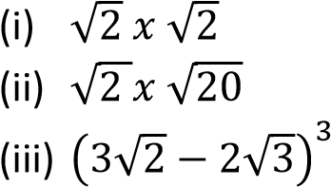
Solution

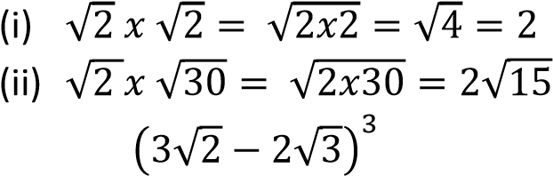
(iii)
Using Pascal’s triangle; the coefficients of the terms in the expansion (a + b)³ are 1 3 3 1
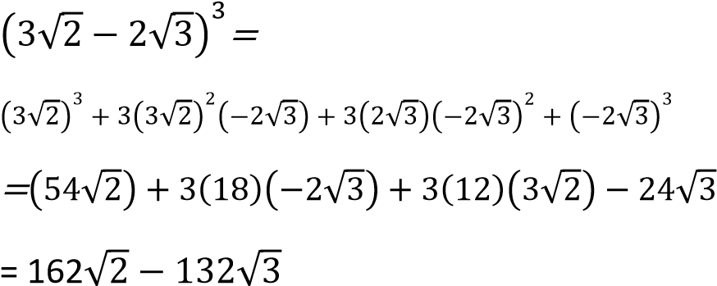

Example 3 Express 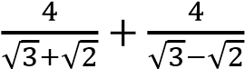 in form b where b and c are integers. (05 marks)
√

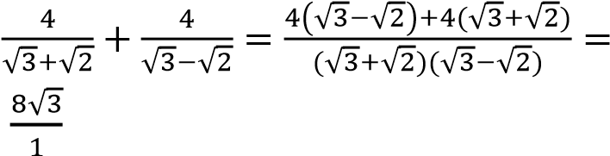
Hence b = 8 and c= 3

Example 4 Show that 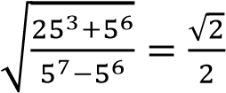

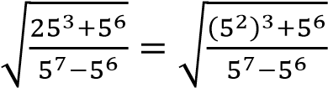
Example 5

Rationalize the following
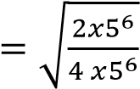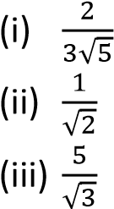

√

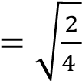 Solution

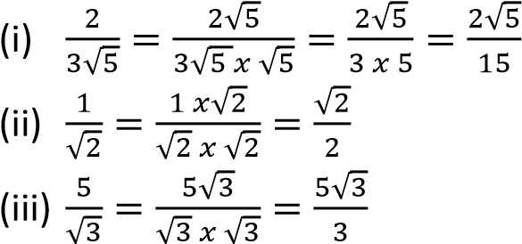
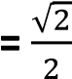
Example 5
Without using a calculator, evaluate 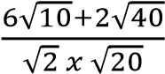.
In the second case rationalize by multiplying the
Solution numerator and denominator by the conjugate
of the denominator.
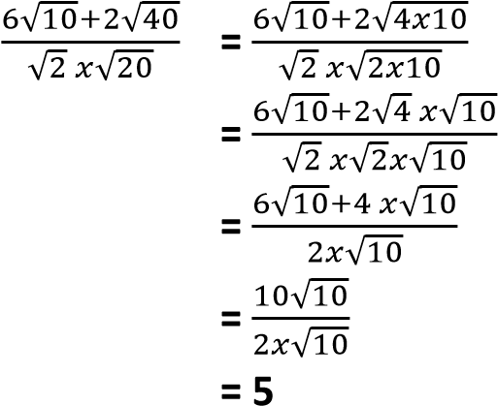
Note

- The conjugate a + 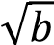 is a - 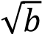 and that a -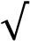 is a + 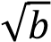
- The product of a surd function and its conjugate is equal to the difference of two squares. i.e. (a + 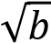)( a -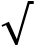 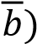 = 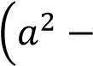
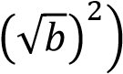

Division of surds
Example 7
There are two types of division of surds;
Rationalize the following - A fraction whose denominators has a single
term such as 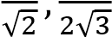, etc. 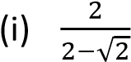
- A fraction whose denominator has double 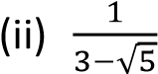 terms, such as 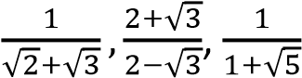, etc. 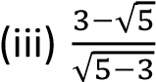
- In both cases, first eliminate the surds from
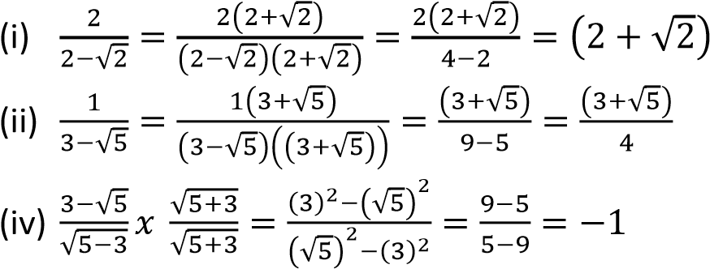
solution the denominator. The process of eliminating surds from the denominator is
called rationalization.
- In the first case rationalize the fraction by multiplying the numerator and denominator by the surd term of the denominator.

Set square angle (30⁰, 45⁰ and 60⁰)
- Consider an equilateral triangle ABC of each side = a units


a

a

a

60
0

60
0

30
0

A

B

C

D

EC=
; sin60
; sin60
- Given a right angled isosceles triangle ABC with equal perpendicular sides each of length a units

a

a

a
√

45
0

45
0

A

B

C

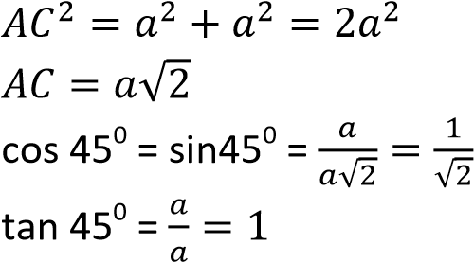

Example 8
Express without a surd in the denominator each of the following
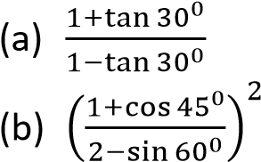
Solution
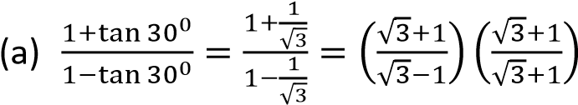

√

√

√

(
)
b

(

)

(

√

√

)

(

√

√

)

√

√

(

√

√

)
(

√

√

)

√

√

√

Application of surds

(i) Architecture and Construction
Use: Surds appear when calculating diagonal lengths or slopes.
Example: To find the diagonal of a square with side 5 meters:
Diagonal=5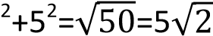
Why it matters: Keeps measurements exact without rounding errors.

(ii) Geometry and Trigonometry
Use: Surds are common in formulas for area, perimeter, and angles.
Example: The height of an equilateral triangle with side a is

√

Why it matters: Helps in precise design and modeling.

(iii) Navigation and Distance Calculation
Use: Surds help calculate direct distances using Pythagoras’ theorem.
Example: If a plane travels 3 km east and 4 km north, the direct distance is
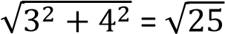=5km
If the values aren’t perfect squares, the result remains a surd.

(iv) Physics and Engineering
Use: Surds appear in formulas for speed, force, and energy. Example: The speed of a wave might be expressed as 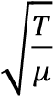.
Why it matters: Ensures accurate modeling of natural phenomena.

Revision exercise on surds
- Simplify
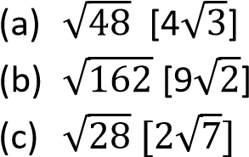
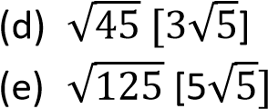
(f)
- Simplify the following suds
- Given that 4, find the value of x [-14]
√

√

√

√

- Find the value of the following simplifying the answer as much as possible
- Express each of the following in the form where a, b and c are integers
- Solve the equations
[x = 5 or x =

TOPIC 2/6: Equations and Inequalities
Competency: The learner investigates equations and inequalities to acquire mathematical computational and analytical skills applicable in the real world.
Contents
Quadratic equations 3
Forming quadratic equations 3
Solving quadratic equations 4
Solving quadratic equations using Factorization method 4
Solving quadratic equations using Completing squares approach 5
Solving quadratic equations using Graphical approach 6
Revision exercise on quadratic equation 9
Application of quadratic equation 10
Simultaneous equation 11
Solving simultaneous equations using elimination method 11
Solving simultaneous equations using substitution method 11
Solving simultaneous equations using graphical method 12
Solving simultaneous equations using matrixes 13
Solving Non-linear simultaneous equation 16
Solving three linear simultaneous equations in three unknown 17
Applications of simultaneous equations 20
Revision exercise for simultaneous equations 21
Inequalities 22
Solving Linear inequalities in one unknown given one in one equation 22
Solving linear inequalities involving indices 22
Solving linear inequalities in one unknown given two inequalities equations 23
Solving Non-linear inequalities in one unknown 24
Limits of inequality 27
Applications of inequalities 29
Revision exercise on inequalities 30
Polynomials 31
Addition and subtraction of polynomial 31
Multiplication of polynomials 32
Division of polynomials 32
Revision exercise 1 on polynomials 33
The remainder and factor theorems 33
Synthetic approach for finding the remainder of polynomial 34
Revision exercise 2 on polynomials 37
Application of polynomials 38

Quadratic equations
These are equations expressed in the form ax² + bx + c = 0 where a, b and c are constants and a 0
They have at most two roots which may be real or complex.
The latter roots are handled exclusively under complex numbers
Example of quadratic equations 2y² + 3y + 5 = 0; a = 2, b = 3 and c = 5 x² + 4x – 10 = 0; a = 1, b = 4, c = -10

Forming quadratic equations
Suppose that the roots of a quadratic equation are α and β, then x – α = 0 and x – β = 0
When forming a quadratic equation
(x – α)( x – β) = 0 x² – (α + )x + αβ = 0
This means that if the roots of a quadratic equation are given, its equation in terms of x is x²-(sum of roots)x + product of roots = 0

Example 1
Form quadratic equation I terms of x with roots
- (2, 3)
Solution
Let x = 2 or x = 3
x – 2 = 0 x – 3 = 0 ⇨ (x – 2)(x – 3) = 0 x² – 5x – 6 = 0
- (p, q)
Solution
Let x = p or x = q
x – p = 0 x – q = 0 ⇨ (x – p)(x – q) = 0
x² – (p + q)x – pq = 0
- (-3, -2)
Solution
Let x = -3 or x = -2
x + 3 = 0 x + 2 = 0
⇨ (x + 3)(x + 2) = 0 x² + 5x + 6 = 0

Example 2
Given that the root of the equation x² + px + q = 0 are α and β, express
(α - in terms of p and q. Deduce
that for one root to be the square of another p³ – 3pq + q² + q = o must hold
Solution For x² + px + q = 0 α + β = -p αβ = q
(α –
=
But
(α –
Hence (α –
If α = β²
then( –
As required

Example 3
Given that the root of the equation x² + px + q = 0 are α and β, Form quadratic equations with roots
Solution
Sum of roots =
Product of roots =
Required equation
Or

(b) pα + qβ and qα + pβ
Solution Sum of roots pα + qβ + qα + pβ = p(α +β) + q(α +β)
=(p + q)(α +β)
=p(p + q)
Product of roots= (pα + qβ)(qα + pβ)
= pqα² + p²αβ + q²αβ + pqβ²
= pq(α² + β²) + αβ(p² + q²)
= pq+ αβ(p² + q²)
=pq(p²-2q) + q(p² + q²)
Required equation

Example 4
Given the equation x³ + x – 10 = 0.
- Show that x = 2 is a root of the equation
Let f(x) = x³ + x – 10
Substituting for x = 2 f(2) = 2³ + x -10 = 8 + 2 – 10
= 10 – 10 = 0
Hence x = 2 is a root of x³ + x –10 = 0
- Deduce the values of α + β and αβ where α and β are roots of the equation. Hence form a quadratic equation whose roots are α² and β².
⇨ x³ + x –10 = (x-2)()
Either x – 2 = 0
Or () = 0
α + β = 2 αβ = 5
Sum of roots = α² + β² =
= (-2)² – 2(5) = 4 – 10 = -6
Product= = 25
The equation become

Solving quadratic equations
Quadratic equations may be solved by
- Factorization method
- Completing square method
- Graphical method

Solving quadratic equations using Factorization method
It is used for quadratic equations that are easy to factorize

Example 5
- 4x² + 7x + 3 = 0
Solution side work
4x(x + 1)+ 3(x + 1) = 0 Product = 4 x 3 = 12
  - + 1)(4x + 3) = 0 Sum = 7
Either x + 1 = 0; x = -1 Factor = (4, 3)
Or 4x + 3 = 0; x = -
- 2x² + 5x + 3 = 0
Solution side work
2x(x + 1)+ 3(x + 1) = 0 Product = 3 x 2 = 6
  - + 1)( 2x + 3) = 0 Sum = 5
Either x + 1 = 0; x = -1 Factors 3, 2
Or 2x + 3 = 0; x =
- x² + x – 20 = 0
Solution Side work
x(x – 4) + 5(x – 4) = 0 Product = -20 (x – 4)(x + 5) = 0 Sum = 1
Either x – 4 = 0; x = 4 Factors ( 5, - 4)
Or x + 5 = 0; x = -5
- 10x² + x – 3 = 0
Solution Side work
5x(2x -1) + 3(2x – 1) = 0 product 10 x – 3 = -30
(5x + 3)(2x – 1) = 0 sum = 1
Either 5x + 3 = 0; x = - Factors (6, -5)
Or 2x – 1 = 0; x =

Solving quadratic equations using Completing squares approach
The idea is to create a perfect square on one side of the equation:
Given the equation ax²+ bx + c = 0
- Dividing the equation by and transposing the constant term to the RHS
- Marking the LHS a perfect square, add a half the coefficient of x squared on both sides
- Factories the terms on the LHS
-
- Taking square root on both sides of the equation
-
- Solving

√

√

-
This is the general quadratic equation formula for finding the square root of any quadratic equation. This formula is locally known as bull dozer formula

Example 6
Solve the following equations by completing squares
- 2x² – x – 3 = 0 Solution 2x² – x – 3 = 0
x
Either
Or
Hence x = -1 and x =
- 18x² + 7x – 1 = 0
Solution
18x² + 7x – 1 = 0
x
Either
Or
Hence x = or x =
- 3x² + 7x + 2 = 0
Solution
3x² + 7x + 2 = 0
Either x =
Or x =
Hence x = -2 and x =

Example 7
Solve the following equations by using the quadratic formula
- 7x² – 5x – 2 = 0
Solution
Either
Hence
- 3x² – 7x – 6 = 0
Either
Hence
- 6x² -5x – 6 = 0
Either
Hence

Solving quadratic equations using Graphical approach
Here, the roots of the equations are established by plotting suitable graphs. It may done by:-
- Single graph plot
- Two graph plot

Single graph method
Given the function y = f(x), tabulate the selected values of x closer to zero within a given range which must be substituted in the function given to obtain the corresponding values of y. These values are plotted on the same x and y axes and joined by a curve. The roots of the function f(x) = 0 are the values of x where the function y = f(x) crosses the x-axis.

Two graphs method
Here the function y = f(x) is split into two and the equations plotted separately on the same axes. The points of intersection of the two graphs are noted and the corresponding values of x are read off on the x – axis.

Example 8
Solve the following equation by using graphical approach
(a) 2x² + 3x – 3 = 0
Solution

Using a single graphs
Let y = 2x² + 3x – 3 taking -3 x 2
Table of values
X | -3 | -2 | -1 | 0 | 1 | 2
y | 6 | -1 | -4 | -3 | 2 | 11

From the graph, the roots of the equation are x = -2.2 and x = 0.7

Using two graphs
By splitting the equation 2x² + 3x – 3 = 0 into two we have 2x² = -3x + 3
Let y₁ = 2x² and y₂ = 3 - 3x
Table of results
X | -3 | -2 | -1 | 0 | 1 | 2
y₁ | 18 | 8 | 2 | 0 | 2 | 8
y₁ | 12 | 9 | 6 | 3 | 0 | -3
From the graph, the roots of the equation are x = -2.2 and x = 0.7
(b) x² + x – 6 = 0
Solution

Using a single graphs
Let y = x² + x – 6 = 0, taking -4 x 3
Table of values
X | -4 | -3 | -2 | -1 | 0 | 1 | 2 | 3
y | 6 | 0 | -4 | -6 | -6 | -4 | 0 | 6
From the graph, the roots of the equation are x
= -3 and x = 2

Using two graphs
By splitting the equation x² + x – 6 = 0
Into two we have x² = 6 - x
Let y₁ = x² and y₂ = 6 - x

Table of results
X | -4 | -3 | -2 | -1 | 0 | 1 | 2 | 3
y₁ | 16 | 9 | 4 | 1 | 0 | 1 | 4 | 9
y₁ | 10 | 9 | 8 | 7 | 6 | 5 | 4 | 3

From the graph, the roots of the equation are x = -3 and x = 2

Minimum and maximum values of quadratic expression
The methods of completing squares and graphing can be used to obtain minimum and maximum values of quadratic expression Completing square method
The general form of quadratic equation y = ax² + bx + c can be expressed as y = ax² + bx + c
The minimum/maximum value is the constant which is attained when
Note
- if a < 0, the value of the function is maximum
- if a > 0, the value of the function is minimum

Example 9
Determine the minimum or maximum values of the following expressions using completing squares
- 2x² – x – 3 = 0
Solution
Let y = 2x² – x – 3 = 0
Since a > 0, the function has got a minimum
value at x = . Hence y
- -4 + 6x – x² Let y = -4 + 6x – x² y = - (x² – 6x + 4) y = -(x² – 6x + (-3)² + 4 – (-3)²) y =-((x – 3)² + 4 – 9) y =-((x – 3)² + -5)
Since a = -1 < 0, the expression has got a maximum value when x = 3. Hence y_{max} = 5

Using graphical method for minimum and maximum value
After graphing, y =f(x) the minimum value of the expression is lowest point if a trough/valley like or curving upwards and the maximum value is the maximum point if downwards

Example 10
Determine the maximum or minimum values of
the following expression using graphical method
- 2x² + 3x – 3 = 0
Solution
Let y = 2x² + 3x – 3 taking -3 x 2
Table of values
X | -3 | -2 | -1 | 0 | 1 | 2
y | 6 | -1 | -4 | -3 | 2 | 11

y_{min} = - 4.1 at -0.75
- 14 – 2x – 3x²
Ley y = 14 – 2x – 3x² ; -3 x 2
Table of results
x | -3 | -2 | -1 | 0 | 1 | 2
y | -7 | 6 | 13 | 14 | 9 | -2
y_{max} = 14.3 at x =-0.3

Revision exercise on quadratic equation

- Given that the roots of the equation x² + px + q = 0 are α and β, find the values of:
- If the roots of the equation x² + 2x + 3 = 0 are α and β, form an equation whose roots
are α² – β and β² – α. *x² + 2 = 0]

- Given that the roots of the equation x² – 2x + 10 = 0 are α and β, form an equation whose roots are

- If α and β are roots of the equation x²
– px + q = 0, find the equation whose roots
are

[qx² – (p²q – 2q²–p)x + (q³ – p³ + 3pq)+1=0]
- The roots of the equation 3x² – ax + 6b = 0 are α and β. Find the condition for one root to be
  - Twice the other [81b = a²)
  - The cube of the other
[a⁴ – 648(b – 1)b² – 18(4a² + 9)b = 0]
- By Factorization method solve the following quadratic equations
  - x² + 9x + 14 [x = -7, x= -2]
  - x² + 2x – 8 = 0 [ x = -4, x = 2)
  - 2x² + x – 10 = 0 [x= 2, x = -
  - 6x² – 19x + 10
- Solve the following equations by completing squares
- 2x² + 5x + 3 = 0
- x² + 9x + 20 = 0 [x = -5 and x = -4]

Application of quadratic equation
1. Projectile Motion
Application: Predicting the path of a thrown object (e.g., ball, arrow).
Example: If a ball is thrown upward, its height h at time t can be modeled by:
h(t)=−4.9t²+20t+1
This equation helps determine how high the ball goes and when it hits the ground. 2. Area Optimization
Application: Maximizing or minimizing area with fixed perimeter or constraints.
Example: A farmer wants to fence a rectangular field next to a river (no fence needed on one side). With 100 meters of fencing, the area A can be modeled by:
A(x) = x(100−2x)
Solving this quadratic helps find the dimensions that give the largest area.
- x² + x – 20 = 0 [x = -5 and x = 4]
- x² – x – 20 = 0 [x = 4 and x = 5]
- Solve the following equations using the quadratic formula (a) 2x2 + 5x + 3 = 0
  - x² + 9x + 20 [-5, -4]
  - x² + x - 20 [-5, 4]

- Determine the maximum or minimum values of the following expression
  - 3x² – 2x + 1
  - 4 – x – x
- Determine the maximum or minimum values of the following expression using graphical method
  - 14 – 2x – 2x²
- Business and Economics
Application: Maximizing profit or minimizing cost.
Example: A company finds that profit P from selling x items is:
P(x) =−5x²+150x−100o
Solving this helps determine how many items to sell for maximum profit.
- Engineering and Design
Application: Designing structures like bridges or roller coasters.
Example: The arch of a bridge might follow a quadratic curve:
Y =−0.01x²+x
Engineers use this to calculate height and span.

P a g e |

Simultaneous equation
Simultaneous equations in two unknowns
These are equations containing two unknowns. The equations may all be linear (equations of straight lines) or one of them may be linear and the other non-linear. Linear simultaneous equations
Simultaneous equations may solved by any of the three methods
- Elimination method
- Substitution method
- Graphical method
- Solving simultaneous equations using matrixes

Solving simultaneous equations using elimination method
This involves elimination of one of the unknown variables so as to be in position to find the other.
Example 1
(a) 5x + 3y = 7
2x -4y = 3
Solution
5x + 3y = 7 ………… (i)
2x -4y = 3 ………….(ii)
To eliminate y the equation are multiplied by relevant factors to make the coefficients of y in both equations equal. Thus eqn. (i) is multiplied by 4 and eqn. (ii) by 3
i.e. 4 x eqn. (i) + 3 x eqn. (ii)

20x + 12y =28
+ 6x – 12y = 9

26x = 37
x =
Substituting x in eqn.(i)
5x + 3y = 7
3y = 7 –
Y =
(b) 3x + 2y = 8
3y + 4x = 11
Solution
Rearrange the eqns.
3x + 2y = 8 …………. (i)
4x + 3y = 11 ……….. (ii)
Eliminate x as follows
4 x eqn. (i) – 3 x eqn. (ii)
12x + 8y = 32
- 12x + 9y = 33

y = 1
Substituting y in eqn. (i)
3x + 2y = 8
3x + 2 x 1 = 8 3x = 6 x = 2

Solving simultaneous equations using substitution method
This involves the expression of one of the unknown variable in terms of the other.
Example 2
Solve the following pairs of simultaneous equation for x and y by substitution method
(a) 5x + 3y = 7
2x -4y = 3
Solution
5x + 3y = 7
5x = 7 – 3y
x = ………… (i)
2x -4y = 3 ……… (ii)
Substituting x in eqn. (ii)
Multiply 5 through
2(7 – 3y) – 20y = 15
14 – 6y – 20y = 15
-26y = 1
y =
Substituting y into eqn. (i)
x =
and y =
(b) 3x + 2y = 8
y = …………………. (i)
3y + 4x = 11 ………….. (ii)
Substituting y in equation (ii)
Multiplying 2 through
3(8 – 3x) + 8x = 22
24 – 9x + 8x = 22 -1x = = -2 x = 2 substituting x into equation (i)
y =
x =2 and y = 1

Solving simultaneous equations using graphical method
This method involve drawing graphs of the two linear equations and finding the coordinates of their points of intersection
Establish at least two possible points with known coordinates satisfying the equations. The coordinates of the point of intersection of the lines drawn are the solutions to the equations

Example 3
Solve the following pairs of simultaneous equations for x and y using graphical method
- 3x + 2y = 8
3y + 4x = 11
For 3x + 2y = 8
x | 0 | 4
y | 4 | -2
For 3y + 4x = 11
x | -1 | 2
y | 5 | 1
From the graph the point of intersection is
(2, 1) Hence x = 2 and y = 1
- x + y = 4
3x + 2y = 6
For x + y = 4
x | 0 | 4
y | 4 | 0
For 3x + 2y = 6
x | 0 | 0
y | 3 | 2

From the graph, the point of intersection is (-2, 6). Hence x = -2, y = 6

Solving simultaneous equations using matrixes
A. Determinant method
Consider the simultaneous equations a₁x + b₁y = c₁ a₂x + b₁y = d₁
⇨ …………… (i)

Matrix B is obtained by interchanging the coefficients of x in eqn. (i) with the column matrix on the right hand side
Matric C is obtained by interchanging the coefficients of y in equation (i) with the column matrix on the right and side of eqn.(i)
For the determinant method and y =

Example 4
- x + 3y – 15 = 0
3x = 17 – 2y Re-arranging the equation x + 3y = 15
3x + 2y = 17
Expressing the equation in matrix form

Hence x = 3 and y = 4
- 5x + 3y = 7
2x -4y = 3
Expressing the equation in matrix form
- 34 + 3y = 3x
3x – 4y- 16 = 0
Rearranging the equations
-3x + 3y = -34
3x – 4y = 16
Expressing the equations in matrix form
Hence x = and y = 18

B. Adjunct method
Consider the simultaneous equations a₁x + b₁y = c₁
a₂x + b₁y = d₁
Arranging in matrix form
…………… (i)
If A=
Adjunct A =
To obtain the values of x and y, the adjunct is pre-multiplied on the both sides, i.e.

Example 5
Solve the following equations using matrix method
- 4x – 3y = 2 x + 2y = 1
- 4x + 3y = 17
5x – 2y = 4
- 7x – y = -1
3x – 2y = - 24

Solution
- 4x – 3y = 2 x + 2y = 1
Express the equation in matrix form
………………… (i)
Let
Adjunct
Pre- multiply both sides of eqn. (i) the adjunct matrix A
11x = 7
11y =2
Hence
- 4x + 3y = 17
5x – 2y = 4
Express in matrix form
………….. (i)
Let
Adjunct A
Pre- multiply both sides of eqn. (i) the adjunct matrix A

-23x = -46
-23y = -69
Hence x = 2, y = 3
- 7x – y = -1
3x – 2y = - 24
Arrange in matrix form
……………..(i)
Let
Adjunct A
Pre- multiply both sides of eqn. (i) the adjunct matrix A
-11x = -22
-23y = -69
Hence x = 2 and y = 15

C. Inverse method Example 6
- 4x – 3y = 2 x + 2y = 1
- 4x + 3y = 17
5x – 2y = 4
- 7x – y = -1
3x – 2y = - 24 Solution
(a) 4x – 3y = 2 x + 2y = 1
Arrange n matrix form
Let
det A = (4 x 2) – (1 x -3) = 11
Inverse,
Pre-multiply both sides of eqn. (i) by the inverse matrix A
Hence x =
Note: when we pre-multiply a matrix by its inverse, we obtain an identity matrix, i.e. AA⁻¹ = 1
Hence x =
- 4x + 3y = 17
5x – 2y = 4
Arrange in matrix form
…………………(i)
Let
det A = 4 x -2 – (5 x 3) = -23
Adjunct A
Inverse A (A⁻
Pre-multiply both sides of eqn. (i) by the inverse matrix A
Hence x = 2, y = 3
- 7x – y = -1
3x – 2y = - 24
Express in matrix form
Let
det A = (7 x -2)- (3 x -1) = -11
Adjunct A
Inverse of matrix A (A⁻¹) =
Pre-multiply both sides of eqn. (i) by the inverse matrix A
Hence x = 2 and y 15

Solving Non-linear simultaneous equation
These are solved basically by using substitution method Example 7
- x² + 2x – y = 14 2x² – 3y = 47
- 2x²-xy + y² = 32 y =

Solution
(a) x² + 2x – y = 14 y = x² + 2x – 14……………… (i) 2x² – 3y = 47 …………………. (ii)
Substituting eqn. (i) into eqn. (ii)
2x² - 3(x² + 2x – 14) = 47
2x² - 3x² – 6x + 42 = 47 -x² – 6x – 5 = 0 x² + 6x +5 = 0 (x+1)(x+5)= 0 x = -1 or x = -5
Substituting x into eqn. (i)
When x = -1, y = (-1)² + 2(-1) – 14 = -15 When x = -5, y = (-5)² + 2(-5) – 14 = 1
Hence (x, y) = (-1, -15) and (-5, -1)
(b) 2x²-xy + y² = 32 ……………….. (i)
y = ……………………………… (ii)
Substituting equation (ii) into eqn. (i)
2x⁴ - 27 x² + 25 =0 (x² – 1)(2x² – 25) = 0 x² = 1
x = 1
2x² – 25 = 0
2x² = 25
Substituting for x into eqn. (i)
- =
When x = 1,
When x = -
When x =
When x =
Hence the solution to simultaneous equations are (x, y)= (1, -5), ( ,
(c) (x – 4y)² = 1
3x = 8y = 11 (06marks)
Solving equations
- – 4y) = 1 …………………… (i)
3x = 8y = 11……………………. (ii)
Eqn. (ii) - 3Eqn. (i)
20y = 8
- =
From eqn. (i)
x = 1 + 4
And
(x – 4y) = -1 …………………… (i)
3x = 8y = 11……………………. (ii)
2(eqn (i)) + eqn. (ii)
- = From equation (i)
- =
(x,y) =

Solving three linear simultaneous equations in three unknown
When solving for three unknowns, there must be three equation that will be solved simultaneously. The methods that will be used to such equation are
- Elimination and substitution

- Row reduction to echelon Elimination and substitution
This involves elimination of one unknown variable so as to remain two unknowns which can easily be solved

Example 7
(a) Solve the simultaneous equations
x – 2y - 2z = 0 2x + 3y + z = 1
3x –y – 3z = 3
X – 2y -2z = 0 ……………………… (i)
2x + 3y + z = 1…………………… (ii)
3x –y – 3z = 3 ……………………...(iii)
Eqn. (i) + 2eqn. (ii)
4x + 4y = 2 ……………………………(iv)
3Eqn. (ii) + eqn. (iii)
9x + 8y = 6 …………………………. (v)
2eqn. (iv) – eqn. (v) x = -2
Substituting x = -2 into eqn. (iv) 5(-2) + 4y = 2 y = 3
Substituting x = -2 and y = 3 into eqn. (ii)
2(-2) + 3(3) + z =2 z = -4 x = -2, y = 3 and z = -4

(b) 2x = 3y = 4z x² - 9y² – 4z + 8 = 0
2x = 3y = 4z, substituting 4z = 2x and y = into the equation x² – 9y² – 4z + 8 = 0 x² – (2x)² – 2x + 8 = 0
-3x² – 2x + 8= 0
x = ; x = -2 or x =
When x = --
1
(x, y, z) = ( -

Row reduction to Echelon matrix form
When x =
(x, y, z) = (

Alternatively
2x = 3y = 4z, substituting 4z = 3y and x = into the equation x² – 9y² – 4z + 8 = 0 3y + 8 = 0
9y² – 36y² – 12y + 32 = 0
-27y² – 12y + 32 = 0
y = ; y = or x =
When y = =
-1
(x, y, z) = ( -
When y =
(x, y, z) = (

This method involves the expression of the three equations into matrix form known as augmented matrix and thereafter transforming the augmented matrix to a unity triangular matrix (a matrix whose elements in the major diagonal are unity and zero below)
Example
Solve the simultaneous equations
(a) x – 2y - 2z = 0
2x + 3y + z = 1
3x –y – 3z = 3

Solution
Expressing the equation in matrix form

The augmented matrix is

(

)

Transforming augmented matrix to a unity triangular matrix
⇨

z =
-
4

y +

𝑧

=

⁄

y +

𝑥

=

⁄

y = 3

x
–

y
2
–

2
z =
0

x
-
2(3)

–

2(
-
4)
0
=

x =
-
2

x =
-
2
, y = 3 and z =
-
4

- 3x – y – 2z = 0 x +3y – z = 5
2x – y + 4z = 26
Expressing the equation into matrix form
The augmented matrix is

(

)

Transforming the augmented matrix into unity

Z = 5

y
-

𝑥

=

10
y
-

=

y

2

=

x
–

y
–

z = 0

x
-

(2)

–

(5) =
0

x = 4

x = 4, y = 2 and z = 5

- 3x – 2y – z = 5 x +3y – z = 4
2x – y + 4z = 13 [3, 1, 2]

Expressing the equation into matrix form
The augmented matrix is

(

)

Transforming the augmented matrix into unity
Z = 2

y
-

𝑥

𝑧

=

11
y
-

=

y = 1

x
–

y
–

z =

x
-

(1)

–

(2) =

x = 3

x = 3, y = 1 and z = 2

Applications of simultaneous equations
- Business and Finance
Application: Calculating costs, revenues, and profits when multiple variables are involved.
Example: A company sells two products. If 3 units of Product A and 2 units of Product B cost sh. 80, and 2 units of Product A and 4 units of Product B cost sh.100, simultaneous equations help determine the individual prices of each product.
- Mixture Problems
Application: Determining concentrations or proportions in chemistry or cooking.
Example: Mixing two solutions with different concentrations to get a desired concentration. If Solution A is 30% acid and Solution B is 50% acid, simultaneous equations help find how much of each to mix for a 40% solution.

3. Travel and Motion

Application: Solving problems involving speed, time, and distance.
Example: Two cyclists start from different points and travel toward each other. One travels 5 km/h faster than the other. Simultaneous equations help determine when and where they meet.
- Economics
Application: Market equilibrium analysis.
Example: Supply and demand equations intersect to find the equilibrium price and quantity in a market.
- Engineering
Application: Circuit analysis and structural design.
Example: In electrical engineering, Kirchhoff’s laws generate simultaneous equations to calculate current and voltage in circuits.

Revision exercise for simultaneous equations
- Using elimination method solve the following pairs of simultaneous equation
  - -3x + 2y =-16 x + 5y = 11 [x = 6, y = 1] (b) 3y – 2x = -18
2y + 3x = -6 [ x = 0, y = -3]
(c) 2x - 3y = 7
X + 4y = -2 [x = 2, y = -1]
(d) 5x + 3y = 8
3x + 2y = 6 [x = -2, y = 6)
- Using substitution method solve the following pairs of simultaneous equation
  - -3x + 2y = 16
5x + 3y = 33 [x = 6, y = 1]
  - y – 2x = -3
7y + 3x = -21 [x = 0, y = -3]
  - 2x + 5y = 26
3x + 2y = 6 [ x = -2, y = 6]
- Solve the following pairs of simultaneous equation using the matrix method
- 2x – 3y = 7
2x + 3y = 1 [x =2, y = -1]
- 2x – 7y = 1
3x + 3y = 15
- 3x – 4y = 5
6x – 3y = 0 [x = -1, y =-2]
- 3x + 2y = 3 x -6y = 1[x =1, y = 0] (e) 2x + 3y= 1
3x + y = 5 [x =2, y = -1]
- Solve the following simultaneous equations elimination and substitution
method
  - 3x – 2y – 2z = -2 x + 3y – 3z = -5
2x – y + 4z = 26 [(x, y, z)=(4, 2, 5)]
  - 2x + 2y – 3z = 1
3x + 3y – z = 5
4x – 2y + 2z = 4 [(x, y, z)=(1, 1, 1)]
  - 4x –y + 2z = 7 x + y + 6z = 2
8x + 3y – 10z = -3 [(x, y, z)=(1, -
- By row reducing the appropriate matric to echelon form solve the systems of equations below
- x +2y – 2z =0
2x + y – 4z = -1
4x – 3y + z = 11 [(x, y, z), (3, 1, 2]
- x – 2y + 3z = 6
3x + 4y – z = 3
4x + 6y – 5z = 0 [(x, y, z)=(2, , 1)]
- 2x – y + 3z = 10 x +2y -5z = 9
5x + y + 4z [ x =2, y = -2, z= 1]
- p + 2q – r = -1
3p –q + 2r = 16
2p + 3q + r =3 [p= 4, q = -2, r = 1]

Inequalities
An inequality is a logical statement that states relationship between two mathematical expressions.
The basic inequalities commonly used are
- Less than (<)
- More than (>)
- Less than or equal ()
- Greater than or equal ()
When solving for equations, the solutions or answers are individual values but when solving inequalities, the solutions are a range of possible real values.
Linear inequalities

Solving Linear inequalities in one unknown given one in one equation
Solving linear inequalities in one unknown given one in one equation is done in the same way as solving for linear equation except
- The inequality symbols must be maintained
- The inequality symbol changes when dividing both sides of inequality equation by a negative number.

Example 1
Solve the following inequalities
- 4x – 2 > x + 7
Solution
4x – x > 7 + 2 3x > 9 x > 3
- 3(2 – x) > 5(3 + 2x) Solution
6 – 3x > 15 + 10x
-9 > 13x
x <
Solution
Multiply both sides by 12
3(x – 2) < 4(2x – 3)
3x – 6 < 8x – 12 -5x < -6 x >

Multiply both sides by 12
6(x – 1) + 4(x – 2) 3(x – 3)
6x – 6 + 4x – 8 3x – 9 7x 5 x

Solving linear inequalities involving indices
When solving inequalities involving indices such as a^{x} > b, where a and b are positive integers, introduce natural logarithms to both sides of the inequality. i.e. Ina^{x} > b xlna > lnb
x >

Example 2
Solve the following inequalities correct to 3 decimal places
- 5^{2x} > 8
Solution
In5^{2x} > In8
2xln5 > ln8
x > 0.646
- 20^{-3x} < 15 Solution
In20^{-3x} > In15
-3xln20 > ln15
  - > -0.301

- (0.8)^{-3x} > 2.4

Solution
In(0.8)^{-3x} > In2.4
  - >
- (0.8)^{3x} > 2.4 Solution
In(0.8)^{3x} > In2.4
3xln0.8 > ln2.4 Note that logarithm of any number between 0 and 1 is negative; so ln0.8 is negative
x <

Solving linear inequalities in one unknown given two inequalities equations
The solution to two linear inequalities can be best handled by use of a number line. When finding a set of integers that satisfy the equations, we only take on integral (discrete) values.

Example 3
Find the set of integers which satisfy simultaneously both of the following equations
- 4x + 3 2x + 5; x + 4 7
Solution
4x + 3 2x + 5; x + 4 7 2x 2 x 3
x 1
The number line show that the set of integers that satisfies the two equations are {1, 2, 3}
- 5 – 2x 3 – x ; 1 -2x 11 – 4x
Solution
5 – 2x 3 – x ; 1 -2x 11 – 4x -x -2 2x 10 x 2 x 5
The number line show that the set of integers that satisfies the two equations are ,x:x ≤ 2-
- 5x – 4 ≥ 4x -3,
Solution
5x – 4 ≥ 4x -3, x ≥ 1 x < 3
The number line show that the set of integers that satisfies the two equations are {1, 2} (3 is not included

Example 4
Show that there is just one integer which simultaneously satisfies the three inequalities and find that number
Solution
x – 1 ≥ 2 -3x ≤ 5 x ≤ 3 x ≥ 3 x ≤ 3

-
2

-
1
0 1 2 3 4 5 6 7 8

9

x ≥

x ≤ 3

x ≥ 3

From the number line, there is only one point of intersection of the three inequalities, which is 3
Hence the set of integers that satisfy the three inequalities is {3}

Solving Non-linear inequalities in one unknown
The following methods are employed
- Sign change
- Graphical method
When using graphical method, the set of values above the axis are positive and those below are negative
When using sign change method, a table describing specific regions of inequalities is used and the necessary tests are performed
If the inequality symbol is ≥ or ≤, care must be taken, because the critical values of the function and the numerator in case of fractions will always satisfy the inequalities
Before solving inequality, all terms must be taken to one side preferably the LHS
Method I: Graphical method

Example 5
Solve the following inequalities
- 2x² – 3x + 1 ≤ 0
Solution
Let y = 2x² – 3x + 1
The curve cuts the x – axis when y = 0
  - 2x² – 3x + 1 = 0
(x – 1)( 2x – 1) = 0 Either x – 1 = 0 or 2x – 1 = 0; x = 1 or x = the curve cuts the y – axis when x = 0
  - y = 1
Since the coefficient of x² is positive, that the curve is U shaped
The solution set is 0.5 ≤ x ≤ 1
- 7x² > 1- 6x
Solution
7x² > 1- 6x
7x² + 6x -1 > 0
Let y =7x² + 6x -1
The curve cuts the x – axis when y = 0
  - 7x² + 6x -1 = 0
(x + 1)(7x – 1) = 0
Either x + 1 = 0 or 7x – 1 = 0
x = -1 or x =
the curve cuts the y – axis when x = 0
  - y = -1

From the graph, the solution is x < -1 and x >
- 2x³ + 3x² 2x
Solution
2x³ + 3x² – 2x 0
Let y = 2x³ + 3x² – 2x
The curve cuts the x – axis when y = 0
- 2x³ + 3x² – 2x = 0 x(2x – 1)(x + 2) = 0 Either x = 0, 2x -1 = 0 or x + 2 = 0
x = 0, x = or x = -2
the curve cuts y – axis when x = 0
- y = 0
From the graph the solution 2 ≤ x ≤ 0 and x ≥ 0.5

(d) Solve the inequality
4x² + 2x < 3x + 6 (06marks)

Method II: sign change

Example 6
(a) 2x² – 3x + 1 ≤ 0 (2x -1)(x-1) ≤ 0
The critical values of (2x -1)(x-1)= 0 are x
= 1 and x = respectively The above illustration shows that the numbers and 1 subdivide the number line into three regions namely
, , x ≥ 1
The corresponding sign in the respective regions can be analysed by choosing any random value in each region, substitute it in the equation (2x -1)(x-1) and put the sign of
the answer on the following number line

+ - +

1
Note that the solution for (2x -1)(x-1) ≤ 0 is equal or less than zero or negative. Closed circles indicate that the critical values are part of the solution.
Hence the solution set for (x – 1)(2x – 1) ≤ 0
is
- 7x² + 6x -1> 0
7x² +7x – x – 1 = 0
  - + 1)(7x -1) = 0

The critical values x = -1 and
+ - +

-1
The solution for (x + 1)(7x -1) > 0 is positive . Open circles indicate that the critical values are not part of the solution Hence the solution set for (x + 1)(7x -1) > 0 is x < -1 and x >
- 2x³ + 3x²- 2x ≥ 0 x(2x² +3x -2) ≥ 0 x(x + 2)(2x – 1) ≥ 0
Critical values x = 0, x =-2, and x =
- + - +

-2 0
The solution for x(x + 2)(2x – 1) ≥ 0 is positive and the critical values are part of the solution
Hence the solution for x(x + 2)(2x – 1) ≥ 0
-

- 4x² + 5x – 6 < 0
4x² + 5x – 6= 0
Critical values
  - =
x = -
+ - +
-2

The solution 4x² + 5x – 6 < 0 is negative and the critical values are not part of the solution
the solution is -

(e)

Finding critical values
3x – 5 = 0; x =
(x + 1) = 0; x = -1
(x + 2) = 0, x = -2
Testing for correct region

- + - +

-2 -1

The solution for is positive
and the critical values are part of the solution

Hence the solution for is -2

The modulus of inequalities The modulus of a number is the magnitude of
that number (absolute value) which is always
positive, e.g. = 1

When finding modulus of an inequality, the following must be considered
- The modulus on one side of the linear inequality is removed by introducing a negative number of the given value on the other side
i.e. if , then -3 < x < 3
- The modulus on both sides of the linear inequality is removed by squaring both
sides
- When the terms under modulus are fractional, square both sides of the inequality

Example 7
Solve the following inequalities
-4< x – 6 < 4
-4 + 6 < x 4 + 6
2 < x < 10
-6 < 3x + 4 < 6
-6 – 4 < 3x < 6 – 4
-10 < 3x < 2

(2x – 3)² > (x + 3)²
4x² – 12x + 9 > x² + 6x + 9
3x² – 18x > 0
3x(x – 6) = 0
Critical values are x = 0 and x = 6

+ - +

0 6

The solution x < 0 and x > 6

(2x + 5)² < (x – 3)²
4x² + 20x + 25 < x² – 6x + 9
3x² + 26x + 16 < 0
(3x + 2)(x + 8) < 0
Critical values are x = -8 and x = -
+ - +

-8 -

The solution is -8 < x < -

Example 8
Find the range of value of x can take for the following inequality to be true
Solution
Squaring both sides
x² < 4(x² – 6x + 9) x² < 4x² – 24x + 36 0 < 3x² – 24x + 36 Divide through by 3 x² – 8x + 12 > 0
(x – 2)(x – 6) > 0
Critical values are x = 2 and x = 6

+ - +

Solution for (x – 2)(x – 6) > 0 (positive)
Hence the solution x < 2 and x > 6

Limits of inequality
This refers to interval within which the inequalities lies or does not lie.
This is done by expressing the function given as quadratic equation in x.
For real values of x, b² ≥ 4ac

Example 9
(a) Given the function y = , find the range of values within which y does not lies

Solution
y =
y(x² + 6x) = 3x – 6 yx² + (6y – 3)x + 6 = 0
For real values of x, b² ≥ 4ac
(6y – 3)² = 24y
36y² – 60y + 9 ≥ 0
Dividing through by 3
12y² – 2y + 3 ≥ 0
(6y – 1)(2y – 3) ≥ 0
The critical values are y = and y =
+ - +

Since the solution of the equation is positive;
the required range
(b) Find the range of values within which the function y = lies
Solution y(4 + x²) ≥ 3 – 2x yx² + 2x + 4y – 3 ≥ 0
For real values of x, b² ≥ 4ac
2² ≥ 4y(4y – 3)
1 ≥ 4y² – 3y
0 ≥ 4y² – 3y – 1
4y² – 3y – 1 ≤ 0
(y – 1)(4y + 1) ≤ 0
Critical values y = 1 and y =

+ - +

- 1

Solution for (y – 1)(4y + 1) ≤ 0 is negative and critical values are part of the solution
Hence range of values is
Simultaneous inequalities
Solving two simultaneous inequalities is best done by representing the inequalities on the graph. The unshaded (feasible) region represents the solution to the inequalities.

Example 10
Show by shading the unwanted regions; the region satisfying the inequalities y ≤ 2x +1 and y ≥ 3
Solution
For y ≤ 2x +1, the boundary line is y = 2x +1
If x= 0, y= 1, (x, y) = (0, 1)
If x= 2, y= 5, (x, y) = (2, 5)
Testing for wanted region using point (0,0); 0 ≤ 1. Hence this point is in wanted region.
For y ≥ 3 boundary line is y = 3
Show by shading the unwanted regions; the region satisfying the inequalities x +2y ≥ 6, y
> x, x< 5 and 3x + 5y ≤ 30

Solution
For x +2y ≥ 6 the boundary line is x + 2y = 6
x | 0 | 6
y | 3 | 0
For x> y
The boundary line is x = y
x | 0 | 5
y | 0 | 5
For x < 5
The boundary line is x = 5
For 3x + 5y ≤ 30
The boundary line
3x + 5y = 30
x | 0 | 5
y | 6 | 3

Applications of inequalities
- Budgeting and Finance
Application: Setting spending limits or estimating costs.
Example: If you have sh. 500 to spend on groceries for the month, the inequality is:
Total cost≤500
This helps ensure you stay within budget.

- Construction and Manufacturing
Application: Ensuring materials meet safety or size requirements.
Example: A beam must be at least 10 meters long but no more than 15 meters:
10≤Length≤15
- Health and Medicine
Application: Monitoring safe dosage or health metrics.
Example: A patient’s blood pressure should stay below 140 mmHg:
Blood pressure<140
- Law and Regulation
Application: Enforcing limits like speed or age.
Example: Legal driving age is 18 or older:
Age≥18
- Software and Staffing
Application: Managing resource allocation or scheduling.
Example: A server can handle up to 100 users:
Number of users≤100
- Real Estate
Application: Filtering properties by price or size.
Example: Looking for homes under sh.300,000:
Price<300,000
- Education
Application: Grading systems and eligibility.
Example: Students need at least 50% to pass:
Score≥50%
- Transportation
Application: Fuel limits or travel time estimates.
Example: A car can travel no more than 600 km on a full tank:
Distance≤600km
- Project Management
Application: Estimating time or cost ranges.
Example: A project must be completed in 30 days or less:
Time≤30

Revision exercise on inequalities
- Solve the following inequalities
  - 5(2 – x) – 2(3 – 6x) + 2(x – 1) > 0
- Solve the following inequalities. Correct 2 decimal places (a) (0.8)-3x > 4.0 [ x > 2.07 (2dp)]
  - (0.6)-2x< 3.6 [x< 1.25 (2dp)]
- Find the integers which simultaneously satisfy the following inequalities
(a) 3x + 2 ≥ 2x – 1, 7x + 3 < 5x + 2 {-
5x + 1 < 4(x + 2)
{2, 3, 4, 5, 6}
- Find the set of values of x for which
(c) 2(x² – 5) < x² + 6 [-4 < x < 4] (d) x² – x – 12 > 0 [ x < -3, x > 4]
(e) 2x(x + 3) > (x + 2)(x – 3) [ x < -6, x > -1]
- Solve the following inequalities
- Solve the following inequalities
(a)
4 and x> 0]
[x < 2, and x > 6]
- If y =, find the range of possible values of y for which x is real
- Find the range of values of x can take for the following inequalities to be true
  - [x > 1]

Polynomials
A polynomial in x is a function in the form f(x) = a₀ + a₁x + a₂x² + a₃x³ + … + a_{n}x^{n} where a0
- Quadratics
If α and β are the two roots, then, x = α and x =β x² – (α + β)x + αβ = 0
- Cubic
If α, β and λ are the three roots, then, x = α, x =β and x = λ
- (x – α)(x – β)(x – λ) = 0 [x² – (α + β)x + αβ+( x – λ) = 0 x³ – λx² – (α + β)x² + (α + β)λx +αβx-αβλ = 0 x³ – (α + β + λ)x² + (αβ + αλ + βλ)x -αβλ = 0
(c) Qurtic
If α, β, λ and ρ are the four roots, then x = α, x =β, x = λ and x = ρ
- (x – α)(x – β)(x – λ)(x – ρ) = 0
[x³ – (α + β + λ)x² + (αβ + αλ + βλ)x –αβλ+ (x – ρ) = 0
X⁴ – (α + β + λ+ρ)x³ + (αβ + αλ + αρ + βλ +βρ +λρ )x² – (αβλ + αβρ + αλρ +βλρ)x + αβλρ = 0
The above illustration shows that:
  - The signs of the terms alternate in the order: +, - , + ….. starting with the first
term.
  - The coefficient of the second term is – (sum of the roots) and the last term with its appropriate sign is the product of the roots
Example 1
Find the sums and products of the roots of the following equations
- 5x⁵ + 4x⁴ – 3x³ + 2x² – x + 6 = 0 Solution
Dividing through by 5 x
sum of roots = product of roots =

- 3x⁴ - 5x³ + 2x² + 0x + 9 = 0 Dividing through by 3
x + 0x + 3 = 0

Sum of roots =
Product of roots = 3

Addition and subtraction of polynomial
Polynomial are added or subtracted if they are of the same degree. This is done by adding or subtracting the coefficients of the corresponding term Example 2
(a) Given the polynomial f(x) = 5x⁵ + 4x⁴ – 3x³ + 2x² – x + 6 and g(x) = 3x⁴ – 5x³ + 2x² + 9
Find (i) f(x) + g (x) (ii) f(x) – g(x)

Solution
(i) f(x) + g(x)
5x⁵ + 4x⁴ – 3x³ + 2x² – x + 6
+ 3x⁴ – 5x³ + 2x² + 0x + 9

= 5x⁵ + 7x⁴ – 8x³ + 2x² – x + 15

f(x) - g(x)
5x⁵ + 4x⁴ – 3x³ + 2x² – x + 6
- 3x⁴ – 5x³ + 2x² + 0x + 9

= 5x⁵ + x⁴ + 2x³ + 0x² – x – 3
(b) Given polynomials f(x) = 2x³ + 4x² – 2x – 8 and
g(x) = x³ -2x² + 3x + 5
Find (i) f(x) + g (x) (ii) f(x) – g(x)
Solution
- f(x) + g (x)
= (2 + 1)x³ + (4 – 2)x² + (-2 + 3)x + (-8 + 5)
= 3x³ + 2x² + x – 3

- f(x) – g(x)
= (2 - 1)x³ + (4 – -2)x² + (-2 - 3)x + (-8 - 5)
= x³ + 6x² – 5x -13

Multiplication of polynomials
When multiplying two functions together, the terms of the first function are multiplied by the terms of the second function Example 3
(a) Given the polynomial f(x) = 5x³ + 2x² + 9 and g(x) = 4x⁴ – 3x³ + 2x² – x + 6
Find f(x) x g (x)
Solution
= 5x³ (4x⁴ – 3x³ + 2x² – x + 6)
+ 2x² (4x⁴ – 3x³ + 2x² – x + 6)
+ 9 (4x⁴ – 3x³ + 2x² – x + 6)
= (20x⁷ – 15x⁶ + 10x⁵ – 5x⁴ + 30x³)
+ (8x⁶ – 6x⁵ + 4x⁴ - 2x³ + 12x²)
+ (36x⁴ – 27x³ + 18x² -9x + 54)
= 20x⁷ – 7x⁶ + 4x⁵ + 35x⁴ + x³ + 30x² – 9x + 54 Hence f(x) .g(x) =
20x⁷ – 7x⁶ + 4x⁵ + 35x⁴ + x³ + 30x² – 9x + 54

Example 4
Find coefficient of x³ in the expansion
(2x³ + x² – 5x + 6)(2x + 4)
Solution
(2x³ + x² – 5x + 6)(2x + 4)
= 2x(2x³ + x² – 5x + 6) + 4(2x³ + x² – 5x + 6)
= (2x⁴ + 2x³ – 10x² + 12x)+ 8x³ + 4x² – 20x + 16 =2x⁴ + 10x³ – 6x² – 8x + 16
The coefficient of x³ is 10

Division of polynomials
The division of polynomial may be done by long division as follows.

Example 5
(a) Divide x³ – 7x – 6 by (x+ 1)
Solution

x²- x - 6
(x + 1) )x₃³ – 7₂x - 6
- x – x

x² – 7x – 6
₂
- x – x

-6x – 6

- -6x – 6
0 + 0

Example 6
Find the remainder when 2x³ + x² + 5x – 4 is divided by 2x - 1
x²+ x + 3
(2x - 1) )2x3³ + x2² + 5x - 4
- 2x – x
2x² + 5x – 4
- 2x² – x
6x – 4
- 6x – 3
-1
Hence the remainder is -1

Example 7
Show that x = -2 is a root of the equation 2x³ – x2 – 8x + 4 = 0. Hence find the other roots
Solution
If x =-2 is a root of the function, then its
Remainder must be equal to zero
Hence x = -2 is a root of 2x³ – x² – 8x+ 4 = 0 x = -2 => x + 2 =0

2x² - 5x + 2
(x - 2) )2x3³ - x² 2- 8x + 4
- 2x + 4x

-5x² - 8x + 4
2
- 5x – 10 x
2x + 4

- 2x + 4
0

Revision exercise 1 on polynomials

- Find the degree of each of the following polynomials
  - x⁶ + 4x⁴ – 2 [6]
  - 2x³ – x² – 8x+ 4 [3]
  - 5x³ + 2x² + 9 [3]
  - 2x⁴ + 10x³ – 6x² – 8x + 16 [4]
- Given that
  - f(x) = x³ + 2x² – 3x + 2 and g(x) = 2x³ – x² + 5x – 4, find f(x) – g(x) [-x³ + 3x² – 8x + 6]
  - f(x) = x³ + 2x² – 3x + 2 and g(x) = 2x³ – x² + 5x – 4, find g(x) – f(x) [x³ - 3x² + 8x - 6]
  - f(x) = 2x³ – 5x² + 6x and g(x) = x³ – 6x² + 5x + 1, find f(x) – g(x) [x³ + x² + x – 1 ]
  - f(x) = 2x³ – 5x² + 6x and g(x) = x³ – 6x² + 5x + 1, find 2f(x) + g(x)
[5x³ – 16x² + 7x + 1 ]
- Given that
  - f(x) = x² – 2x + 5 and g(x) = x³ + 6x – 4, find xf(x) + 3g(x)
Since a cubic equation has at most three roots; the remaining two roots are obtained by solving the quadratic equation by factorization
2x2 – 5x + 2 = 0
2x2 – 4x – 2x + 2 =0
2x(x – 2) – 1(x – 2) = 0
(2x – 1)(x – 2) = 0 2x – 2 = 0 or x – 2 = 0
x = or x = 2 the other roots are x = and x = 2
[4x³ – 2x² + 23x – 12]
(b) f(x) = x³ + 6x – 4 and g(x) = x² – 2x + 5, find 3f(x) + xg(x) [2x³ + 2x² + 13x – 12]

Other methods of finding the remainder
Apart from using long division, the remainder when a function is divided by a certain factor can be obtained by remainder theorem and synthetic approach.

The remainder and factor theorems
When a number say 186 is divided by 4, this can be represented simply as follow

46

–

16

26

-

24

2

4

)
186

the quotient is 46 and the remainder is 2

The above alogarithm can be written as
Or simply 186 = 4Q + R, where the quotient Q = 46 and the remainder, R = 2. This is referred
to as the remainder theorem

The remainder theorem states that, when a function f(x) is divided by by (x – a) and leaves a
remainder, then the remainder of the function
is f(a)
From f(x) = (x –a)Q(x) + R
When we substitute for x = a; f(a) = R

When R = 0, => f(a) = 0. This is referred to as the

factor theorem,

Example 8
Find the remainder when
- f(x) = x³ + 3x² – 4x + 2 is divided by x – 1
Solution
Let x³ + 3x² – 4x + 2 = (x – 1)Q(x) + R
Putting x = 1: 1 + 3 – 4 + 2 = R
2 = R
- f(x) = 3x³ + 2x – 4 is divided by x – 2 Solution
Let 3x³ + 2x – 4 = (x – 2)Q(x) + R
Putting 2: 24 + 4 – 4 = R R = 24
- f(x) = 2x³ + 4x² – 6x + 5 is divided by x – 1
Let 2x³ + 4x² – 6x + 5 =(x – 1)Q(x) + R
Putting 1: 2 + 4 – 6 + 5 = R
R = 5
- 8x³ + 4x + 3 is divided by 2x -1
Let 8x³ + 4x + 3 = (2x – 1)Q(x) + R
Putting : 1 + 2 + 3 = R
R = 6

Synthetic approach for finding the remainder of polynomial
The synthetic approach can be illustrated as follows f(x) = a₀x^{n} + a₁x^{n-1} + a₂x^{n-2} + …. + a_{n} is divided by x – a, then the following steps are taken using a table
- The factor in question must be linear
- The 1st row of the table contains the coefficients of x in f(x) in descending order.
- The at most left hand side of the 3rd row contains a value a from the division, x – a i.e. if x – a = 0, then x = a
- The first digit in the second row comes under the second digit in the first row and this digit is equal to a₀ x a, where a₀ is the coefficient of x^{n}.
- The second digit in the 3rd row is the same as the sum of the digits in the 1st and 2nd
rows
- The next digit in the 2nd row is equal to a₀ x the 2nd digit in the 3rd row
- The corresponding numbers in the 1st and
2nd row are added to give the digit in the
3rd row and the process continues
- The last digit in the 3rd row is the remainder of the polynomial and the digit to the left of the remainder are coefficients of the quotient provided the divisor is in the form tx + b, where t = 1. If t ≠ 0, then we divide the digit to left of the remainder by t to obtain the coefficients of the quotient.

Example 9
Find the remainder and quotient when the function
(a) f(x) = x³ + 3x² – 4x + 2 is divided by x – 1 from f(x) = x³ + 3x² – 4x + 2, the coefficients of x in a descending order are 1, 3, -4 and 2
From x – 1 = 0, => x = a = 1
1st row 1 3 -4 2
2nd row 1 4 0
3rd row 1 4 0 (2)
+
; a
=1

←remain
der

The remainder is 2
Quotient x² + 4x (b) x⁵ + x – 9 is divided by x + 1 x⁵ + x – 9 x⁵ + 0x⁴ + 0x³ +0x² + x - 9
1st row 1 0 0 0 1 -9
+; x = -1
nd 2 row -1 1 -1 1 -2
3rd row 1 -1 1 -1 2 (-11) ←remainder
Remainder: -11
Quotient: x⁴ – x³ + x² –x + 2
(c) 4x⁵ – 3x³ + 2x + 7is divided by 2x – 1
4x⁵ – 3x³ +2x+ 7 4x⁵+ 0x⁴– 3x³ +0x² +2x+7
1st row 4 0 -3 0 2 7
2nd row 2 1 -1 - +; x =
2

-
1

(

)

3rd row 4 2 - ←remainder
The quotient is – x + ] = 2x⁴
+ x³ – x and remainder is

Example 10
The polynomial x⁴ + px³ –x2 + qx – 12 has factors x + 1 and x + 2.
Find the values of p and q, hence factorize the polynomial completely.
Solution
Let f(x) = x⁴ + px³ –x² + qx – 12
By factor theorem Putting x = -1 f(-1) = 1 – p - 1 – q – 12 =0
p + q = -12 …………………………. (i)
Putting x = -2 f(-2) = 16 – 8p – 4 – 2q – 12 = 0
4p + q = 0 ………………………….(ii)
Eqn. (ii) – eqn. (i)
3p = 12 p = 4 substituting for p into eqn. (i) 4 + q = -12 q = -16 f(x) = x⁴ + 4x³ –x² + 16x – 12
Now (x + 1)(x + 2) = x² + 3x + 2
Since (x + 1)(x + 2) is a factor, then x² + 3x + 2 is also a factor of f(x)
By long division to find other factors
2
x + x – 6
x² + 3x + 2 x⁴ + 4x³ –x² - 16x – 12
- x⁴ + 3x³ + 2x² x³ – 3x² – 16x – x³ + 3x² + 2x
- 6 x² –18x – 12
- – 6 x² –18x – 12
0 + 0 + 0
x⁴ + 4x³ –x² + 16x – 12
=( x² + 3x + 2)( x² + x – 6)
Now x² + x – 6 = (x + 3)(x – 2)
Hence x⁴ + 4x³ –x² + 16x – 12
= (x + 1)(x + 2) (x + 3)(x – 2)

Example 11
When f(x) = x³ – ax + b is divided by x + 1, the remainder is 2 and x + 2 is a factor. Find a and b.
Solution
By substitution for x = -1 in the function
(-1)3 – a(-1) + b = 0 -1 + a + b = 2 a + b = 3 ………………. (i)
since x + 2 is a factor, substituting for x = -2 in the function gives zero (-2)³ – a(-2) + b = 0
-8 + 2a + b = 0
2a + b = 8 …………….(ii)
Eqn. (ii) – eqn. (i) a = 5 substituting for a in eqn. (i)
5 + b = 3 => b = -2

Example 12
The function f(x) = x³ + px² – 5x + q has a factor x – 2 and has a value of 5 when x = -3. Find the values of p and q
Solution
By substitution for x = 2 in the function
2³ + p(2)² – 5(2) + q = 0
4p + q = 2 ………….(i)
By substitution for x = -3 in the function
(-3)³ + p(-3)² – 5(-3) + q = 5
9p + q = 17 ………. (ii)
Eqn. (ii) – eqn.(i) 5p = 15 p = 3
From eqn. (i) 4 x 3 + q = 2 q = -10
Hence p = 3 and q = -10

Example 13
The polynomial x⁴ + px³ – x² + qx – 12 has a factor x² + 3x + 2.
Find the value of p and q and hence factorise completely Solution x² + 3x + 2 = (x + 1) (x + 2) Let f(x) = x⁴ + px³ – x² + qx – 12 f(-1) = (-1)⁴ + p(-1)³ – (-1)² + q(-1) – 12 = 0
1 – p – 1 + q – 12 = 0 -p + q = 12……………..(i) f(-2) =(-2)⁴ + p(-2)³ – (-2)² + q(-2) – 12 = 0
16 – 8p – 4 – 2q – 12 = 0
-8p – 2q = 0
4p – q = 0 …………….(ii)
Eqn. (i) + eqn. (ii) 3p = 12 p = 4
From eqn. (i) q = -4 – 12 = -16
Hence p = 4 and q = -16 x⁴ + px³ – x² + qx – 12= x⁴ + 4x³ – x² – 16x – 12
By long division to find other factors
2
x + x – 6
x² + 3x + 2 x⁴ + 4x³ –x² - 16x – 12
- x⁴ + 3x³ + 2x² x³ – 3x² – 16x – x³ + 3x² + 2x
- 6 x² –18x – 12
x⁴ + 4x³ –x² + 16x – – 12 – 6 x² –18x – 12
=( x² + 3x + 2)(0 + 0 + x² + x –0 6)
Now x² + x – 6 = (x + 3)(x – 2)
Hence x⁴ + 4x³ –x² + 16x – 12
= (x + 1)(x + 2) (x + 3)(x – 2)
Example 14
If 4x³ + ax²+ bx + 2 is divisible by x² + k², show that ab = 8
Solution

By long division

4x + a
(x² + k²) 4x³ + ax² + bx + 2

- 4x³ + 4 k²

ax² + (b – 4 k²)x + 2

- ax²+ a k²
Since the remainder is zero,
₂ ₂ (b – 4 k²)x + 2 - ak²
(λ – 4k )x + 2 - ak = 0
Comparing coefficients of x:
b – 4 k² = 0 …………………. (i)
2 - ak² = 0
k……………….……… (ii)
Eqn. (ii) into eqn. (i)
b -
⇨ ab – 8 = 0
ab = 8

Revision exercise 2 on polynomials
- Given that f(x) 3x³ – 4x² -5x + 2, factorize f(x) completely and hence solve the
equation f(x) = 0
- Prove that a – b is a factor of a²(b – c) + b²(c – a) + c²(a – b) and write down two other factors of the expression. Hence or otherwise factorize the expression completely
[-(a – b)(b – c)(c – a) or (b – a) )(b – c)(c – a)]
- The polynomial ax³ + bx² – cx – 2 is divisible by x +2. When divided by x – 1 it leaves a remainder of 18 and when divided by x + 3, it leaves a remainder -50. Determine the values of a, b, and c. Hence factorize the polynomial completely
[ a = 6, b = 13, c = -1; (x + 2)(2x +1)(3x-1)]
- Factorize completely
f(xyz) = (x + y)³(x – y) + (y + z)³(y – z)+
(z + x)³(z – x)
[(x + y + z)(x – y)(y – z)(z – x)
- When the quadratic expression ax2 + bx + c is divided by x – 1, x – 2 and x + 1, the remainders are 1, 1, and 25 respectively, determine the factors of the expression [(2x
– 3) and (2x – 3)]
- The remainder when px³ + 2x² – 5x + 7 is divided by x – 2 is equal to the remainder when the same expression is divided by x +
1. Find the value of p [p = 1]
- Given that x – 4 is a factor of 2x³ – 3x² – 7x + k, where k is a constant, find the remainder when the expression is divided by 2x -1 [k = - 52, remainder = -56]
- The expression px³ + qx² + 3x + 8 leaves a remainder of -6 when divided by x – 2 and a remainder of -34 when divided by x + 2. Find the values of constants p and q. [p = 1, q = -7]
- Show that x – 2 is a factor of x³ – 9x² + 26x – 24. Find the set of values of x for which x³ – 9x² + 26x – 24< 0
[x < 2 and 3< x < 4]
- The remainder when x³ – 2x² + kx + 5 is divided by x – 3 is twice when the same expression is divided by x + 1. Find the value of the constant k [k = -2]

Application of polynomials
1. Physics and Motion
Application: Modeling acceleration, velocity, and displacement.
Example: The position of an object under constant acceleration can be expressed as: s(t) = at²+bt+c
where s(t)s(t) is displacement, tt is time, and a,b,ca, b, c are constants. 2. Engineering and Design
Application: Designing curves and structures.
Example: The shape of a bridge arch or roller coaster track can be modeled using polynomial equations to ensure safety and aesthetics.
- Economics and Business
Application: Forecasting trends and optimizing profits.
Example: A company’s profit based on production volume might follow a polynomial:
P(x) = −2x³+15x²−30x+100
Solving this helps find the production level that maximizes profit.
- Computer Graphics
Application: Rendering curves and animations.
Example: Bézier curves used in graphic design and animation are based on polynomial functions, enabling smooth transitions and shapes.
- Signal Processing
Application: Filtering and analyzing signals.
Example: Polynomial functions help approximate and smooth out noisy data in audio and image processing.
- Astronomy
Application: Predicting planetary motion and orbits.
Example: Polynomial approximations are used to model the trajectory of celestial bodies over time.
- Medicine and Biology
Application: Modeling growth rates and drug absorption.

Example: Polynomial regression can of a drug in the bloodstream over time. estimate tumor growth or the concentration

TOPIC 3/6: Coordinate Geometry 1
Competency: The learner analyses linear relationships to solve geometric problems and interpret

spatial relationships in real-life situations

.
Contents
Coordinate geometry 1 2
To show that given points are vertices of a right-angle triangle 3
Finding the mid-point of a line segment 4
Revision Exercise 1 4
Calculating the gradient of a straight line 4
Calculating gradient of parallel lines 6
Revision Exercise 2 7
Equation of a straight line 8
Perpendicular distance of a point to a line 10
Intersection of two lines 10
Calculating angle between two lines 11
Revision Exercise 3 13
Locus 14
Applications of coordinate geometry 1 17
Revision Exercise 4 18

Coordinate geometry 1
This is the area of mathematic where geometrical relationships are described algebraically by reference to the coordinates The length of the line segment
Given two points A(x₁, y₁) and B(x₂, y₂) in x-y plane, the distance between A and B, denoted
by is

√
(

)

(

)

Proof

Geometrical approach
Using Pythagoras theorem

Vector method approach
AB = OB – OA
Using Pythagoras theorem

Example 1
(a) Find the between the points
(i) A(1, 3) and B(7, 11)

Solution
Using

√
(

)

(

)

(ii) P(-1, 2) and Q(3, 7) Solution
= 5
(b) The points A, B and C have coordinates A(-3, 2), B(-1, -2) and C(0, n) where n is a constant. Given that , find the possible values of n.

Solution
Using

√
(

)

(

)

=

Bu t
⇨

Squaring both sides
25()=
24n² + 104n + 112 = 0
3n² + 13n + 14 = 0
(3n + 7)(n + 2) = 0
Either n = or n = -2
Hence the values of n are and -2

To show that given points are vertices of a right-angle triangle.
Suppose that the points A, B and C are vertices of a triangle ABC, to show that ABC is a right angled triangle, then by applying the Pythagoras theorem
Either

or
or

Example 2
Prove that the following points are vertices of a right-angled triangle
(a) A(2, 3), B(5, 6) and C(8, 3)

Solution
Since = 36, the triangle ABC is a right angled triangle
(b) P(2, 1), Q(5, -1) and R(9, 5)

Solution
Since = 65, the triangle PQR is a right angled triangle

+

=

Note: if the triangle is isosceles, then two of the sides must be equal and for equilateral triangle all the sides must be equal

Example 3
Prove that the following points A(1, 2), B(3, 7) and C(6, 14) are vertices of an isosceles triangle.

Solution
Since , hence, the triangle ABC, is isosceles triangle.

Finding the mid-point of a line segment

The mid-point , M of a line segment AB with A(x₁, y₁) and B(x₂, y₂) is given as

Example 4
- Find the coordinates of the midpoint of the line joining each of the following pairs of points
  - A(8, 4) and B(2, -4) Solution
The midpoint of AB =
= M(5, 0)

  - P(-6, -2) and Q(-4, -5) Solution
The midpoint of PQ =
= M(-5, -3.5)

- Find the coordinated of point S given that M(3, -2) is the midpoint of the straight line
joining S to T(9, -2) Solution
The midpoint of PQ =
⇨
Also
y = -2
Hence S(-3, -2)

Revision Exercise 1
- Find the distance between each of the following pairs of points
  - (-7, 3) and (-2, 5)
  - (2, -3) and (7, 7)
  - (4, -1) and (-2, 1)
- Prove that a triangle with vertices (1, 2), (13, 7) and (6, 14) is isosceles.
- Find the midpoint of the following point
  - (2, 1) and (4, 5) [3, 3)
  - (-1, 4) and ( 3, 1) [1, 3]
  - (-2, 6) and (0, 2) [-1, 4]
- Prove that the points A(-2, 0), B(0, 2) and C(2, 0) are vertices of an equilateral triangle.
- The points L, M and N have coordinates (3, 1), ((2, 6) and (x, 5) respectively. Given that the distance LM is equal to the
distance MN, calculate the possible values
of x. [-3 or 7]
- Given that the distance between P(r, 4) and Q(2, 3) is equal to the distance between R(3, -1) and S(-2, 4). Calculate the possible value of r. [-5 or 7]
- A triangle has vertices A(6, 2), B(x, 6) and C(-2, 6). Given that the triangle is isosceles with AB = BC, Calculate the value of x. [3]
- F(5, 1), G(x, 7) and H(8, 2) are vertices of a triangle. Given that the length of the side FG is twice the length of side FH, find the value of x. [3 or 7]
- Given that the distance from A(13, 10) to
B(1, y) is three times the distance from B to
C(-3, -2), find the value of y. [1 or -8]
- M(6,5) is the midpoint of a straight line joining the point A to point B, find the coordinates of B [10, 7]

Calculating the gradient of a straight line
The gradient of a line joining points A(x1, y1) and B(x2, y2) is the measure of steepness of the line AB and it is a ratio of the change in ycoordinate to the change in x-coordinate.
i.e., gradient =
The gradient is usually denoted by m which may be positive or negative
Note:
- If the line slopes downwards from left to right, the gradient

- On the other hand, if the line slopes upwards from left to right, the gradient is positive.

Angle of a straight line to the horizontal Suppose that the line in the second
illustration makes θ is the horizontal as shown below
From trigonometry,

This means that if m =

Example 5
- Find the gradient of the straight line joining each of the following pairs of points.
  - A(7, 4) and B(-1, -2) Solution
    - =
  - A(-3, -2) and B(-4, -5) Solution
    - =
- Find the angle which the straight line joining each of the following pairs of points makes with the horizontal
  - A(5, 4) and B(6, 8) Solution
Angle
  - A(-3, -5) and (-4, -2)
Angle
i.e.
Hence the angle which AB makes with the horizontal is 71.6⁰ with positive xaxis downwards as shown in the diagram.

Calculating gradient of parallel lines
If two are parallel, their gradients are equal.
In the diagram above L₁ is parallel to L₂ and both L₁ and L₂ have the same gradient. Gradient of perpendicular lines
If two lines are perpendicular, the product of their gradients is -1.
If m₁ and m₂ are the gradients of L₁ and L₂ respectively, then m₁ x m₂ = -1

Example 6
- Given the points A(2, 3), B(5, 5), C(7,2) and
D(4, 0)
(i) Prove that AB is parallel to DC
Gradient of AB, m
Gradient of DC, m
Since the gradient of AB and DC are equal, the lines AB and DC are parallel (ii) Prove that AC is perpendicular to BD
Gradient of AC, m
Gradient of BD, m
Since m₁ x m₂ = -1, AC is perpendicular
BD
- Prove that the point P(1, 3), Q(3, 4), R(5, 0) and S(3, -1) form a parallelogram.

Gradient of PQ, m
Gradient of SR, m
PQ and SR are parallel

PQ and SR are equal

Gradient of PS, m
Gradient of QR, m

PS and QR are parallel So the figure PQRS could either be a rectangle of parallelogram
For a rectangle
PQ and PS are perpendicular, thus the product of their gradients = -1
Since the gradient of PQ and x gradient of
PS =
Hence the figure PQRS is a rectangle not a parallelogram.
- The quadrilateral ABCD has vertices A(-2, -3), B(1, -1), C(7, -10) and D(2, -9).
  - Prove that Ad is parallel to BC
Gradient of AD, m
Gradient of BC, m
Since the gradient of AD and BC are
equal, the lines AD and BC are parallel

  - Prove that AD is perpendicular to BC
Gradient of AD, m
Gradient of BC, m
Since m₁ x m₂ = -1, AD is perpendicular
BC
  - Prove that the area of the quadrilateral ABCD is 32½ sq. units
Since all the sides of a quadrilateral are different, the figure is a trapezium
- A quadrilateral ABCD has vertices A(-2, 1),
B(0, 4), C(3, 2) and D(1, -1)
  - Prove that all sides of the quadrilateral have the same length. Solution

Hence all the sides of the quadrilateral are equal in length
  - Prove that AB is parallel to AD

Gradient of AB, m
Gradient of DC, m
Since the gradient of AB and DC are
equal, the lines AB and DC are parallel

  - Prove that AD is parallel to BC
Gradient of AD, m
Gradient of BC, m
Since the gradients of AD and BC are
equal, the lines AD and BCC are parallel

  - What is the name of the quadrilateral ABCD?
It could be a square or a rhombus
For square, gradient of AB x gradient of
BC =
Hence the quadrilateral is a square.

Revision Exercise 2
- Find the gradient of the straight line of each of the following pairs of points. (a) (-2, 5) and (5, -3)
  - (3, 7) and (7, -4)
  - (6, 3) and (7, 4)
- Find the angle between a line joining the following points with the horizontal (a) (2, 5) and (-3, -2) [54.46⁰]
  - (3, 7) and (-6, 11) [-23.96⁰]
  - (5, -3) and (5, 2) [90⁰]
- A triangle has vertices A(3, -2), B(2, -14) and C(-2, -4).Find the gradients of the straight lines AB, BC and CA. Hence prove that the triangle is right-angled
- The straight line joining the points P(6, 5) to Q(q, 2) is perpendicular to the straight line joining point Q to R( 9, -1). Find the value of q. [3, 11]
- Prove that the quadrilateral PQRS with vertices P(-1, 3), Q(2, 4), R(4, -2) and S(1, -3) is a rectangle and calculate the area [20 sq. units]
- The four points A(5, 4), B(6,2), C(12, 5) and D(11, 7) are vertices of a quadrilateral. Prove that the quadrilateral is a rectangle and calculate its area. [15 sq. units]
- Prove that the points A(2, 3), B(4, 8), C(8, 9) and D(4, -1)for a trapezium.
- The quadrilateral ABCD has vertices S(1, 1), T(4, 5), U(12, -1) and V(1, -1) are vertices of a quadrilateral STUV.
  - Prove that ST is perpendicular to TU, and that SV is perpendicular to UV.
  - Calculate the length of each of the sides ST, TU, UV, and VS. [5, 10, 11, 2]
  - Prove that the area of the quadrilateral STUV is 36 square units.

- The quadrilateral CDEF has vertices, C4, 0), D(8, 4), E(2, -8) and F(0, 2). The points P, Q,
R and S are midpoints of the sides CD, DE,
EF and FC respectively. Prove that the Quadrilateral PQRS is a rhombus and show that its area is 15 sq. units.

Equation of a straight line
The general equation of a straight line is given by y = mx + c, where m = gradient of the line i.e. m = and c = y-intercept. For lines passing through the origin, c = 0; hence y = mx.

Example 7
(a) Find the equation of with gradient = 5 and passes through the point
(i) A(2, 5)

Solution Method 1
The general equation of a line is y = mx + c Substituting for m = 5 and points of A
5 = 5(2) + c c = -5
Hence the line is y = 5x – 5

Method 2
Let B(x, y) lie on the line
From m =
y – 5 = 5(x – 2)
y = 5x – 5

(ii) P(2, 7)
Using y = mx + c
Substituting for m = 5 and points of P
7 = 5(2) + c c = 17
Hence the line is y = 5x +17

(b) Find the equation of a straight line joining the following points
- A(0, 5) and B(3, 4)
Solution
Gradient =
Substituting coordinates for A in general equation
Hence equation of the line is y =
- P(-2, -5) and Q(3, -7) Solution
Gradient =
Substituting coordinates for P in general equation
-
Hence equation of the line is y =
(c) Find the equation of a perpendicular bisector of the line joining the following points
(i) (2, 0) and (-1, 4)

Solution
Let M be the midpoint of AB
⇨ M( =M(0.5, 2)
Let P(x, y) lie on the perpendicular bisector
Gradient of AB, m
Gradient of MP, m
But m₁ x m₂ = -1
4(y – 2) = 3(x –
8y -16 = 6x – 3
8y – 6x = 13
(ii) P(-3, -5) and Q(3, -7)

Solution
Let M be the midpoint of AB
⇨ M(
Let R(x, y) lie on the perpendicular bisector
Gradient of PQ, m
Gradient of MR, m
But m₁ x m₂ = -1
5(y+6) =2x
5y – 2x + 30 = 0

(d) A straight line, L passes through point (-2, 1) and makes an angle of 45⁰ with the horizontal.
(i) Find the equation of the line L.

Solution
Gradient of the line L = tan 45⁰ = 1 ⇨ m = 2
Substituting the coordinates of the point in the general equation, y = mx + c
1 = 1(-2) + c => that c = 3
Hence the equation of the line L is y = x + 3
(ii) Given that L intersects the x-axis at A and the y-axis at B find the distance AB

Solution
At A, y = 0; x = -3
Hence coordinates of A(-3, 0)
At B x = 0 y = 3
Hence coordinates of B(0, 3)
units

Perpendicular distance of a point to a line
Just like in vectors, the shortest distance of a point from a given line is the perpendicular distance of a point from the
line
Suppose that the equation of the line is in the form ax + by + c = 0
The perpendicular distance of a point
P(x

Example 8
Find the perpendicular distance of the following points from the given lines
- (-2, 6) from x + y + 4 = 0 Solution a =1, b = 1 and c = 4 Substituting for (x, y) = (-2, 6)
d =units
- (7, -4) from 3x – 5y = 7

Solution
Rearranging the equation 3x – 5y – 7 = 0 a =3, b = -5 and c = -7 Substituting for (x, y) = (7, -4)
d =units

(c) (8, -5) from y = 3x -1 Solution
Rearranging the equation 3x – y – 1 = 0 a =3, b = -1 and c = -1 Substituting for (x, y) = (8, -5)
d =units

Intersection of two lines
The point of intersection of two or more lines is obtained by solving the equations of the lines simultaneously.

Example 9
- Find the coordinates of the point of intersection of each of the following pairs of
straight lines
  - y = x + 3 and y = 4x + 6 Solution
Let y = x + 3 ……………………(1)
And y = 4x + 6 …………………(2) Equating (1) and (2) x + 3 = 4x + 6; x = -1 substituting x I (1) y = 4(-1) + 6; y = 2
Hence the point of intersection is (-1, 2)
  - 2x - 3y = 7 and 3x – 7y = 13
Let 2x – 3y = 7 ……………………(1)
And 3x – 7y = 13 …………………(2) Equating (1) and (2) x + 3 = 4x + 6; x = -1 3eqn,(1) – 2eqn. (2)
5y = -5 => y = -1
Substituting for y into eqn. (1)
2x – 3(-1) = 7; x = 2
Hence the point of intersection (2, -1)

- (i) Find the equation of the straight line L, which passes through the point P(2, 4) and perpendicular to the line 5y + x = 7 Solution
Let Q(x, Y) lie on the same line
Gradient of PQ, m
From5y + x = 7; y =
Gradient, m
But for perpendicular lines, m₁ x m₂ = -1
4 = 5(x – 2)
6
(ii) Given that the line L meets line y = x + 6 at point S. find the coordinates of S. Solution
At S the two equations are equal
- 6 = x + 6; x = 3
Substituting x in y = x + 6 y = 3 + 6 = 9
Hence coordinates of S are (3, 9)
(c) The line L has equation 2x – y – 1 = 0. The line M passes through point A(0, 4) and is perpendicular to the line L. The line N passes through point B(3, 0) and is parallel to M.
(i) Find an equation of M and show that he line L and M intersect at the point A(0, 4).

Solution
Let K(x, y) lie on line M
Gradient of AK, m
From 2x – y = 1; y = 2x -1
Gradient, m₂ = 2
For perpendicular line m₁ x m₂ = -1
⇨
2(y – 4) = -x
2y + x = 8
At the point, P of intersection, the two lines are equal
2x – 1 = y ………………………..(1)
2y + x = 8 ……………………….. (2) Substituting for y in eqn. (1) into equation (2) 2(2x-1) + x = 8 x = 2
Substituting for x in eqn. (1) y = 2(2) – 1 = 3
Hence point of intersection P (2, 3)
(ii) Find an equation of N and hence find the coordinates of point Q where the
Line L and Line N intersect
Let D (x, y) lie on N
Gradient BD, m1 =
From line 2y + x = 8
y =
Gradient m
For parallel lines m₁ = m₂.
⇨

2y + 3x = 3
At point Q, Line L = line N
2x – 1 = y …………………..(1)
2y + x = 3 …………………….(2)
Substituting for y in eqn. (2)
2(2x -1) + x = 3 5x – 2 = 3 x = 1
Substituting for x in eqn. (1) y = 2(1) -1 = 1 hence Q(1, 1)
(iii) Prove that

Hence = =

√
(

)

(

)

√

√
(

)

(

)

√

√
(

)

(

)

√

Calculating angle between two lines
Suppose that two lines y = m1x + c1 and y = m2x + c2 are inclined at angle α and β respectively as shown below
The sum of two interior angles = opposite exterior angle ⇨ θ + β = α
θ = α – β
tan θ = tan (α – β)
θ =

Hence the acute angle between two intersecting lines is
Note that the angle between parallel lines is zero while that between perpendicular line is 90⁰.

Example 10
(a) Find the acute angle between the following pairs of lines
(i) 4y – 3x = 6 and 2y + x = 3

Solution
For 4y – 3x = 6
y =
For 2y + x = 3
y =
From θ =
θ =
= =63.4⁰

(ii) 2x – 5y = 15 and 3y + 2x = 6

Solution
For 2x – 5y = 15
y =
For 3y + 2x = 6
y =
From θ =
θ =
(iii) y = 4 and 3y + 2x – 6 = 0

Solution
For y = 4, => m₁ =
For 3y + 2x – 6 = 0
y =
From θ =
θ =

(b) Calculate the area of the triangle which has sides given by the equations 2y – x = 1, y + 2x = 8 and 4y + 3x = 7

Solution
At point P
4y + 3x = 7 …………………………………(1)
2y – x = 1 …………………………………...(2)
Eqn. (1) – 2eqn.(2)
10y = 10; y = 1 Substituting for y in eqn. (2) x = 2(1) – 1 = 1
Hence P(1, 1)

At point Q
y + 2x = 8 …………………………………(1) 2y – x = 1 …………………………………...(2)
Eqn. (1) + 2eqn.(2)
5y = 10; y = 2 Substituting for y in eqn. (2) x = 2(2) – 1 = 3
Hence Q(3, 2)

At point R
y + 2x = 8 …………………………………(1) 4y + 3x = 7 ……………………………....(2)
3Eqn. (1) - 2eqn.(2)
-5y = 10; y = -2
Substituting for y in eqn. (1)
2x = 8 + 2 =10 => x = 5
Hence r(-2, 5)
Finding dimensions
Finding <QPR For 4y + 3x = 7
y =
For 2y – x = 1
y =
From θ =
<QPR =
=

Method 1 using sine rule
Area of PQR =
sq. units

Method 2 using Heron’s formula

Area of PQR =
√

(

)
(

)
(

)
Where a, b, and c are sides of a triangle and s =
s =
Area =
√
(

√

)
(

√

)
(

√

)
(

√

)
= 5sq. units

Revision Exercise 3
- Find the gradient of each of the following straight lines
  - y = 4x -2 [4]
  - y = 2x + 3 [3]
  - y = 2 – 5x [-5]
- Find the equation of the straight line that has the following properties
  - Gradient 1 and passes through (2, 4) [y = x + 2]
  - gradient and passes through (2, 5)
- Find the equation of a straight line that has the following properties
  - Passes through (-2, 3) and parallel to y = 5x + 4
  - Passes through (6, -2 and is perpendicular to y = -3x + 4
  - Passes through and is perpendicular to 3y + 10x – 8 = 0
- Find the equation of a straight line joining the following pairs of points (a) (2, 4) and (-1, 0) [3y = 4x +4]
  - (-4, 1) and(6, 2) [10y = x + 14]
  - (3, 4) and (-1, 4) [y =4]
- Find the equation of the perpendicular bisector of the straight lines joining each of
the following pairs of point
  - (5, 5) and (2, -2) [4y+ 2x = 11]
  - (-1, 4)and (3, 3) [2y – 8x + 1 = 0]
  - (3, 2) and (-4, 1) [y = -7x – 2]
- Find the equation of a straight line:
  - L₁ which is perpendicular bisector of points A(-2, 3) and B(1, -5) [16y – 6x + 13 = 0]
  - L₂ which is a perpendicular bisector of the points B(1, -5) and (17, 1)
[3y + 8x – 60 = 0]
  - Show that L₁ is perpendicular to L₂.
- The perpendicular bisector of a straight line joining the points (3, 2) and (5, 6) meet the x-axis at A and they-axis at B. Prove that the distance AB is equal to .
- A is a point (1, 2) and B is a point (7, 4). The straight line L₁ passes through B and is perpendicular to AB; the straight line L₂ passes through A and is also perpendicular to AB. The line L₁ meets the x-axis at P and the y-axis at Q. Line L₂ meets the x-axis at R and the y-axis at S.
  - Find the equations of each of L₁ and L₂. [y = -3x + 25, y = -3x + 5]
  - Calculate the area of the triangle OPQ.
  - Calculate the area of the triangle ORS.
  - Find the area of the trapezium PQSR.
[100 sq. units]
- P is the point with coordinates (2, 1) and L is the straight line which is perpendicular to OP and which passes through P.
  - Find the equation of L. [y = -2x + 5]
  - Given that line L meets the x-axis at A and y-axis at B. calculate (i) the area of the triangle OAP. [1.25]
    - The area of the triangle OBP [5]
    - Find the ratio of the area OAP to that of OBP [1:4]
- Find the shortest distance between each of the following
  - The point (2, 4) and the line
3x – 4y + 8 = 0
  - The point (5, -1) and the line
12x + 5y – 3 = 0 [4]
  - The point (9, -3) and the line y = x.
[6]
- Find the coordinates of the point of intersection of each of the following pairs of
straight lines
  - y = 2x + 3 and y = 4x + 1 [1, 5]
  - y = x + 3 and y = 4x + 6 [-1, 2]
  - 2x – 3y = 7 and 3x – 7y = 13 [2, -1]
  - x + 3y – 2 = 0 and 3x + 5y –
- Find the equation of the straight line L, which passes through the point (2, 4) and perpendicular to the line 5y + x = 7
[y = 5x – 6]
(b) Given that the line L meets the line y = x + 6 at point S, find the coordinates of point S.[3, 9]
- Calculate the area of the triangle which has sides given by the equations 2y – x = 1, y + 2x = 8 and 4y + 3x = 7 [5sq. units]
- The point A has coordinates (2, -5). The straight line 3x + 4y – 36 = 0 cuts the x-axis at B and the y – axis at C. Find
  - The equation of the line through A which is perpendicular to the line BC.
[4x – 3y = 23]
  - The perpendicular distance from the line BC. [10]
  - The area of the triangle ABC. [75 sq. units]

Locus
A locus is the set of all points in a plane that satisfy some condition. For example the locus of points equidistant from two given points say A and B is a perpendicular bisector of AB.
Locus can be expressed in terms of the
Cartesian coordinates (x, y) of the form (r, θ)

Example 11
(i) Find the locus of point P(x, y) that is equidistant from the point A(2, -1) and
B(-1, 2)

Solution Method 1
y = x

i.e.

Method 2

A(
-
1
,
2)

B(2,
-
1)

P(x, y)

M
(

)

Gradient of AB =
Since AB and MP are perpendicular, the product of their gradients =
-
1

Gradient of MP=
y = x

- Find the locus of a point which moves so that of the squares of its distance from points A(-2, 0) and B(2, 0) is 25 units.

25
=

(

)

(

)

=
25

- The locus of P(x, y) is such that the distance OP is half the distance PR, where O is the origin and R is the point (-3, 6)
  - Show that the locus of P describes a circle in the x-y plane Solution
Given OP = i.e. 4OP² = PR²
4(x²+ y²) = (x+ 3)² + (y – 6)² 4x² + 4y² = x² + 6x + 9 + y² – 12y + 36 x² + y² – 2x + 4y – 15 = 0 (a circle in x – y
plane)
  - Determine the radius of the circle and the centre of the circle. Solution x² + y² – 2x + 4y = 15 After completing squares we have
    - – 1)² + (y + 2)² = 20
The centre of the circle is (1, -2) and the
radius= units
√

=
2

√

  - Where does P cut the line x = 3? Solution
Substituting x = 3 in the equation
    - – 1)² + (y + 2)² = 20
((3 – 1)² + (y + 2)² = 20 (y + 2)² = 16 i.e. y + 2 = y = -2 i.e. y = -6 or y = 2
P cuts the line x = 3 at the point (3, 2) and (3, -3)

- Find the locus of P(x, y) if its distance from A(-1, 1) is equal to the distance from the
line 2x – y = 1 Solution
⇨ 5x²+10x + 5 + 5y² – 10y + 5 = 4x(y+1)+ (y+1)² x² + 4y² + 4xy + 14x – 12y + 9 = 0 is the locus
- A point R moves so that its distance from point (2, 0) is twice its distance from (0, -1). Show that the locus of R is a circle and determine its radius and its centre. Solution
Let P (2, 0), Q(0, 1) and R (x, y)
Given PR = 2QR => PR² = 4QR²
(x – 2)² + y² = 4[x² + (y+ 1)²] x² - 4x + 4 +y² = 4x2 + 4y² + 8y + 4 3x² + 3y² + 4x + 8y = 0 hence a circle
⇨

The centre is at and the radius
- Find the locus of a point P(x, y) whose distance from the point A(3, -2) is always 5units.

Solution
AP = 5 => AP2 = 25
i.e. (x – 3)² + (y + 5)² = 25 x² + y² – 6x + 4y – 12 = 0 The locus is a circle with centre (3, -2) and radius 5 units.
(vii) A is a point on the x-axis and C is a point (2, 3). The perpendicular to AC through C meets the y-axis at B. Find the locus of the midpoint of AB.

Solution
Let A(a, 0), B(0, b) and M(x, y) is the midpoint of AB
- M i.e. M
Since AC is perpendicular BC
3)=2(2-a) …………………….(i)

Now at M , x =

and y =

⇨

a = 2x and b = 2y

Substituting into eqn. (i)

3(2y - 3) =2(2 – 2x) i.e. 4x + 6y= 13

- P is a variable point given by parametric equations
Show that the locus of P is a straight line
Solution
By eliminating t
From

From .
Equating t
(x -1)(2 +y) =y(x – 1) y – x = -1 (which is a line)
- A point P moves such that its distance from two points A(-2, 0) and B (8,6) are in ratio AP: PB = 3:2. Show that the locus of P s a circle. (05marks)
Squaring both sides
4(
= 9(x² -16x + 64 + y² -12y + 36)
4x² + 16x + 16 + 4y²
= 9x² – 144x + 900 + 9y² – 108y
5x² + 5y²- 160x -108y + 884 = 0

Example 12
The locus of P is such that the distance of OP is half distance PR, where O is the origin and R is the point (-3, 6)
- Show that the locus of P describes a circle in the x-y plane

PR = 2OP
(PR)² = 4(OP)²
But (OP)2 = (x – 0)² + (y – 0)²
= x² + y²
(PR)² = (x+3)²+(y-6)²
⇨ x+3)²+(y-6)² = 4(x² + y²)
simplifying x² + y² -2x + 4y – 15 = 0
Hence the locus of P describes a circle in x-y plane
- Determine the radius and the center of the circle
Comparing x² + y² – 2x + 4y -15 = 0 with x² +
y² + 2gx + 2fy + C = 0 g = -1, f = 2, c = -15
Center of the circle is ( -g, -f) = (1, -2)
Radius R
=
= (4d.p)

- Where does P cut the line x = 3? Substituting 3 in the equation x² + y² -2x + 4y – 15 = 0 y = -6 or 2
Hence P cuts the line x = 3 at (3, 2) and
(3, -6)

Applications of coordinate geometry 1
- Navigation and GPS
Application: Determining the shortest path or distance between two locations.
Example: GPS systems use coordinates (latitude and longitude) to calculate the distance between your current location and your destination using the distance formula:

- Architecture and Engineering
Application: Designing buildings, bridges, and layouts with precision.
Example: Architects use coordinate geometry to plot blueprints and ensure accurate placement of structural elements using points, lines, and angles on a coordinate plane.

- Computer Graphics and Animation
Application: Creating and manipulating digital images and animations.
Example: Video games and animation software use coordinate geometry to move characters, detect collisions, and render 3D environments.
- Physics and Kinematics
Application: Analyzing motion and forces.
Example: The trajectory of a projectile or the path of a moving object can be modeled using equations of lines and curves in coordinate space.

- Robotics and Automation
Application: Programming movement and spatial awareness.
Example: Robots use coordinate geometry to navigate environments, avoid obstacles, and reach target positions using coordinatebased path planning.
- Astronomy
Application: Mapping stars and planetary motion.
Example: Astronomers use coordinate systems to track celestial bodies and predict their positions over time.

Revision Exercise 4

- Find the equation to the locus of a point which moves so that its distance from the point (3, 4) is always 5 units.
[x² + y² – 6x – 8y = 0]
- A and B are points (1, 0) and (7, 8) respectively. A point P moves so that the angle APB is a right angle. Find the equation of locus of P.
[x² + y² – xx – 8y + 7 = 0]
- A variable point P is given by parametric equation x = ct, y = . Show that the locus of
P is xy = c².
- Find the locus of point P which is equidistant from the line x = 2and the circle x² + y² = 1.
[x² + 6x – 9 = 0]
- A Point P is twice as far from the line x + y = 5 and from the point (3, 0). Find the locus of P.
[7x² + 7y² – 38x + 10y – 2xy + 47 = 0]
- Find the Cartesian equation of a curve given parametrically by
  - [y – x + 1= 0]
  - x = 2t and y = and sketch it
  - P(3, 2) and Q(5, 6) are two fixed points and R moves so that angle PRQ is right angle. Show that the locus of R is given by the equation x² + y² – 9x – 6y + 26 = 0
  - Show that the locus of P is , given that PA + PB = 4 where A and B are
the points (1, 0) and (-1, 0) respectively

Exercise 5 (Topical question)
- ABCD is a quadrilateral with A(2, -2), B(5, 1), C(6, 2) and D(3, 1). Show that the quadrilateral is a rhombus.
- PQRS is a quadrilateral with vertices P(2, 1), Q(4, -1) and S(2, 1). Show that the quadrilateral is a rhombus
- The Locus of P is such that the distance OP is half the distance PR, where O is the origin and R id the point (-3, 6).
- Show that the locus of P describes a circle in x – y plane
[x² + y² – 2x + 4y – 15 = 0 (a circle in x – y plane)]
- Determine the centre and radius of the circle.
[The centre of the circle is (1, -2) and the radius= = 2 units]
- Where does P cuts the line x = 3
[(3, 2) and (3, -3)]
- A Point P is twice as far from the line x + y = 5 as from the point (3, 0). Find the locus of P. [7x² + 7y² -38x + 10y + 47 = 0]
- Find the locus of point P which is equidistant from the line x = 2and the circle x² + y² = 1.
[x² + 6x – 9 = 0]
- The points R(2, 0) and P (3. 0)lie on the xaxis and Q(0, -y) lie on the y-axis. The perpendicular from the origin to RQ meets PQ at S(X, -Y). Determine the locus Of S in terms of X and Y. [2X²+ 3Y² – 6X = 0]
- The point A(2, 1), P(α, β) and point B(1, 2) lie in the same plane. PA meets the x-axis at point (h, 0) and PB meets the y-axis at point (0, k). Find h and k in terms of α and β.
- A is a point (1, 3) and B is a point (4, 6). P is a variable point which moves in such a way that . Show that the locus of P describes a circle. Find the centre and radius of the circle

- Find the locus of the point P(x, y) which moves such that its distance from the point S(-3, 0) is equal to its distance from a fixed line x = 3 [y² + 12x = 0]
- Given the vector a = i – 3j + 3k and b = -i – 3j + 2k. find
(iv) acute angle between vectors a and b
[30.86⁰]
(ii) equation of the plane containing a and b [-3x+ 5y +6z = 0]
- The points A and B lie on the positive sides of the x-axis and y-axis respectively. If the length of AB is 5 units and angle OAB is θ, where O is the origin, find the equation of the line AB (leave θ in your answer)
[y = -xtanθ + 5sinθ]
- (a) Find the equation of the locus of a point which moves such that its distance from D(4, 5) is twice its distance from the origin. [8x² + 8y² + 8x + 10y – 41 = 0] (b) the line y = mx intersects the curve 2x2 – x at point A and B. Find the equation of the locus of point P which divides AB in the ratio 2:5. [y = 7x² –x]
- Find the locus of the point which is equidistant from the line x = 2 and the circle x² + y² = 1 [y² +6x – 9 = 0]
- The point R(2, 0) and P(, 0) lie on x-axis and Q(0, -y) lie on the y-axis. The perpendicular from the origin to RQ meets PQ at point (X, -Y). Determine the locus of S in terms of X and Y [2X2 + 3Y2 – 6X = 0]
- The point A(2,1), P(α, β) and point B(1,2) lie in the same plane, PA meets the x-axis at point (h, 0) and PB meets the y-axis at the point (0, k). Find h and k in terms of α and
- A is a point (1, 3) and B the point (4, 6), P is a variable point which moves in such a way that AP2 + PB2 = 34. Show that the locus of P describes a circle. Find the center and radius of the circle.

TOPIC 4/6: Partial Fractions
Competency: The learner decomposes rational expressions into partial fractions useful in integral calculus and real-world context.

Contents
Partial fractions 2
Denominators with linear factors, e.g. 3x – 1, x + 2 and 3x – 4 2
Exercise 1 3
Denominators with linear factors Quadratic factors 3
Exercise 2 4
Repeated factors 4
Expressing improper fractions into partial fractions 5
Revision exercise on partial fractions 6

Partial fractions
There are three established types of partial fractions depending on the nature of the denominator.

Denominators with linear factors, e.g. 3x – 1, x + 2 and 3x – 4
Each linear factor (ax + b) in the denominator has a corresponding partial fraction of the form ’ where a, b and c are constants.

Example 1
(a) Express each of the following in partial fraction. Hence find the integral of each with respect to x.

Solution
Let
Multiplying by (x+1)(x-2) ⇨ x – 1 = A(x – 2) + B(x+1) then we find the values of A and B
Putting x = 2: 1 = 3B, => B =
Putting x = -1:
-2 = -3A,

Solution
⇨
Multiplying through with
1=
Putting x = 0;
1 = -9A
Putting x = 3; 1 = 18B =>
Putting x = -3; 1 = 18C =>
⇨

Solution
Multiplying by
2x + 1= A(x+2)(3x+1)+B(x-1)(3x+1)+C(x-1)(x+2)
Putting x = 1; 3 = 12A =>
Putting x = -2; -3 = 15B =>
Putting x = -C =>
Hence,

Solution
⇨
Multiplying through by (x+1)(x-1)(x+2)
2x² – x+1= A(x-1)(x+2)+B(x+1)(x+2)+C(x+1)(x-1)
Putting x = -1; 4 = -2A =>
Putting x = 1; 2 = 6B =>
Putting x = -2; 11 = 3C =>

Exercise 1
Express the following in partial fraction
(i)

Denominators with linear factors Quadratic factors
Each quadratic factors (ax²+bx +c) has a corresponding partial fraction of the form 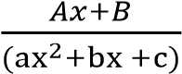 where a, b, c and A and B are
constants.

Example 2
Express each of the following fractions in partial fraction.

Solution
Let
Multiplying through by (x – 6)(x²+3x+5)
7x²+2x-28= A(x²+3x+5)+ (Bx +C)(x – 6)
Putting x = 6; 236= 59A, => A = 4
Equating coefficients of x²
7 = A + B
7 = 4 + B; => B = 3
Equating constants
-28 = 5A – 6C
-28 = 20 – 6C C = 8

Solution
Let
Multiplying through by
2x – 1 = A(x²+1)+ (Bx + C)(x-1)
Putting x = 1; 1 = 2A => A =
Putting x= 0; -1 = A –C => C =
Putting x= -1; 2A + 2B – 2C => B =
Note the values of x = 0 and x = -1 are conveniently chosen, but the constants B and C by expansion of the expression and equating constants, i.e. -1 = A –C => C =
2 = C – B
B = 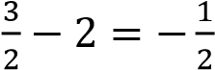
Thus,

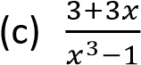

Solution
Note memorize the identities
Then
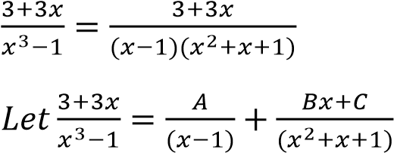
Multiplying through by (x – 1)(x²+x+1)
3+3x = A(x²+x+1) + (Bx+C)(x – 1)
Putting x = 1, 6 = 3A, => A = 2 By expanding and equating coefficients x²: A + B = 0, => B = 0 – 2 = -2 x⁰: A – C = 3, => C = 2 – 3 = -1
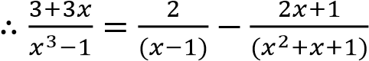
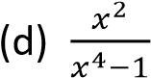

Solution
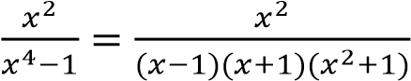
Let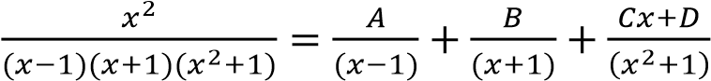
By multiplying through by (x – 1)(x+1)(x²+1) x²= A(x+1)(x²+1)+ B(x -1)(x²+1) + (Cx+D)(x²-1) By equating coefficients x³: A + B + C = 0 …………………… (i) x²: A – B + D= 1 ………………………(ii) x¹: A + B – C = 0 ……………………….(iii) x⁰: A – B – D = 0 ……………………….(iv)
Eqn. (ii) – Eqn. (iv)
2D = 2 => D =
Eqn.(i)+ (iii)
2A+ 2B = 0 …………………………. (v)
Eqn. (ii) + Eqn. (iv)
2A – 2B = 1………………………….(vi)
Eqn. (v)+ Eqn. (vi)
4A = 1 => A =
Eqn. (v)
- = 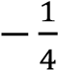
Eqn. (i)
- = 0
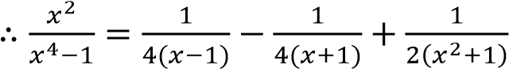

Exercise 2
Express the following fractions in partial fractions
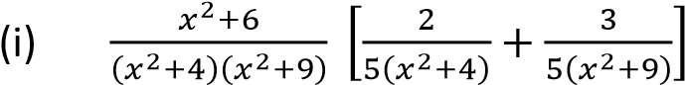

Repeated factors
Each repeated factor (ax²+ b)^{n} in the denominator has corresponding partial fraction
of the form: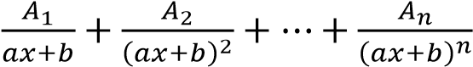,
where a, b, A_{i} are constants (i = 1, 2, ….n)

Example 3
Express each of the follow in partial fraction
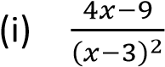

Solution
Let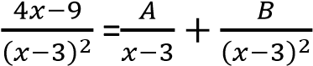
Multiplying through by (x-3)²
4x – 9 = A(x-3) + B = Ax – 3A + B Equating coefficients x¹: x = 4 x⁰: -3A + B = 4; B = 3
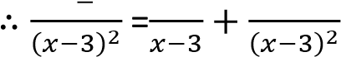
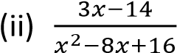

Solution
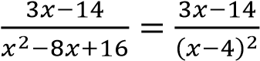
Let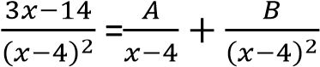
Multiplying through by (x-4)²
3x – 14 = A(x-4) + B = Ax – 4A + B Equating coefficients x¹: x = 3 x⁰: -4A + B = -14; B = -2
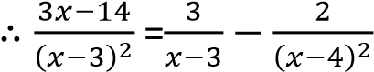

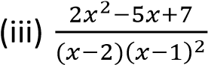

Solution
Let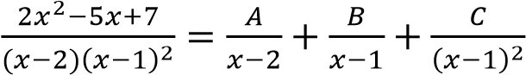
Multiplying through by (x – 2)(x – 1)²
2x²-5x+7 = A(x -1)²+B(x – 2)(x-1)+C(x – 2)
Putting x = 1: 4 = -C, => C = -4
Putting x = 2: A = 5
Putting x = 0, 7 =A – 2B – 2C; B = -2
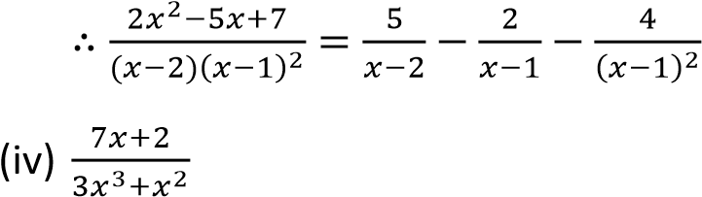

Solution
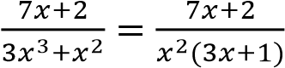
Let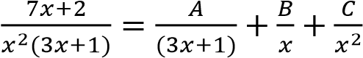
Multiplying through by x²(3x+1)
7x+ 2 = Ax² +Bx(3x+1)+C(3x+1)
Putting x = 0; c = 2
Putting x = -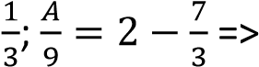 A = -3
Putting x= -1; -5 = A + 2B- 2C, => B = 1
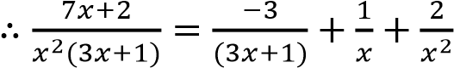

Expressing improper fractions into partial fractions
Improper fractions are those whose index of the numerator is equal to or greater than that of the denominators.
They are first changed to proper fraction by long division or otherwise, before being integrated.
Example 4

Express the following improper fractions into partial fractions
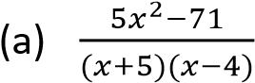

Solution
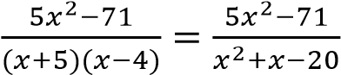
Using long division
5
x²+x-20 5x²+0x-71
- 5x²+5x-100
-5 +29
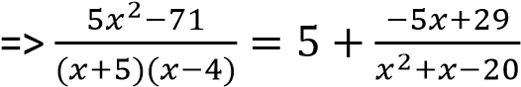
Let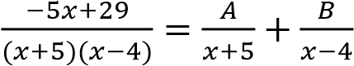
Multiplying through by (x+5)(x-4)
-5x + 29 = A(x – 4)+ B(x + 5)
Putting x = 4, B = 1
Putting x = -5; A = -6
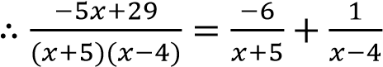

Hence 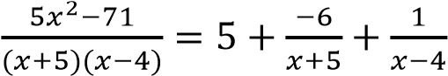

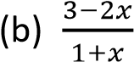

Solution
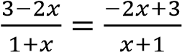

Using long division 5
-2 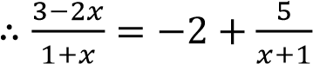
x+1 -2x+3
-2x -2

Revision exercise on partial fractions
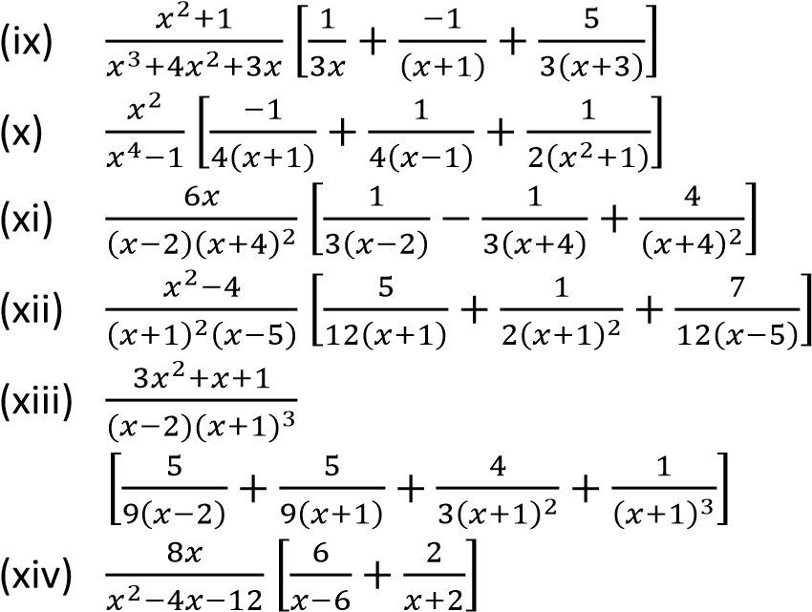
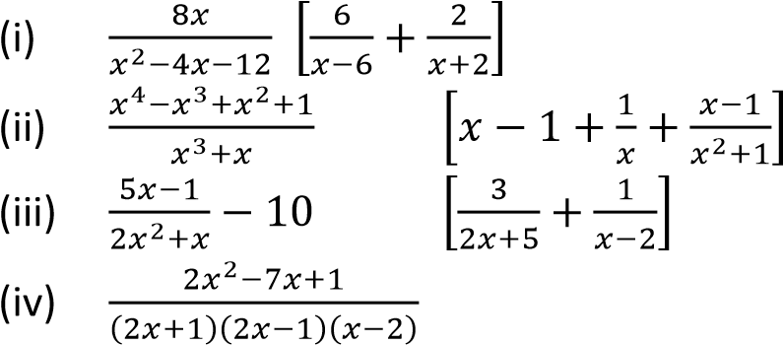
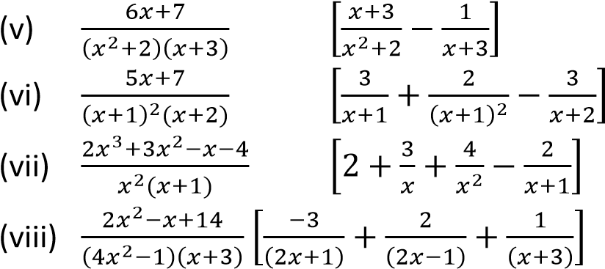
Express the following into partial fraction
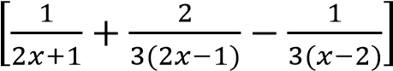
.

TOPIC 5/6: Trigonometry
Competency: The learner applies trigonometric functions, identities, and equations to solve problems in mathematics and real-life application in navigation, construction, aviation and other fields..

Contents
Trigonometry ..................................................... 2
The Pythagoras theorem in trigonometry ..... 5
Elimination of trigonometric parameter in
trigonometry .................................................. 7 Revision exercise 1 ......................................... 8
Measuring angles in radians .......................... 8
Revision exercise 2 ....................................... 11
Graphs of trigonometric functions .............. 12
Compound angles in trigonometry .............. 12
Revision exercise 3 ....................................... 15
Double angles and half angles in
trigonometry ................................................ 16 Revision exercise 4 ....................................... 18
Harmonic form in trigonometry ................... 20
B: Maximum and minimum values .............. 21
The t-formula in trigonometry ..................... 24 Revision exercise 5 ....................................... 26
The factor formulae in trigonometry ........... 27
Inverse trigonometric functions .................. 30
Revision exercise 6 ....................................... 32
Solution to triangles in trigonometry .......... 33
The cosine rule ......................................... 33
The Sine Rule ........................................... 34
The Tangent Rule ..................................... 36
Expressions for sinA, sin and cos in
terms of the sides of the triangle ................ 37 Area of a triangle in trigonometry ............... 38
Applications of trigonometry in finding
distances and bearings ................................ 39 Revision exercise 7 ....................................... 41
Applications of trigonometry ....................... 44

Trigonometry
The word ‘trigonometry’ suggests ‘tri’-three, ‘gono’-angle, ‘metry’-measurement. As such, trigonometry is basically about triangles, most especially right-angled triangles.

Important to note
- For a right angled triangle below
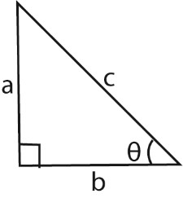

• sinθ =

• cosθ =

• tanθ =

•

cosecθ =
1
𝑠𝑖𝑛
θ
=
𝑐
𝑎

secθ =
1
𝑐𝑜𝑠
θ
=
𝑐
𝑏

cotθ =
𝑐𝑜𝑠
θ
𝑠𝑖𝑛
θ
=
𝑏
𝑎

- All positive angles are measured anticlockwise from positive x-axis
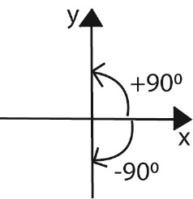
- A circle drawn with the centre O, divides the co-ordinate axis into four equal parts called quadrants
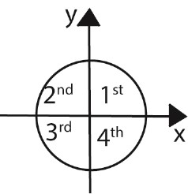
The quadrants are also labeled anti-clockwise from the positive x – axis.
The signs the trigonometric ratios in the quadrants are given below
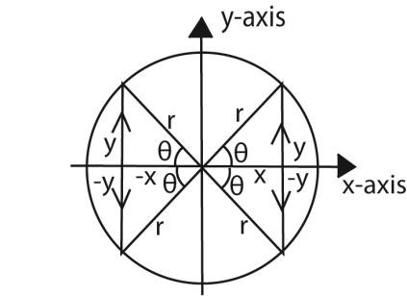
Ratio | Quadrant
Ratio | 1st | 2nd | 3rd | 4th
cosθ | 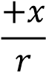 | 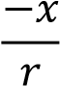 | 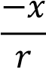 | 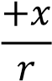
sinθ | 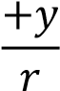 | 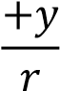 | 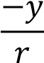 | 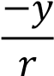
tanθ | 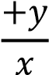 | 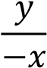 |  | 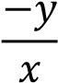
secθ | 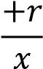 | 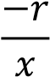 | 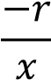 | 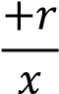
cosecθ | 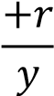 | 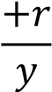 | 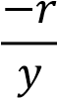 | 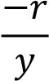
cotθ | 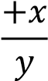 | 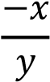 | 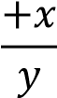 | 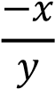
Note
- If θ is the angle in the 1st quadrat
- In the 2nd quadrat the angle is (180 – θ)
- In the 3rd quadrat the angle is (180 + θ)
- In the 4th quadrat the angle is (360 –θ)
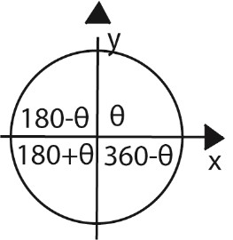
Solving equations
We make use of the quadrants to find the ranges of values within which the angle follows Example 1
Solve the following equations for 0⁰ ≤ θ ≤360⁰
- 3cosθ + 2 = 0 Solution
cosθ = 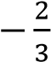
But cos is negative in the 2nd and 3rd quadrants.
Ignoring the negative sign, the angle obtained is referred to as the key or principle angle, i.e. key
angle = 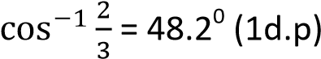
In the 2nd quadrant, θ = 180 – 48.2 = 131.8⁰
In the 3rd quadrant, θ = 180 + 48.2 = 228.2⁰
,θ: θ= 131.8⁰, 228.2⁰}
Note that: the key angle s not part of the solution but only a guide.
- 4cos²θ – 1 = 0 Solution
cosθ = 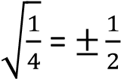
Key angle, θ = 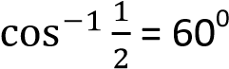
When cosθ = ½ (positive is 1st and 4th quadrants)
1st quadrant θ = 60⁰
4th quadrant θ = 360 – 60 = 300⁰
When cosθ = -½ (positive is 2nd and 3rd quadrants)
3rd quadrant θ = 180 – 60 = 120⁰ 4th quadrant θ = 180 + 60 = 240⁰
,θ: θ= 60⁰, 120⁰, 240⁰, 300⁰}

- cosecθ + 2 = 0 Solution cosecθ = -2 => sinθ = - ½ (taking reciprocal) Key angle = 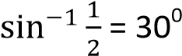
In the 3rd quadrant θ = 180 + 30 = 210⁰
In the 4th quadrant θ = 360 – 30 = 330⁰
,θ: θ= 210⁰, 330⁰}
- 3sec²θ – 4 = 0 Solution
secθ = 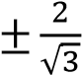 => cosθ =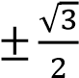
Key angle = 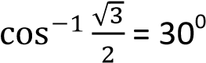
For cosθ = 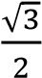; θ = 30⁰, 330⁰
For cosθ = 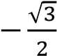; θ = 120⁰, 210⁰
,θ: θ= 30⁰, 120⁰, 210⁰, 330⁰}

(d) Definitions of angle
- Acute angle is an angle between 0⁰ and 90⁰.
It lies in the 1st quadrant
- Right angle is an angle = 90⁰
- Obtuse angle is an angle between 90⁰ and 180⁰. It lies in the 2nd quadrant
- Reflex angle is an angle between 180⁰ and
360⁰. It lies in the 3rd and 4th quadrant Example 2
- If sinθ = and 0⁰ ≤ θ ≤ 360⁰. Find the possible values of 3tanθ – cotθ
Solution
If sinθ = ; θ lies in 1st or 2nd quadrants
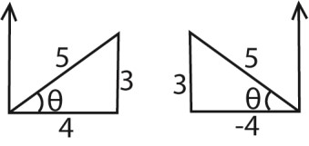
In 1st quadrant

3tanθ – cotθ = 3.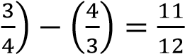 - If θ⁰ ≤ θ ≤ 360⁰ then θ⁰ ≤ 3θ ≤ 1080⁰
[multiply the interval through by 3]
In 2nd quadrant
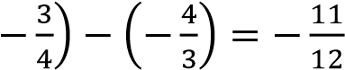
(ii) 2cos2θ + 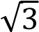 = 0
3tanθ – cotθ = 3.
Solution
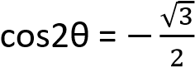
the possible values are 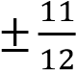
and θ⁰ ≤ 2θ ≤ 720⁰
- If cosθ = 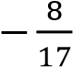 and θ is reflex, find the value ₀ ₀ ₀ ₀ of 4sec₂θ + tanθ 2θ = 150 , 210 , 510 , 570
,θ: θ = 75⁰, 105⁰, 255⁰, 285⁰}
Solution
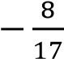
Set square angles: 30⁰, 45⁰, and 60⁰
If cosθ = and θ is reflex, θ lies in the 3rd
quadrant (i) From equilateral triangle ABC with side
equal to 1 unit
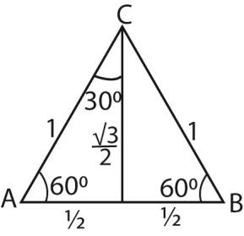
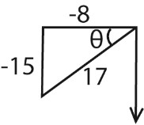

cos 60
0

=
sin
30
0

=

1

cos 30
0

=
60
sin
0

=
√

tan 30
0

60
cot
=
0

=
1
√

tan 60
0

=
30
cot
0

=

√

4sec²θ + tanθ = 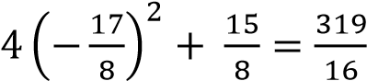

Example 3
Solve for θ, where θ⁰ ≤ θ ≤ 360⁰
(i) 3tan²3θ = 1
Solution
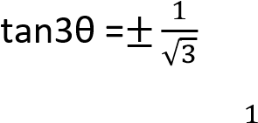 (ii) From the right angled triangle PQR below
taking tan3θ =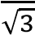
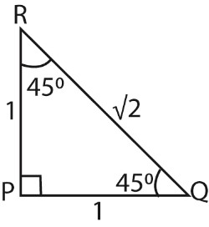
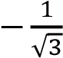
- 3θ = 30⁰, 210⁰,390⁰,570⁰,750⁰, 930⁰ θ = 10⁰, 70⁰, 130⁰, 190⁰, 250⁰, 310⁰
taking tan3θ =

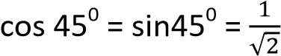
- 3θ = 150⁰, 330⁰,510⁰,690⁰,870⁰, 1050⁰ θ = 50⁰, 110⁰, 170⁰, 230⁰, 290⁰, 350⁰
0
,θ: θ=10⁰, 50⁰, 70⁰, 110⁰, 130⁰, 170⁰, 190⁰, ^{tan45 = 1}
230⁰, 250⁰, 290⁰, 310⁰, 350⁰}
Note

Example 4
Without using tables or calculators find the value of
- cos240⁰
Solution
- tan 3990⁰ Solution
tan 3990⁰ = tan [(360 x 11)+ 30]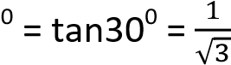
- sin 570⁰ Solution
sin 570⁰ = sin {(360 x 1) + 210]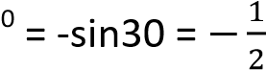
- sec 225⁰ Solution sec 225⁰ = sec (225 – 180)0 = sec 45⁰ = -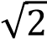

The Pythagoras theorem in trigonometry
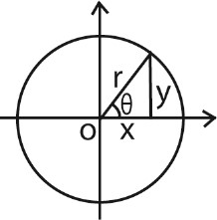
For any acute angle θ x = rcosθ and y = rsinθ
By Pythagoras theorem
x² + y² = r²
Substituting for x and y (rcosθ)² + (rsinθ)² = r² r²(cos²θ + sin²θ) = r² cos²θ + sin²θ = 1
Now tanθ = 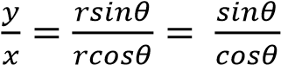
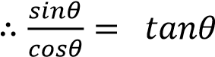
Identities cos²θ + sin²θ = 1 …………………(i) Identity (i) cos²θ
1 + tan²θ= sec²θ ……………… (ii) Identiy (i) sin²θ
1 + cot²θ = cosec²θ ………….(iii)

Example 5
Show that
(i) sin²θ + (1 + cosθ)² = 2(1 + cosθ) Solution sin²θ + (1 + cosθ)²
= sin² θ + 1 + 2cosθ + cos² θ
= sin² θ + cos² θ + 1 + 2cosθ
= 1 + 1 + 2cosθ (Recall that sin² θ + cos² θ = 1) = 2 + 2cosθ = 2(1 + cosθ) sin² θ + (1 + cosθ)² = 2(1 + cosθ)
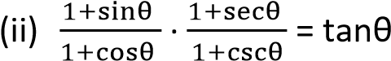
Solution
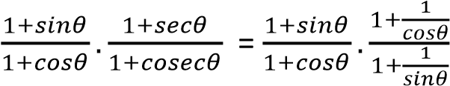
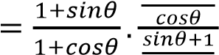
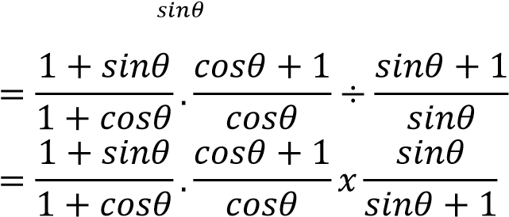
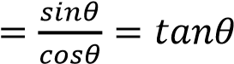
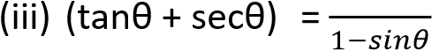
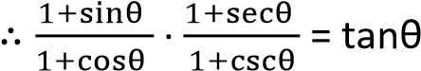 2

Solution
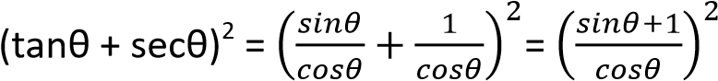
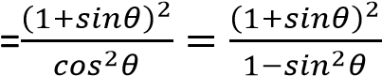
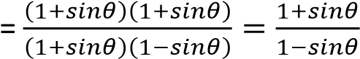
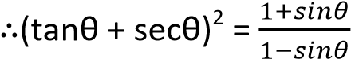

Example 6
Solve the following equations for 180⁰ ≤ x ≤ 180⁰
- 2cos²θ + sinθ – 1 = 0
Solution
2(1 – sin²θ) + sinθ – 1 = 0
2sin2θ – sinθ – 1 = 0
(sinθ – 1)(2sinθ + 1) = 0
Either sinθ = 1 or sinθ = 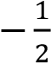
When sinθ = 1; θ = 90⁰
When sinθ = 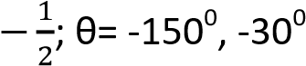, 210⁰, 330⁰
*θ: θ= -150⁰, - 30⁰, 90⁰ for given range]
- cosθ + √3sinθ = 1
Solution
1st approach
√3sinθ = 1- cosθ
Squaring both sides
3sin²θ = 1 – 2cosθ + cos²θ
3(1 – cos²θ) = 1 – 2cosθ + cos²θ
4cos²θ – 2cosθ – 1 = 0
(2cosθ + 1)(cosθ – 1) = 0
Cosθ = 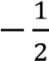 cosθ = 1
θ = ± 120⁰ θ = 0⁰
*θ: θ= 0⁰, ± 120⁰]
2nd approach
√3sinθ = 1- cosθ
Dividing through by cosθ
√3tanθ = secθ – 1
Squaring both sides
3tan²θ = sec²θ – 2secθ + 1
3tan²θ = sec²θ – 2secθ + 1
3[sec²θ – 1] = sec²θ – 2secθ + 1 2sec²θ + 2secθ – 4 = 0 sec²θ + secθ – 2 = 0 (secθ + 2)(secθ – 1) = 0 secθ = -2 or secθ = 1 cosθ = - or cosθ = 1
*θ: θ= 0⁰, ± 120⁰]
3rd approach
√3sinθ = 1- cosθ
Dividing through by sinθ
√3 = cosecθ – cotθ
Rearranging
√3 + cotθ = cosecθ
Squaring both sides
3 + 2√3cotθ + cot²θ = cosec²θ
3 + 2√3cotθ + cot²θ = 1+ cot²θ cotθ = -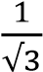; => tanθ = -√3
*θ: θ= -60⁰, 120⁰]

Example 7
(a) Given that 7 tanθ + cotθ = 5secθ, derive a quadratic equation for sinθ. Hence or otherwise, find all values of θ in the interval 0⁰ ≤ θ ≤ 180⁰ which satisfy the equation, giving your answer to the nearest 0.10 where necessary
Solution
7 tanθ + cotθ = 5secθ
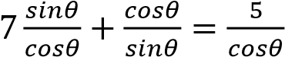
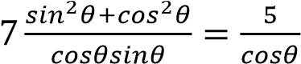
7sin² + cos² = 5sin
7sin²θ + (1 – sin²θ) = 5sinθ
6sin² – 5sin + 1 =0
(3sin – 1)(2sin -1) = 0
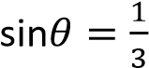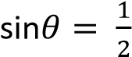
θ = 19.5⁰, 160.5⁰ θ = 30⁰, 150⁰
*θ: θ= 19.5⁰, 30⁰, 150⁰, 160.5⁰]

Example 8
Find the solution of 3cotθ + cosecθ = 2 for 0⁰ ≤ θ ≤ 180⁰.
Solution
3cotθ + cosecθ = 2
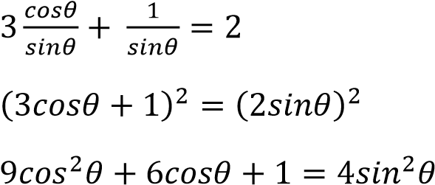
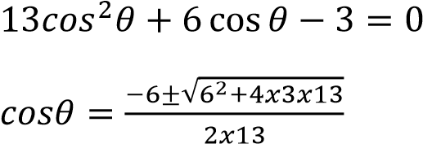
cosθ = 0.3021 cosθ = 0.7637 θ = 72.40 θ = 40.2
*θ: θ = 72.4⁰, 40.2⁰]

Elimination of trigonometric parameter

in trigonometry
This involves the use of identities to eliminate the trigonometric values in equation
Example 9
- If x = tanθ + secθ and y = tanθ – secθ; show that xy + 1 = 0 Solution x + y = tanθ x – y = 2secθ
secθ = 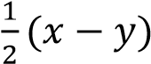
Using identity: 1 + tan²θ = sec²θ
1 + (x + y) 2 = 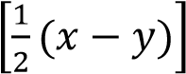
4 + x² + 2xy + y² = x²-2xy + y² 4xy + 4 = 0 xy + 1 = 0 as required
- x = 2 + 3sinθ and y = 3 + 2cosθ show that
4(x – 2)² + (y – 3)² = 36 Solution x = 2 + 3sinθ => sinθ = 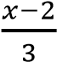 y = 3 + 2cosθ => cosθ = 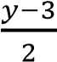 Using identity sin²θ + cos²θ= 1
.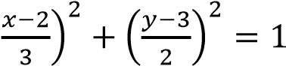
4(x – 2)² + (y – 3)² = 36 as reqyured (c) x = 2sinθ and y = tanθ, prove that
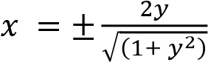
Solution x = 2sinθ; => cosecθ = y = tanθ; => cotθ = Using identity: 1 + cot²θ = cosec²θ
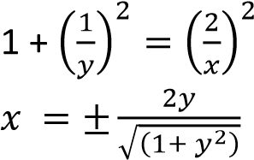

Revision exercise 1
1. Solve for θ, where θ⁰ ≤ θ ≤ 360⁰
- secθcosecθ + 2secθ – 2cosecθ – 4 = 0
[θ: θ = 60⁰, 210⁰, 300⁰, 330⁰]
- tan²θ – (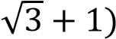tanθ + 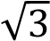 = 0
[θ: θ = 45⁰, 60⁰, 225⁰, 240⁰]
- Show that
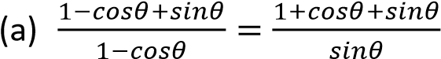
(b) tanθ + cotθ = secθcosecθ
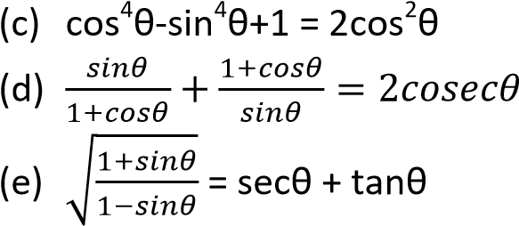
- Solve the following equations for
-180⁰ ≤ x≤ 180⁰
- 2cos²θ + sinθ – 1 = 0
*θ: θ = -150⁰, - 30⁰, 90⁰]
- sin2θ + 5cos2θ = 3
*θ: θ = ±45⁰, ±135⁰]
- 4cot²θ + 24cosecθ + 39 = 0
*θ: θ = 16.6⁰, 23.6⁰, 156.4⁰, 163.4⁰]

4. Solve each of the following equations in the stated range
- 4cos²θ + 2sin θ = 4 0⁰ ≤ θ ≤ 360⁰
*θ: θ = 0⁰, 48.6⁰, 131.4⁰, 180⁰, 360⁰]
- 2sec²θ – 4tanθ – 2 = -180⁰ ≤ θ ≤ 360⁰
*θ: θ = -135⁰, -161.6⁰, 18.4⁰, 45⁰]
- 5cos²3θ = 3(1 + sin3θ), 0⁰ ≤ θ ≤ 360⁰
*θ: θ = 7.9⁰, 52.1⁰, 90⁰, 127.9⁰, 172.1⁰]
- Solve for θ; 00 ≤ θ ≤ 3600
  - tanθ + 3cotθ = 4
*θ: θ = 45⁰, 71.6⁰, 225⁰,251.6⁰]
  - 4cosθ – 3sinθ = 2
*θ: θ = 29.50, 256.70+
- Solve
  - cosθ + √3sinθ = 2 0 ≤ θ ≤ π
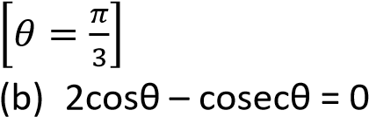 0⁰≤ θ≤ 270⁰
 | *θ: θ = 45⁰, 225⁰]
(c) | 2sin²θ + 3cosθ = 0 | 0⁰≤ θ≤ 360⁰
 | *θ: θ = 240⁰, 120⁰]
  - 3sinθ + 4cosθ = 2 -180⁰ ≤ θ ≤ 180⁰ *θ: θ = - 29.55⁰, 103.29⁰]
  - 3tan²θ + 2sec² θ = 2(5 – 3tanθ) for 0⁰ < θ <180⁰ *θ: θ = 38.66⁰, 116.57⁰]
- Without using a tables or calculator , show that tan 15⁰ = 2 - √3
- Solve equation
8cos⁴θ – 10cos²θ + 3 for 0⁰ ≤ θ ≤ 180⁰
*θ: θ = 30⁰, 45⁰, 135⁰, 150⁰]
- Eliminate θ from the following equation
    - x = asecθ and y = b + ccosθ
[ac = x(y – b)]
    - x = secθ +tanθ and y = secθ – tanθ
[xy = 1]
- Solve the simultaneous equation
Cos x + 4siny = 1
4secx – 3cosecy = 5 for values of x and y between 0⁰ and 360⁰
[x = 78.8⁰, 281.5⁰; y = 11.5⁰, 168.5⁰]

- Prove each of the following identities
- Sinxtanx + cosx =secx
- Cosecx + tanxsecx = cosecxsec²x
- Cosecx – sinx = cotxcosx
- (sinx + cosx)² - 1 = 2sinxcosx
12. Eliminate θ from each of the following pairs of relationships
- x =3sinθ, y = cosecθ *xy = 3+
- 5x = sinθ, y = 2cosθ *100x² + y² - 4 = 0]
- x = 3 + sinθ, y = cosθ *(x-3)² + y² =1]
- x = 2 + sinθ, cosθ = 1+y
[(x-2)² + (y+1)² = 1]

Measuring angles in radians
A radian is defined as an angle subtended at the centre of a circle by an arc that is equal to the radius of the circle. One radian is represented
by π, where 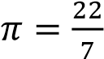
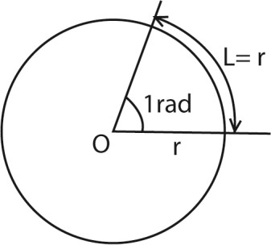
How to convert between degrees and radians
1 revolution = circumference of a circle
But circumference of a circle subtends an angle 2π at the centre.
⇨ 1 revolution = 2π = 360⁰ π = 180⁰ 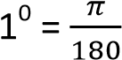 radians
x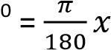 radians

Example 10
Convert the following angles to radians
- 330⁰
- 90⁰
- 30⁰
Solution
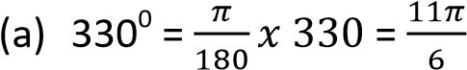radians 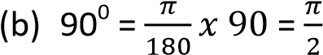radians 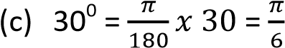radians
Converting radians to degrees
2π radians = 360⁰
1 radian = 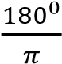 x radians =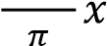 Example 11
Convert each of the following radians to degrees
- radians
- 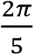 radians
(iii)  Solution | π radians
- radians = 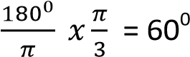
- 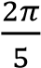 radians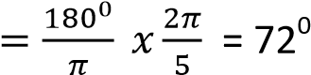
- π radians 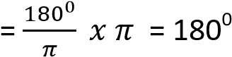

Some equivalent angles in degrees and radians


90
0

=

𝜋

270
0

=

𝜋

180
0

=

𝜋

0
0

=

45
0

=
𝜋

315
0

=

𝜋

225
0

=

𝜋

135
0

=

𝜋

Example 12
Find each of the following values
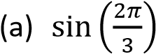
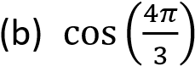
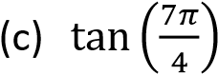
Solution
Convert the angles from radian to degrees
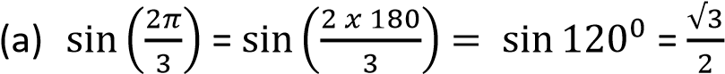

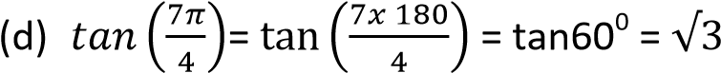

Length of an arc
Suppose that the angle subtended by the length L of an arc AB of a circle is θ as shown.
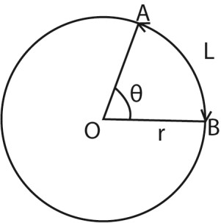
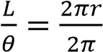
L = rθ where θ must be in radians

Example 13
Find the length of an arc of a circle of radius 14 if it subtends an angle
(i)
(ii) 150⁰
Solution
- L = rθ = 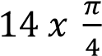= 11cm
- Convert degrees to radians
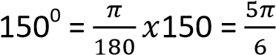 radians
L = 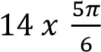 = 36.67cm

Example 14
A sector was drawn which had a perimeter of 80cm, and centre angle of 130⁰. Calculate the radius
Solution
The sides of a sector are composed of an arc, and two more sides which are radii of a circle.
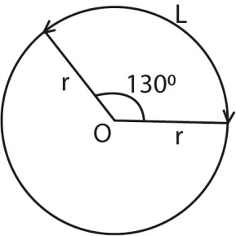
2r + L = 80
L = 80 – 2r
Converting 130⁰ to radians
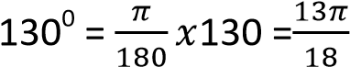
But L = rθ
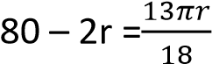
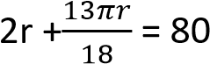
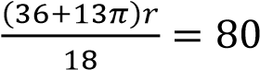
r = 18.74cm
Area of a sector of a circle
A sector of a circle is a portion of the interior of a circle intercepted by a central angle.
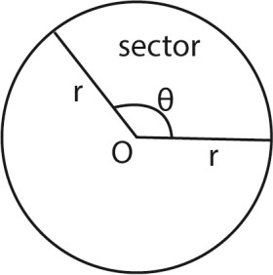
The area of a sector of a circle of radius r and central angle θ is given by
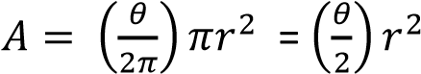
Where θ must be in radians

Example 15
Find the area of a sector with radius 14cm and angle (i) (ii) 1200
Solution
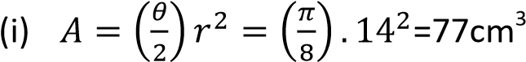
(ii) Converting 120⁰ to radians
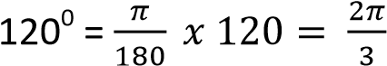
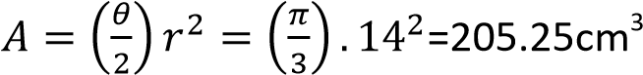
Solving trigonometric functions whose range is in radians
When the range of the trigonometric function is in radians, the answer should be given in radians

Example 16
Solve the following equations for the ranges indicated
(i) cosθ + √3sinθ = 1 0 ≤ θ ≤ π
Solution
√3sinθ = 1- cosθ
Squaring both sides
3sin²θ = 1 – 2cosθ + cos²θ
3(1 – cos²θ) = 1 – 2cosθ + cos²θ
4cos²θ – 2cosθ – 1 = 0
(2cosθ + 1)(cosθ – 1) = 0
Cosθ = 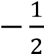 cosθ = 1
θ = ± 120⁰ θ = 0⁰
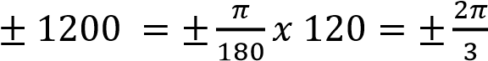 Radians
0⁰ = 0 radians
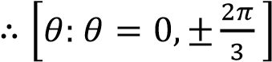
(ii) 2cos²θ + sinθ – 1 = 0 0 ≤ θ ≤ π
Solution
2(1 – sin²θ) + sinθ – 1 = 0
2sin2θ – sinθ – 1 = 0
(sinθ – 1)(2sinθ + 1) = 0
Either sinθ = 1 or sinθ = 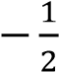
When sinθ = 1; θ = 90⁰
When sinθ = 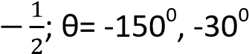, 210⁰, 330⁰
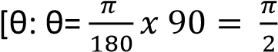 for given range]

Revision exercise 2
- Express each of the following in radians
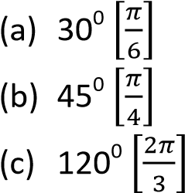
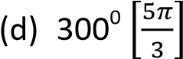
- Express the following angle in degrees 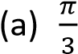 rad [60⁰] 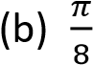 rad [22.5⁰]
  - 3π rad *540⁰]
  - 5.2π rad*936⁰]
- A sector of the circle of radius 7 cm subtends an angle radians at the centre.
Calculate the
  - Length of the arc 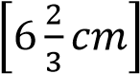
  - Perimeter of the sector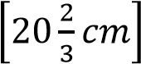
  - Area of the sector 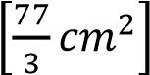
- AOB is a sector of a circle, centre O, and is such that OA = OB = 7cm and angle AOB is 300. Calculate the
  - Perimeter of sector AOB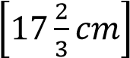
  - The area of AOB 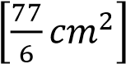
- Find the value each of the following
  - Sinπ *0+
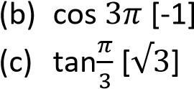
- Solve the following equations for the ranges indicated
  - 2sec²θ = 3 + tanθ for 0 ≤ θ ≤ 2π
*θ: θ = 0.25π, 0.85π, 1.25π, 1.85π+
  - 2sin²xcosx + cosx – 1 for 0 ≤ θ ≤ 2π
*θ: θ = 0.38π, 1.62π, 2π+
  - 2tanθ + 4cotθ = cosecθ for –π ≤ θ ≤ π
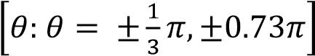

Graphs of trigonometric functions
The following are the characteristic of the three major trigonometric functions
The sine function
- It is continuous (with no breaks)
- The range -1 ≤ sinθ ≤ 1
- The shape of the graph from θ = 0 to θ = 2π is repeated every 2π radians
- This is called a periodic or cyclic function and the width of the repeating pattern that is measured on horizontal axis is called a period. The sine wave has a period of 2π, a maximum value of +1 and a minimum value of -1.
- The greatest value of sine wave is called the amplitude.
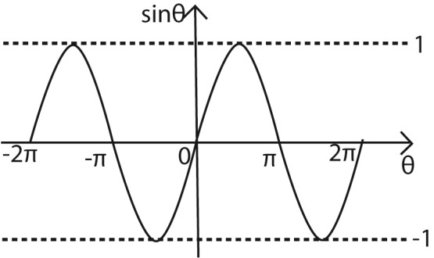
The coosine function
- It is continuous (with no breaks)
- The range -1 ≤ sinθ ≤ 1
- Has a period of 2π
- The shape is the same as the sine wave but displaced a distance to the left on the horizontal axis. This is called a phase shift

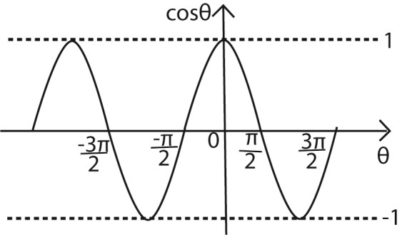
The tan function
- The tan function is found using; 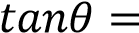
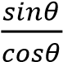. It follows that tanθ = 0 when sin θ = 0; and tanθ is undefined when cosθ = 0
- The graph is continuous, but undefined when θ= 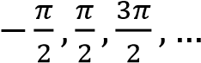
- The range of values for tanθ is unlimited
- It has a period π
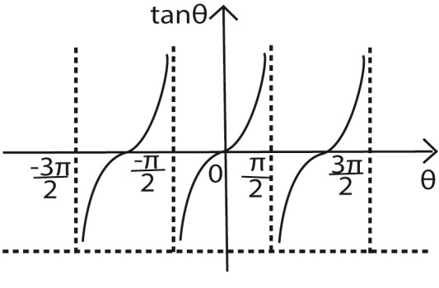

Compound angles in trigonometry
Consider a cardboard ABCD of unit diagonal that stands on the edge A, making an angle β with the horizontal ground. Let the unit diagonal AC be inclined at an angle α to the side
AB (see diagram)
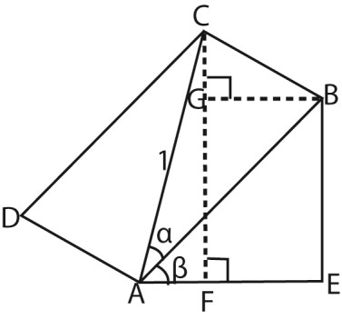
Angles EAB= ABG(Alternative angles)
Angle ABG = β
Angle [ABG + GBC] = 90⁰
Angle GBC = 90 – β
From triangle GBC,
Angle BCG = 180 – (90 + 90 – β)
Angle BCG = β
From
- Triangle ABC:
cosα = 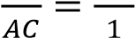; => AB = cosα
- Triangle ABE:
cosβ = 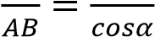; => AE = cosβcosα
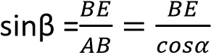; => BE = cosαsinβ
- Triangle BCG:
cosβ = 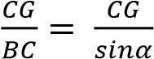; => CG = sinαcosβ
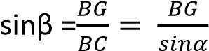; => BG = sinαsinβ
- Triangle ACF:
cos(α + β) = 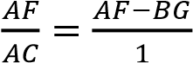 = AE –BG
cos(α + β) = cosαcosβ – sinαsinβ
sin(α + β) = 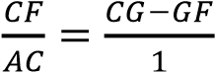 = CG + GF
sin(α + β) = sinαcosβ + cosαsinβ
It follows that
(i) cos(α + β) = cosαcosβ – sinαsinβ (ii) cos(α - β) = cosαcosβ + sinαsinβ
[substituting –β for β)
(iii) sin(α + β) = sinαcosβ + cosαsinβ (iv) sin(α - β) = sinαcosβ - cosαsinβ
[substituting –β for β)
These can also be derived using vector approach.
Consider two unit vectors  and  each
inclined at angles α and β, respectively to the positive x-axis


α
-
β

O

x

α

β

y

A (cosα, sinα)

B (cosβ, sinβ)

Using the definition of a vector product: 
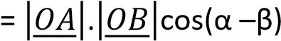
Since  and 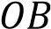 are unit vectors,
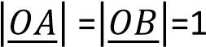
= cos(α –β)
⇨
cosαcosβ + sinαsinβ = cos(α –β) Substituting 90 –α for α cos(90 –α )cosβ + sin(90 –α )sinβ
= cos(90 –α –β)
sinαcosβ + cosαsinβ = sin(α +β) Other expansions can be similar substitutions
i.e. tan(α +β) = 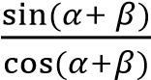
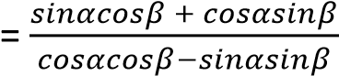
Dividing through by cosαcosβ
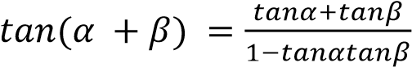
Similarly
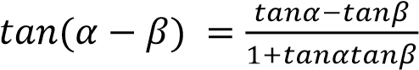
The following is a summary of compound angles
- cos (α + β) = cosαcosβ – sinαsinβ
- cos (α – β) = cosαcosβ + sinαsinβ
- sin (α + β) = sinαcosβ + sinβcosα
- sin (α - β) = sinαcosβ – sinβcosα
- tan (α + β) = 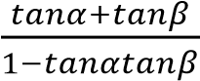
- tan (α -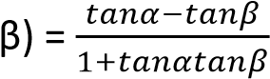

Example 17
Calculate the value of sin15⁰ given that sin45⁰ =
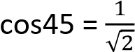, sin3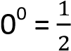 and cos30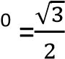
Sin15⁰ = sin(45⁰ – 30⁰)
= sin45⁰cos30⁰ – sin30⁰cos45⁰
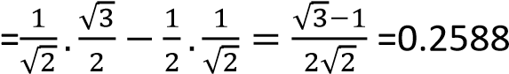

Example 18
Prove that tan(45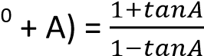 From tan (α + β) = 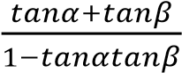 tan(45⁰ + A) = 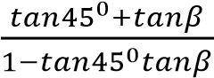
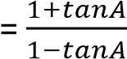

Example 19
Acute angles A and B are such that: cosA = , sinB . Show without using tables or calculator
that tan (A + B) = 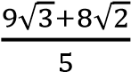
Solution
Using cos²θ + sin²θ =1
.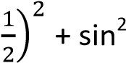A =1
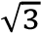
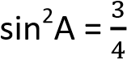=> sinA =
tanA =
√

1

=
√

Similarly;
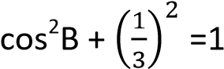
cosB = 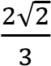
tanB =

√

1

=
1

√

But
From tan (α + β) = 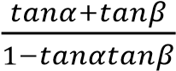
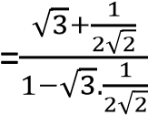
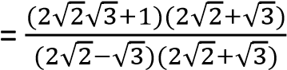 tan (A + B) = 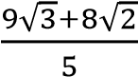

Example 20
Solve cos(θ + 35⁰) = sin(θ + 25⁰) for 0⁰ ≤ θ ≤ 360⁰
Cosθcos35⁰ – sinθsin35⁰ =sinθcos25⁰ + cosθsin25⁰
Dividing through by cosθ
Cos35⁰ – tanθsin35⁰ = tanθcos25⁰ + sin25⁰
tanθ = 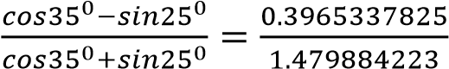
θ = 15⁰, 195⁰ for 0⁰ ≤ θ ≤ 360⁰

Example 21
- Prove than 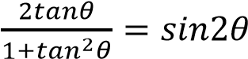
Solution
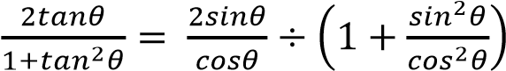
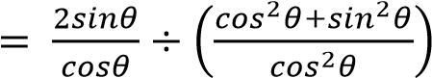
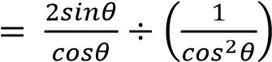
- Solve sin2θ = cosθ for 0⁰ ≤ θ ≤ 90⁰ Solution sin2θ = cosθ 2sinθcosθ = cosθ sinθ = θ = 30⁰ for 0⁰ ≤ θ ≤ 90⁰

Example 22
Given that α, β and γ are angles of a triangle, show that tanα + tanβ + tanγ = tanαtanβtanγ
Hence find tanγ if tanα = 1 and tanγ = 2. Solution α + β + γ= 180⁰ (angle sum of a triangle) tan (α + β + γ) = tan180⁰ = 0 tan* (α + β) + γ+ = 0
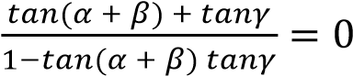
⇨ 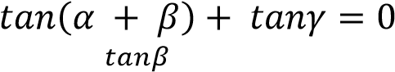
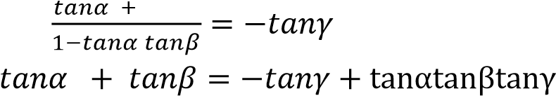
tanα + tanβ + tanγ = tanαtanβtanγ

Example 23
In a triangle ABC, prove that 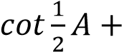
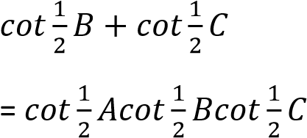
Solution
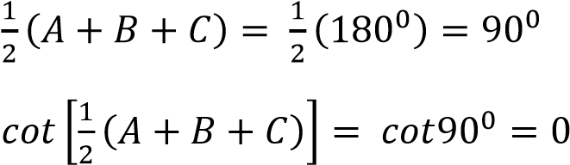
⇨ 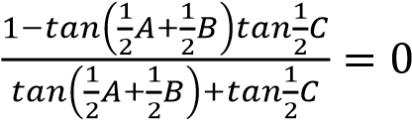
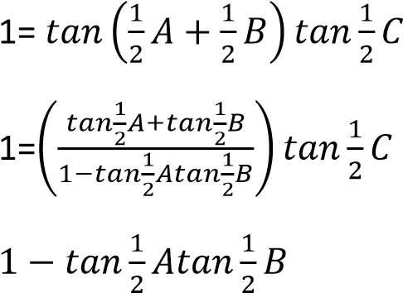
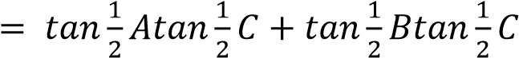
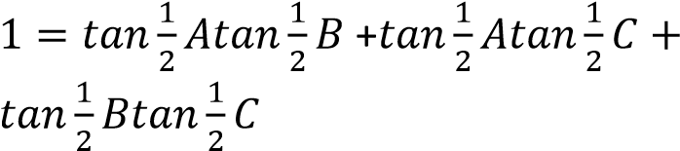
Dividing each side by 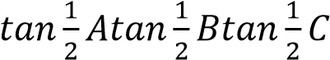

Example 24
Prove that the angle θ, between the straight
line y = m₁x + c₁ and the straight line y
= m₂x + c₂ is given by tanθ = 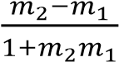
Let the lines be inclines at angles α and β with the x-axis respectively
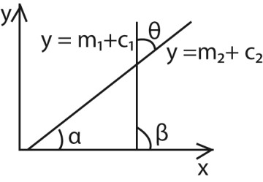
From the diagram above θ = β – α
⇨ tanθ = tan(β – α)
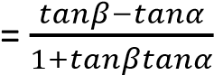
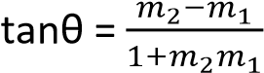

Revision exercise 3
1. (a) Show that sin(α +β) - sin(α - β) = 2cosαsinβ
- If sin(α +β) = 5cos(α - β) show that tanα = 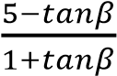
- Without using tables or calculator, show that cos15⁰ = sin75⁰ (d) If α +β = 45⁰, show that tanα = 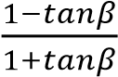 2. Prove that:
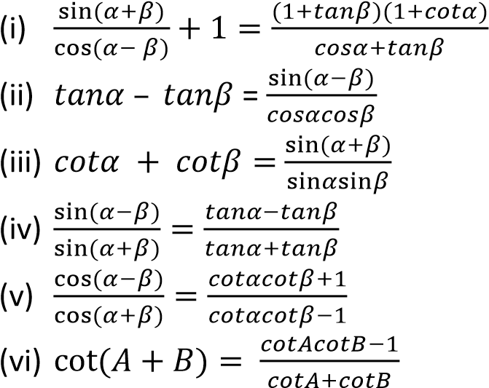
- (a) Determine solution of tan2x + 2sinx = 0 for 0⁰ ≤ x ≤ 180⁰ [x: x= 0⁰, 60⁰, 120⁰, 180⁰]
(vii) Show that in triangle ABC,
tanA + tanB + tanC = tanAtanBtanC
- Find the values of tan α for each of the following (a) sin(α - 30⁰) = cos α *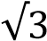]
  - sin(α + 45⁰) = cos α *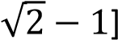
  - cos(α + 60⁰) = sin α *2 - √3+
  - sin(α + 60⁰) = cos(α – 60⁰) [1]
  - cos(α + 60⁰) = 2cos(α + 30⁰) *4 + 3√3+
  - sin(α + 60⁰) = cos(45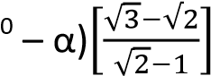
- Given that
  - tan(α –β) = ½ and tanα = 3 find the value of tanβ *1+
  - tan(α +β) = 5 and tanβ = 2 find the value of tanα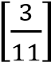
- Given that
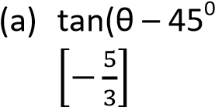) = 4, find the value of θ
  - tan (θ + 60⁰) find the value of cotθ
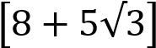

Double angles and half angles in

trigonometry
- From cos (θ + θ) = cosθcosθ – sinθsinθ
  - cos2θ = cos²θ – sin²θ…………. (i)
Either cos2θ = cos²θ -1 + cos²θ (cos²θ + sin²θ = 1+ cos2θ = 2cos²θ -1 …………………………. (ii) Or cos2θ = 1– sin²θ – sin²θ
  - cos2θ = 1 – 2sin²θ …………….(iii) It follows that
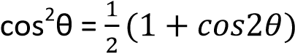 …………………..(iv)
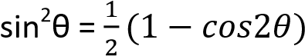 …………………..(iv)
The identities imply
Cos6θ = cos²3θ – sin²3θ
=2cos²3θ – 1 = 1 – 2 sin²3θ
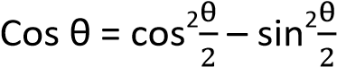
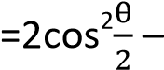 1 = 1 – 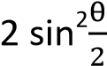
- sin(θ + θ) = sinθcosθ + cosθsinθ
  - sin2θ = 2sinθcosθ It follows that
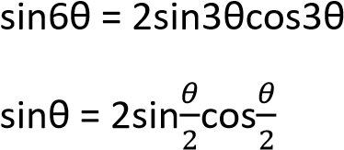
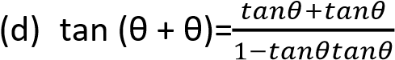
  - 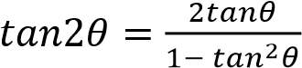
It follows that
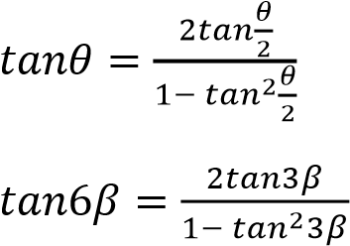
Note that in all cases, the angles on the right hand side are half the angles on the left hand side [half angle formulae]

Example 25
Show that
(a) cosec2θ + cot2θ = cotθ Solution
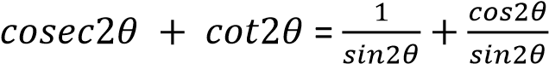
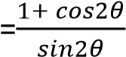
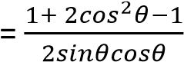
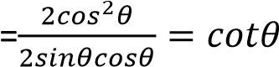
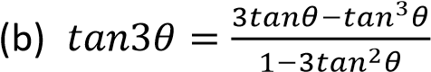
Hence deduce that if 3θ + α = 45⁰, then
tanα = 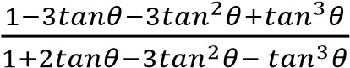
Solution
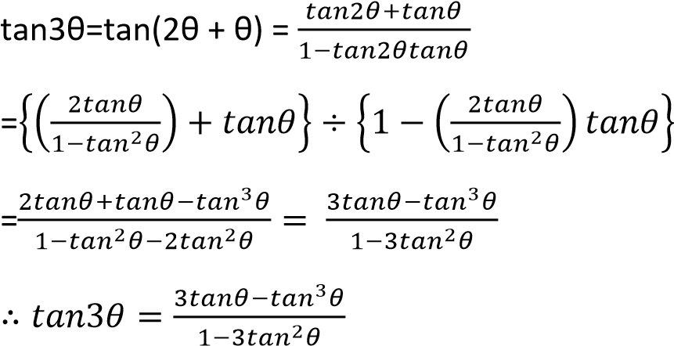
Hence 3θ + α = 45⁰ => α = 45⁰ - 3θ
Tanα = tan(45⁰ - 3θ)
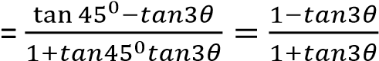
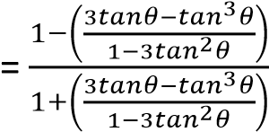
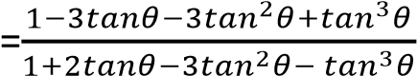 tanα = 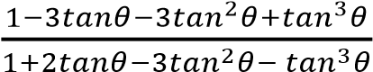

Example 26
If tanα = and α is acute, without using tables or calculator work out the value of
(a) tan2α
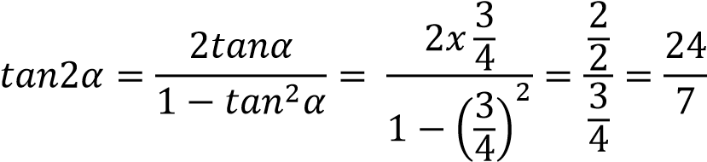
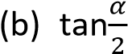
similarly 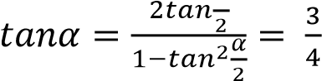
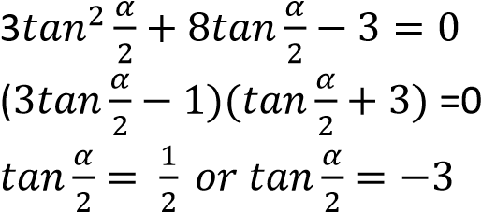
⇨

Since α is acute, tanα cannot be negative
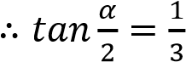

Example 27
(a) Show that cos3α = 4cos² α -3cos α. Hence solve the equation 4x 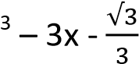= 0 for 0⁰
≤ α ≤ 180⁰ Solution
Cos3α = cos(2α +α)
= cos2αcosα – sin2αsinα
=(2cos²α -1)cosα – 2sin²αcosα
=(2cos²α -1)cosα – 2(1-cos²α)cosα
= 2cos³α – cosα -2cosα + 2cos³α
=4cos² α -3cos α
Hence 4x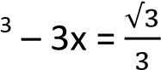
i.e. 4cos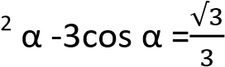
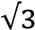
0⁰ ≤ α ≤ 180⁰; cos3α =
For the range 0⁰ ≤ α ≤ 180⁰
⇨ 0⁰ ≤ 3α ≤ 540⁰
3α = 54.7⁰, 414.7⁰ α = 18.23⁰, 138.23⁰ (2d.p)
*α: α= 18.23⁰, 138.23⁰]
(b) Given that t = tan22, show that t² + 2t – 1 = 0,
Hence show that 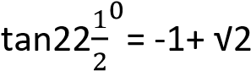
Solution
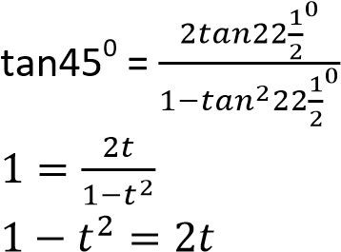
t² + 2t – 1 = 0 (as required) solving
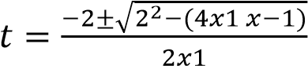

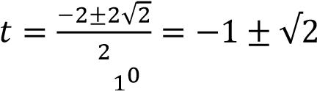
Since 22 is an acute angle,
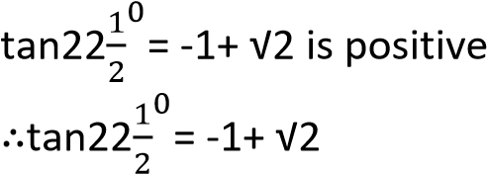

Example 28
(a) Show that 3sinθ = 3sinθ – 4sin³θ. Hence solve the equation sin3θ + sinθ = 0 for 0⁰
≤ θ ≤ 360⁰
Solution
Sin3θ = sin(2θ + θ)
= sin2θcosθ + cos2θsinθ
= 2sinθcos²θ + (1- 2sin²θ)sinθ
= 2sinθ(1- sin²θ) + (1- 2sin²θ)sinθ
= 3sinθ – 4sin³θ
Hence sin3θ + sinθ = 0
3sinθ – 4sin³θ + sinθ= 0
4sinθ – 4sin³θ = 0 4sinθ(1-sin²θ) = 0 4sinθ(1-sinθ)(1+sinθ) = 0 sinθ = 0; θ = 0⁰, 180⁰, 360⁰ sinθ = 1; θ = 90⁰ sino = -1; θ = 270⁰
θ: θ= 0⁰, 90⁰, 180⁰, 270⁰, 360⁰

(b) Prove that cot 2θ = 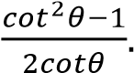 Hence solve
the equation cot2θ + 2cotθ = 2 for
0⁰ ≤ θ ≤ 360⁰ Solution
cot 2θ = 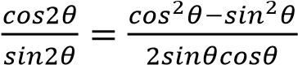
dividing through by sin²θ
cot 2θ = 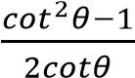
Hence, cot2θ + 2cotθ =0
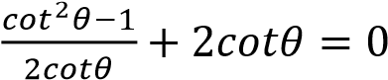
5cot²θ -4cotθ – 1 = 0 (5cotθ + 1)(cotθ -1) = 0 cotθ = 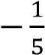 or cotθ = 0
⇨ tanθ = -5 ot tanθ = 1
When tanθ= -5; θ= 101.3⁰, 281.3⁰
When tanθ = 1, θ = 45⁰, 225⁰
,θ: θ= 45⁰, 101.3⁰, 225⁰, 281.3⁰}

Revision exercise 4
1. Prove that
- sinαcosecβ + cosαsecβ = 2sin(α + β)cosec2β
- cos⁶θ + sin⁶θ = 1-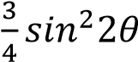
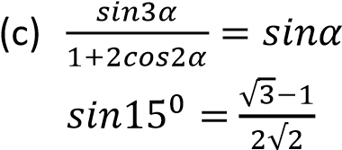 and hence deduce that
2. (a) Solve the equation for θ, 0⁰≤ θ ≤ 360⁰ sin²θ – 2sinθcosθ – 3cos²θ = 0 *θ: θ = 71.6⁰, 135⁰, 251.6⁰, 315⁰]
(b) show that 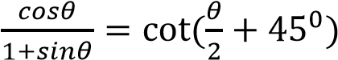. Hence
or otherwise solve the equation 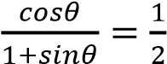 for 0⁰ ≤ θ ≤ 360⁰ *θ= 36.8⁰]

3. (a) solve the equation 8. (a) Express sinθ + sin3θ in form pcosθsinqθ
4cos2θ – 2cosθ + 3 = 0 for 0⁰ ≤ θ ≤ 360⁰ where p and q are constant [p =2, q = 2]
[θ: θ= 60⁰, 104.5⁰, 255.5⁰, 300⁰] (b) Find the solution of
(b) Solve the equation sinθ + sin = 0 for cos7θ + cos5θ = 2cosθ for 00 ≤ θ ≤ 3600
0 ₀[0⁰, 60⁰, 270⁰, 360⁰]
0 ≤ θ ≤ 360
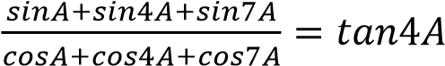
(c) Prove that
[θ: θ= -360⁰, -240⁰, 0⁰, 2405⁰, 360⁰]
4. (a) Prove that

- By expressing 2sinθsin(θ + α) as difference of cosines of two angles or otherwise, where α is constant, find its least value 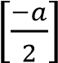
- Solve for θ in the equation
Cosθ – cos(θ + 60⁰) = 0.4 for
0⁰ ≤ θ ≤ 360⁰ *θ = 126.4⁰, 353.6⁰] 5. (a) Show that cos3θ = 4cos³θ – 3cosθ.
Hence solve the equation 4x 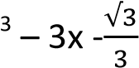=0
[x: x = -0.746, -0.204, 0.959]
(b) Find all solutions of the equation
5cosx – 4sinx = 6 in the range
-180⁰ ≤ x ≤ 180⁰ [x: x = -59.1⁰, -18.3⁰]
- (a) Express in terms of
√
.

1

/
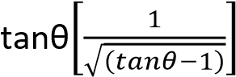
  - Find the solution of the equation
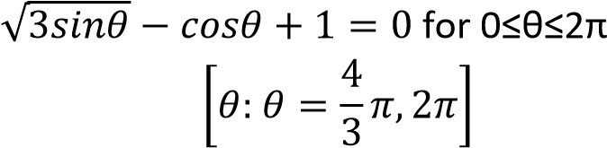
  - Factorize cosθ – cos3θ – cos7θ + cos9θ in form Acospθsinqθsinrθ where A, p, q and r are constants [A= -4, p =5, q = 5, r = 2]
- (a) Given that sinα + sinβ = p and cosα
+ cosβ = q show that
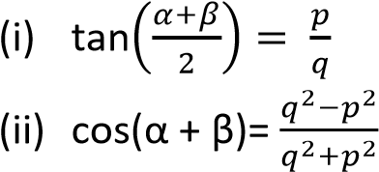
  - Solve the simultaneous equation: cosα + 4sinβ = 1
4secα – 3cosecβ = 5 *θ= 78.5⁰, 281.5⁰]
- Eliminate θ from each of the following pairs of expression
  - x+1 = cos2θ, y = sinθ *x + 2y² = 0]
  - x = cos2θ, y = cosθ -1 [x = 2y² + 4y + 1]
  - y – 3 = cos2θ, x = 2 – sinθ
[2x² – 8x + y + 4 = 0]
- Solve the following equations for 180⁰ ≤ θ ≤ 180⁰
  - Sin2θ + sinθ = 0 *±120⁰, ±180⁰]
  - Sin2θ – 2cos²θ = 0 *-135⁰, 45⁰, ±90⁰]
  - 3cos2θ + 2+ cosθ = 0 *±70.5⁰, ±120⁰]
  - sin2θ = tanθ *0⁰, ±45⁰, ±135⁰, ±180⁰]
- Solve the following equations for 360⁰ ≤ θ ≤ 360⁰, giving your answer correct to 1 decimal place
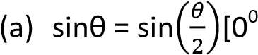, ±120⁰, ±360⁰]
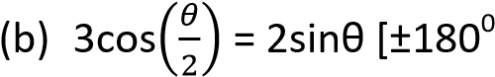, 97.2⁰, 262.8⁰]
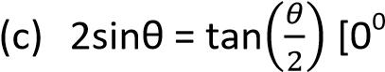, ±120⁰, ±240⁰, ±360⁰]
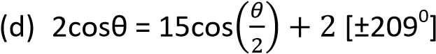
- Prove the following identities
  - 2cos²θ – cos2θ = 1
  - 2cosec2θ = cosecθsecθ
  - 2cos³θ + sin2θsinθ =2cosθ
  - tanθ + cotθ = 2cosec2θ
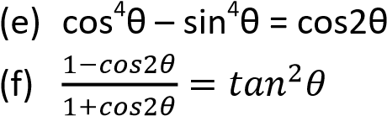
  - Cotθ – tanθ = 2cot2θ
  - cot2θ + cosecθ = cotθ
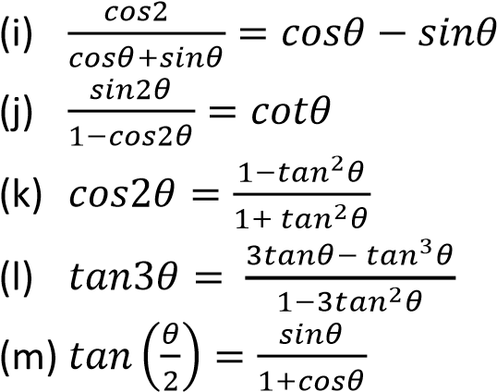
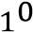
- Express tan22 in the form a + b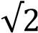 where a and b are integers [a = -1, b= ±1]
- Solve the equation
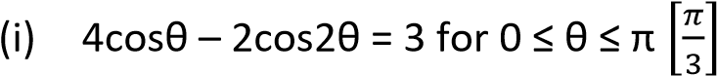
- Cos2θ + cos3θ + cosθ = 0 for 0⁰ ≤ θ ≤ 360⁰ *θ
= 45⁰, 120⁰, 135⁰]
- cosθ + sin2θ = 0 for 0⁰ ≤ θ ≤ 360⁰ *θ = 90⁰, 210⁰, 270⁰, 330⁰]
- 2sin2θ = 3cosθ for -180⁰ ≤ θ ≤ 180⁰ *θ = -90⁰, 48.6⁰, 90⁰, 132.4⁰]
- Sinθ – 4sin4θ = sin2θ – sin3θ for –
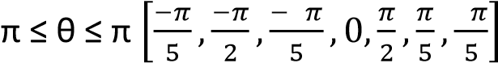

Harmonic form in trigonometry
These are trigonometric functions expressed in the form of Rcos(x ± α) and Rsin(x ±α). They are in two ways
- solving equations in the form acosθ + bsinθ + c = 0
- determining the maximum and minimum values of the function
acosθ + bsinθ + c = 0 where a, b and c are constants
A: Solving equations

Example 29
(a) Express 3cosθ – 4sinθ in the form Rcos(θ
+ α), where R and α are constants
Solution
Let 3cosθ – 4sinθ = Rcos(θ + α)
= R(cosθcosα – sinθsinα)
= Rcosθcosα – Rsinθsinα
Comparing coefficient of cosθ and sinθ
Rcosα = 3 ……….. (i)
Rsinα = 4 ………… (ii) Eqn (ii) eqn (i) tanα = ; α = 53.1⁰
Eqn. (i)² + eqn. (ii)²
R²cos²α + R²sin²α = 3² + 4² = 25
R²[cos²α + sin²α+ = 25
R² = 25
R = 5
3cosθ – 4sinθ = 5cos(θ + 53.1⁰)

(b) Solve the equation 3cosθ – 4sinθ = 5 for 0⁰ ≤ θ ≤ 360⁰.
Solution
3cosθ – 4sinθ = 5cos(θ + 53.1⁰)
⇨ 5cos(θ + 53.1⁰) = 5 cos(θ + 53.1⁰) = 1 x + 53.1⁰ = 0⁰, 360⁰ x = - 53.1⁰, 306.9⁰
Hence x = 306.9⁰

Example 30
(a) Express sinθ -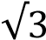cosθ in the form Rsin(θ
– α)
Solution
Let sinθ -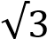cosθ = Rsin(θ – α)
=R(sinθcosα – cosθsinα)
Equating coefficients
Rcosα = 1 …………………. (i) Rsinα = ……………….. (ii)
Eqn. (ii) eqn. (i) tanα = 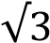; => α = 60⁰
R²[cos²α + sin²α+ = 4
R² = 4; R = 2 sinθ -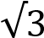cosθ = 2sin(θ – 60⁰)
(b) Solve the equation sinθ -cosθ + 1 = 0 for 0⁰ ≤ θ ≤ 360⁰ sinθ -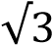cosθ = 2sin(θ – 60⁰)
⇨ 2sin(θ – 60⁰) + 1 = 0
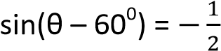
θ – 60⁰ = 210⁰, 330⁰ θ = 270⁰, 390⁰
Hence θ = 270⁰ for the given range

Example 31
(a) Express 4cosθ – 5sinθ in the form Acos(θ +
β), where A is constant and β is an acute angle
Let 4cosθ – 5sinθ = Acos(θ + β)
= A(cosθcosβ – sinθsinβ)
= Acosθcosβ – Rsinθsinβ
Comparing coefficient of cosθ and sinθ
Acosβ = 4 ……….. (i)
Asinβ = 5 ………… (ii) Eqn (ii) eqn (i) tanα = ; α = 51.3⁰
Eqn. (i)² + eqn. (ii)²
A²cos²β + A²sin²β = 4² + 5² = 41
A²[cos²α + sin²α+ = 41
A² = 41
A = 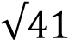
3cosθ – 4sinθ = 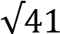cos(θ + 51.3⁰)
(b) Solve the equation 3cosθ – 4sinθ = 2.2 for
0⁰ ≤ θ ≤ 360⁰
Solution
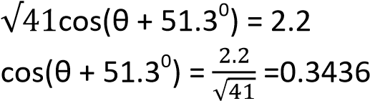
3cosθ – 4sinθ = 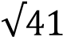cos(θ + 51.3⁰) ⇨

(θ + 51.3⁰) =69.9⁰, 290.1⁰ θ = 18.6⁰, 238.3⁰

B: Maximum and minimum values
The maximum and minimum values of a circular function may be obtained using three methods
- Express the given function either in for Rcos (θ ± α) or Rsin(θ ± α) if possible, where R and α are constants.
- Differentiating the given function with respect to the given function say θ
- Sketching the graphs of the function given and noting their maximum and minimum points.
In this chapter approach I will be considered.

Example 32
Determine the maximum and minimum values of the following, stating the value of θ for which they occur
(a) sinθ + cosθ + 7 Let 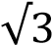sinθ + cosθ = Rsin(θ + α)
=R(sinθcosα +cosθsinα)
Equating coefficients
Rsinα = 1 …………………. (i) Rcosα = 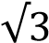……………….. (ii) Eqn. (i) eqn. (ii) tanα = 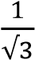; => α = 30⁰
R²[cos²α + sin²α+ = 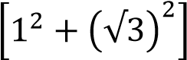= 2
R² = 4; R = 2 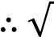 sinθ + cosθ = 2sin(θ + 30⁰)
- sinθ + cosθ + 7 = 2sin(θ + 30⁰) + 7 The minimum value occurs when
sin(θ + 30⁰) = -1
- Minimum value = 2(-1) + 7 = 5 Now for sin(θ + 30⁰) = -1
θ + 30⁰ = 270⁰ θ = 240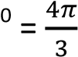
The minimum value is .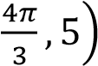
And maximum value occurs when
sin(θ + 30⁰) = 1
- Minimum value = 2(1) + 7 = 9 Now for sin(θ + 30⁰) = 1
θ + 30⁰ = 90⁰ θ = 60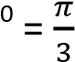
The maximum value is .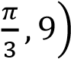
(b) 5cosθ – 12sinθ – 13
Solution
Let 5cosθ – 12sinθ = Rcos(θ - α)
= R(cosθcosα + sinθsinα)
= Rcosθcosα + Rsinθsinα
Comparing coefficient of cosθ and sinθ
Rcosα = 5 ……….. (i)
Rsinα = 12 ………… (ii) Eqn (ii) eqn (i) tanα = ; α = 67.4⁰

Eqn. (i)² + eqn. (ii)²
R²cos²α + R²sin²α = 5² + 12² = 169
R²[cos²α + sin²α+ = 169
R² = 169
R = 13
2cosθ – 12sinθ = 13cos(θ – 67.4⁰)
- 5cosθ – 12sinθ – 13 =13cos(θ – 67.4⁰)-13 The minimum value occurs when
cos(θ – 67.4⁰) = -1
- Minimum value = 13(-1) -13 = -26 Now for cos(θ – 67.4⁰) = -1
θ – 67.4⁰= 180⁰ θ = 247.4⁰
The minimum value is 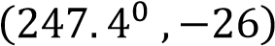
And maximum value occurs when cos(θ – 67.4⁰) = 1
- Minimum value = 13(1) - 13 = 0 Now for cos(θ – 67.4⁰) = 1
θ - 67.4⁰ = 0⁰ θ = 67.4⁰
The maximum value is 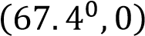

Example 33
(a) Given that p = 2cosθ + 3cos2θ and q = 2sinθ + 3sin2θ, show that 1 ≤
p² + q² ≤ 25
If p² + q² = 19 and θ is acute, find θ and
show that pq = 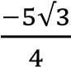
Solution p² = 4cos²θ + 12cosθcos2θ + 9cos²2θ ….(i) q² =4sin²θ + 12sinθsin2θ + 9sin²2θ …….(ii)
Eqn. (i) + eqn. (ii) p² + q² = 4 + 12(cosθcos2θ + sinθsin2θ) + 9 p² + q² = 13 + 12cosθ *cos(-θ) = cosθ+ But -1 ≤ cosθ ≤ 1
Multiplying through by 12
-12 ≤ 12cosθ ≤ 12
Adding 13 throughout
1 ≤ 12cosθ +12 ≤ 25
1 ≤ p² + q² ≤ 25 as required If p² + q² = 19, =>13 + 12cosθ = 19 cosθ = ; θ =60⁰ *θ is acute+
⇨ p = 2cos60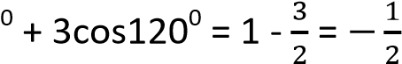
q = 2sin60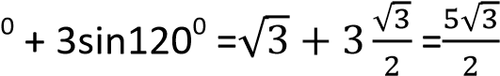
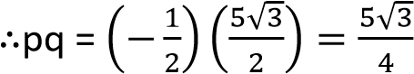
- Express f(x) = 5sin²θ – 3sinθcosθ + cos²θ in the form p + qcos(2θ – α)
Hence show that 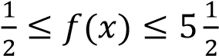
Solution
Using sin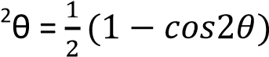and
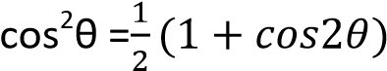
f(x) = 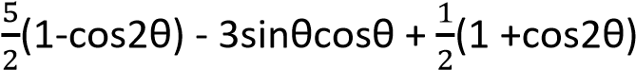
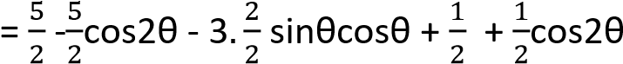
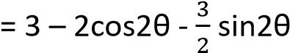
= 3 – *2cosθ + 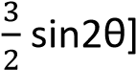 Now:
3 – *2cosθ + 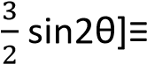 p + qcos(2θ – α)
= 3 + *qcos2θcosα + qsin2θsinα+
By comparing: p = 3, qsinα = and qcosα
= 2
  - tanα = ; α = 36.9⁰
And q = 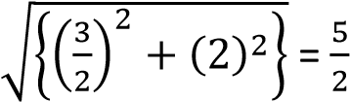
  - 3 – *2cosθ + 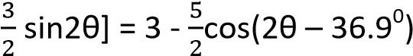
But -1 ≤ cos(2θ – 36.9⁰) ≤ 1
Multiplying through by -
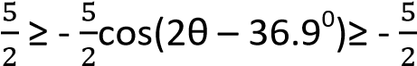
Adding 3 throughout
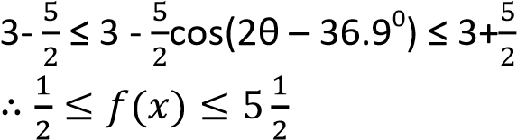
- Find the maximum and minimum points of the function; f(x) =3cosθ – 4sinθ + 20 for 0⁰
≤ θ ≤ 360⁰
Solution
Let 3cosθ – 4sinθ = Rcos(θ + α)

= Rcosθcosα - Rsinθsinα Comparing coefficient of cosθ and sinθ
Rcosα = 3 ……….. (i)
Rsinα = 4 ………… (ii) Eqn (ii) eqn (i) tanα = ; α = 53.1⁰
Eqn. (i)² + eqn. (ii)²
R²cos²α + R²sin²α = 3² + 4² = 25
R²[cos²α + sin²α+ = 25
R² = 25
R = 5
3cosθ – 4sinθ = 5cos(θ – 53.1⁰)
- 3cosθ – 4sinθ +20 =5cos(θ – 53.1⁰) + 20 The minimum value occurs when
cos(θ – 53.1⁰) = -1
- Minimum value = 5(-1) +20 = 15
Now for cos(θ – 53.1) = -1
θ – 53.1⁰= 180⁰ θ = 126.8⁰
The minimum value is 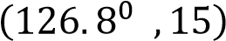
And maximum value occurs when cos(θ – 53.1⁰) = 1
- Minimum value = 5(1) 20 = 25 Now for cos(θ – 53.1⁰) = 1
θ + 53.1⁰ = 0⁰, 360⁰ θ = -53.1⁰, 306.8⁰
The maximum value is 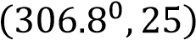

Example 34
Find the maximum and minimum points of the following
(a) f(θ) = 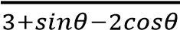
Solution
Let sinθ – 2cosθ = Rsin(θ - α)

= Rsinθcosα - Rcosθsinα Comparing coefficient of cosθ and sinθ
Rcosα = 1 ……….. (i)
Rsinα = 2 ………… (ii) Eqn (ii) eqn (i) tanα = ; α = 63.4⁰ Eqn. (i)² + eqn. (ii)²
R²cos²α + R²sin²α = 1² + 2² = 5
R²[cos²α + sin²α+ = 5
R² = 5
R = 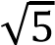
sinθ – 2cosθ = 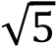sin(θ – 63.4⁰)
- 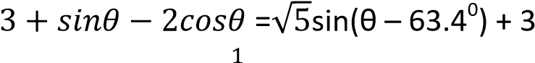
- f(θ) = 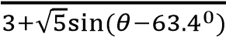
Note: for a fractional function, a maximum point is obtained when the denominator is minimum and the vice versa for the maximum point
The minimum value occurs when
sin(θ – 63.4⁰) = 1
- Minimum value = 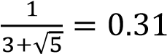
Now for sin(θ – 63.4) = 1
θ – 63.4⁰= 90⁰ θ = 153.4⁰
The minimum value is (153.4⁰. 0.31)
And maximum value occurs when
sin(θ – 63.4⁰) = -1
- Maximum value = 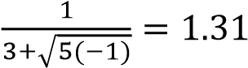
Now for sin(θ – 63.4⁰) = -1
θ - 63.4⁰ = 270⁰ θ = 333.4⁰
The maximum value is 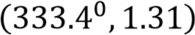

(b) f(θ) = 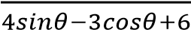
Solution
Let 4sinθ – 3cosθ = Rsin(θ - α)

= Rsinθcosα - Rcosθsinα Comparing coefficient of cosθ and sinθ
Rcosα = 4 ……….. (i)
Rsinα = 3 ………… (ii) Eqn (ii) eqn (i) tanα = 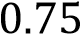; α = 36.9⁰
Eqn. (i)² + eqn. (ii)²
R²cos²α + R²sin²α = 3² + 4² = 25
R²[cos²α + sin²α+ = 25
R² = 25
R = 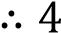sinθ – 3cosθ = sin(θ – 36.9⁰)
- sinθ – 3cosθ + 6 = sin(θ – 36.9⁰)+ 6
- f(θ) = 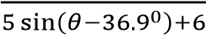
The minimum value occurs when
sin(θ – 36.9⁰) = 1
- Minimum value 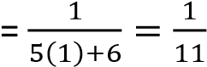
Now for sin(θ – 63.4) = 1
θ – 36.9⁰= 90⁰ θ = 126.9⁰
The minimum value is (126.9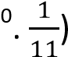
And maximum value occurs when
sin(θ – 36.9⁰) = -1
- Maximum value = 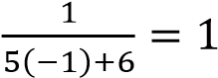
Now for sin(θ – 36.9⁰) = -1
θ – 36.9⁰ = 270⁰ θ = 306.9⁰
The maximum value is 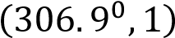

The t-formula in trigonometry
Although this form has been tackled indirectly, it is formally stated here
Suppose that t = tan, we have


From the triangle

above

t

1

√

𝑡

𝜃
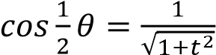 and 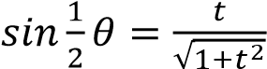
But 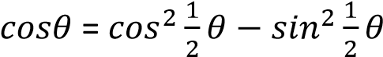
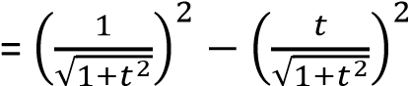
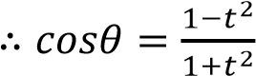
And 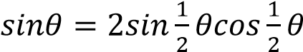
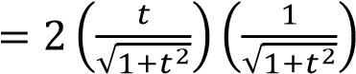
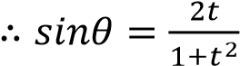
The t- formula is used widely in solving equations and proving trigonometric identities. These can be extended as follows
- For t= tanθ, sin2θ =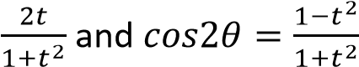
- For t= tan.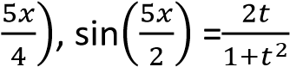 and
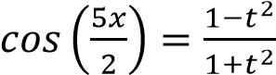

Example 35
Show that if t = tanθ, then 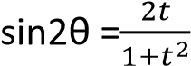 and
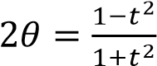 . Hence solve the equation 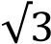cos2θ + sin 2θ = 1 for 0⁰ ≤ θ ≤ 360⁰.
Solution

From the triangle above

t

1

√

𝑡

θ

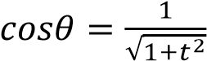 and 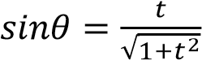
But  = 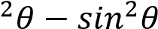
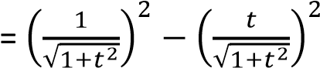
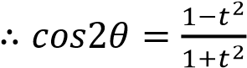
And
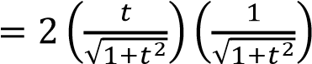
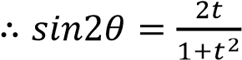
Hence 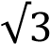cos2θ + sin 2θ = 1
⇨ 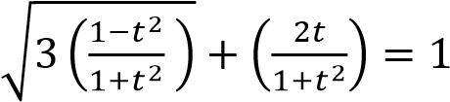
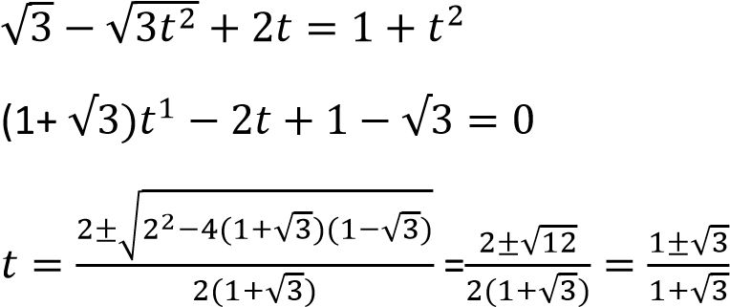
t == 1 or
1

√

1

√

t=.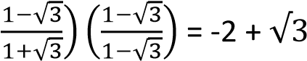
If tanθ = 1; θ = 450, 2250
If tanθ = -2 + 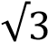; θ = 165⁰, 345⁰ θ: θ = 45⁰, 165⁰, 225⁰, 345⁰

Example 36
Find all the solutions of the equation 5cosθ – 4sinθ = 6 for -180⁰ ≤ θ ≤ 180⁰
Solution
Let t = tanthen

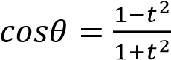
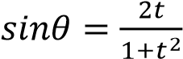
⇨ 5.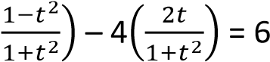
5 – 5t² – 8t = 6 + 6t²
11t² + 8t + 1 = 0
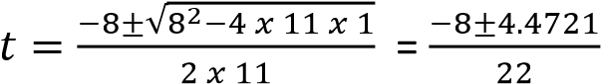
t = 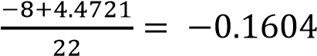 or
t = 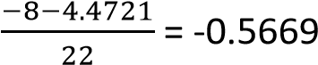
Taking t = -0.1604
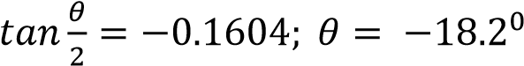
Taking t = -0.5669
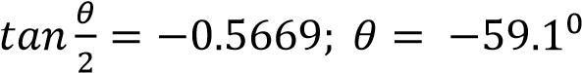
θ = -59.1⁰, -18.2⁰

Example 37
Solve the equation
3tan²θ + 2sec² θ = 2(5 – 3tanθ) for 0⁰ < θ <180⁰
Let t = tan θ
3t²- 2(1 + t²) = 2(5 -3t)
5t² + 6t – 8 = 0
t = 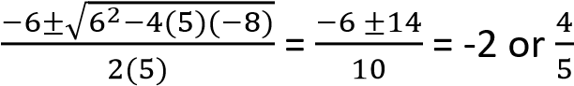
Taking t = -2; θ = tan⁻¹(-2) = 116.57⁰
Taking t = 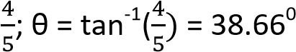
Hence θ = 38.66⁰, 116.57⁰

Example 38
Show that tan4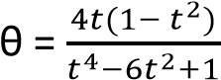 , where t = tanθ.
Solution
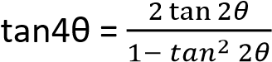 and tan2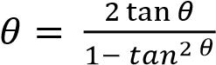
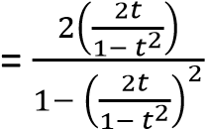
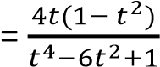

Example 39
Solve the equation cosθ + sinθ + 1 = 0 for 0⁰ ≤ θ ≤ 360⁰ Solution cosθ + sinθ + 1
Let t = tan
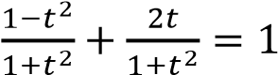
1 – t² + 2t = 1(1 + t²)
2t + 2 = 0; t = -1
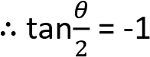
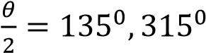
θ = 270⁰, 630⁰
Hence θ = 270⁰

Revision exercise 5
- Solve equation 3cosθ + 4sinθ = 2 for 0⁰
≤ ≤ 360⁰ [119.6⁰, 346.7⁰]
- (a) Show that cos4x = 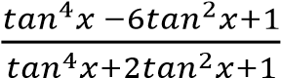
(b) Show that if q = cos2x + sin2x, then (1+q)tan²x – 2tanx + q – 1 = 0. Deduce that if the roots of the above equation are tanx₁ and tanx₂, the tan(x₁+ x₂) = 1
- Find the values of R and tanα in each of the following equations
  - 2cosθ + 5sinθ = Rsin(θ + α) 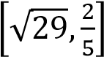
  - 2cosθ + 5sinθ = Rcos(θ -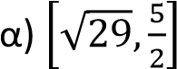
  - cosθ + sinθ = Rcos(θ -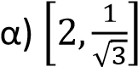
  - 5sinθ – 12cosθ = Rsin(θ -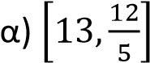
  - Cosθ – sinθ = Rcos(θ + α)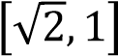

- Find the greatest and least values and state the smallest non-negative value of x for which each occurs
  - 12sinx + 5cosx [13, 67.4⁰; -13, 247.4⁰]
  - 2cosx + sinx [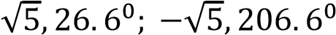-
  - 7 + 3sinx – 4cosx [12, 143.1⁰; 2, 323.1⁰]
  - 10 – 2sinx + cosx
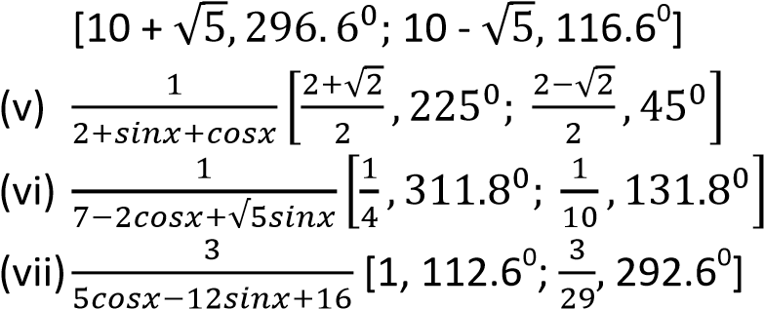

- Solve each of the following equations for 0⁰
≤ x ≤ 360⁰
  - sinx + cosx = 1 [90⁰, 330⁰]
  - 4sinx – 3cosx = 2 [60.4⁰, 193.3⁰]
  - sinx + cosx = 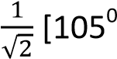, 345⁰]
  - 5sinx + 12cosx = 7 [80.0⁰, 325.2⁰]
  - 7sinx – 4cosx = 3 [51.6⁰, 187.9⁰]
  - cosx – 3sinx = 2 [237.7⁰, 339.2⁰]
  - 5cosx + 2sinx = 4[63.8⁰, 339.8⁰]
  - 9cox2x – 4sin2x = 6 [14.2⁰, 141.8⁰, 194.2⁰, 321.8⁰]
  - 7cosx + 6sinx = 2 [118.1⁰, 323.1⁰]
  - 9cosx – 8sinx = 12 [313.6⁰, 323.1⁰]

The factor formulae in trigonometry
The following identities were developed from compound angles cos (A + B) = cosAcosB – sinAsinB ……….(i) cos(A – B) = coaAcosB + sinAsinB ………… (ii) sin(A + B) = sinAcosB + sinBcosA ………….(iii) sin(A – B) = sinAcosB – sinBcosA ………….(iv)
eqn. (i) + eqn (ii) cos(A + B) + cos(A – B) = 2cosAcosB eqn. (i) – eqn (ii) cos(A + B) - cos(A – B) = -2cosAcosB eqn. (iii) + eqn (iv) sin(A + B) + sin(A – B) = 2sinAcosB eqn. (iii) - eqn (iv) sin(A + B) - sin(A – B) = -2sinBcosA For simplification, A + B =α and A – B = β Add: 2A = α + β i.e. A = .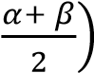
Subtract 2B = α - β i.e. A = .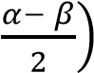
Substituting for A and B in the above equation
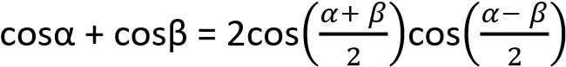
cosα - cosβ = -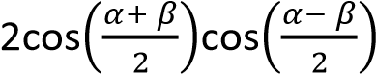
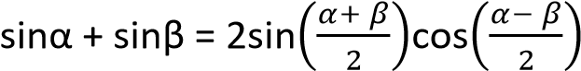
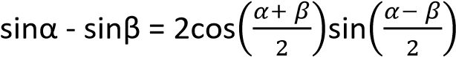

Example 40
Show that if X, Y and Z are angles of a triangle, then
(a) cosX + cosY + cosZ – 1 = 4sin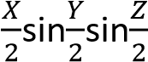
solution
LHS cosX + cosY + cosZ – 1
= 2cos 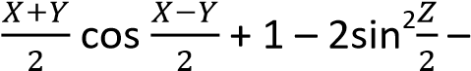 1
(to eliminate -1)
= 2cos 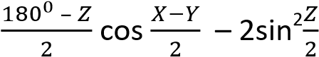
(since X + Y = 180⁰ – Z)
= 2sin 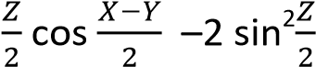
(Since cos(90⁰ – A) = sinA)
= 2sin 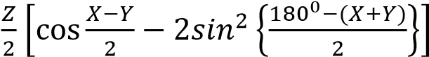
= 2sin 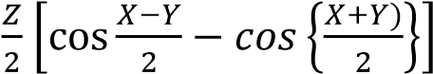
(Since sin (90⁰ – A) = cos A)
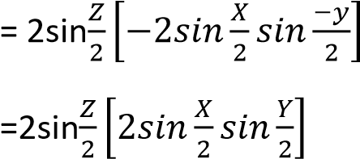
(Since sin(-A) = -sinA)
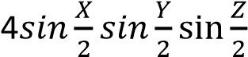 as required
- Sin3X + sin3Y + sin3Z =
-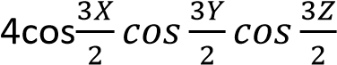
Solution
LHS: Sin3X + sin3Y + sin3Z
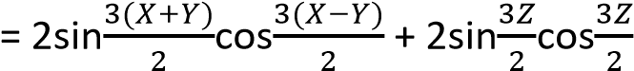
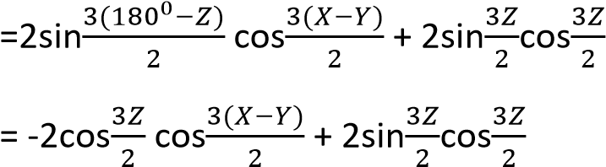
Since sin(270⁰ – A) = -cosA}
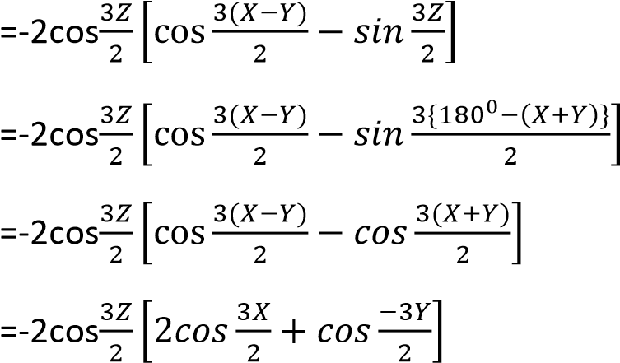
Since cos(-A) = cosA
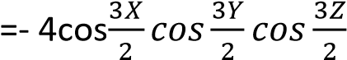
- cos4X + cos4Y + cos4Z + 1
= 4cos2Xcos2Ycos2Z
Solution
LHS: cos4X + cos4Y + cos4Z + 1
= 2cos2(X + Y)cos2(X – Y) + 2cos²2Z -1 + 1
= 2cos2(180⁰ – Z)cos2(X – Y) + 2cos²2Z
= 2cos2Z[cos2(X – Y) + cos2{180⁰ – (X + Y)}]
= 2cos2Z[cos2(X – Y) + cos2 (X + Y)]
= 2cos2Z[2cos2X cos-2Y]
Since cos(-A) = cosA
=4cos2Z2cos2X cos2Y
- sin²Y + sin²Z = 1 + cos(Y – Z)cosX LHS: sin²Y + sin²Z
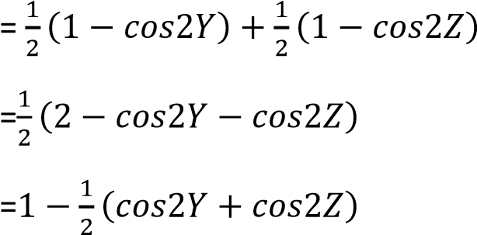
= 1 – cos(180⁰ –X)cos(Y – Z)
=1 + cos(Y – Z)cosX

Example 41
- Factorize cosθcos3θ – cos7θ + cos9θ and express it in the form Acospθsinqθsinrθ where A, p, q and r are constants Solution f(θ)= cos9θ + cosθ – (cos7θ +cos3θ) = 2cos5θcos4θ – 2cos5θcos2θ
=2cos5θ(cos4θ – cos2θ)
= -4cos5θ(-sin3θsinθ)
=-4cos5θsin3θsinθ
⇨ A = -4, p = 5, q = 3, r = 1
- Given that p = sinα + sinβ q = cosα + cosβ. Show that
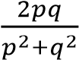= sin(α + β)
Solution
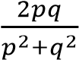
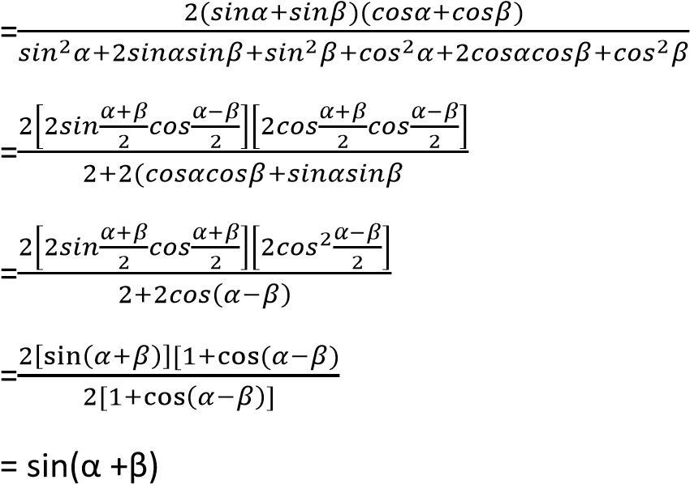

Example 42
Solve 5cos²3θ =3(1 + sin3θ) for 0⁰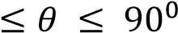.
Solution
5cos²3θ =3(1 + sin3θ)
5(1 – sin²3θ) = 3(1 + sin3θ)
5 – 5sin²3θ = 3 + 3sin3θ
5sin²3θ + 3sin3θ – 0 = 0 (sin3θ + 1)(5sin3θ – 2) = 0 sin3θ + 1 =0
3θ = 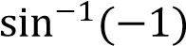 = -90⁰, 270⁰

Example 43
(a) solve the equation cos2x = 4cos²x -2sin²x for
0 
cos2x = 4cos²x -2sin²x cos²x – sin²x = 4cos²x -2sin²x
3cos²x - sin²x = 0
4cos²x – 1 = 0
(2cos x + 1)(2cos x – 1) = 0
Either 2cos x + 1 = 0 cos x = 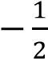
x = cos⁻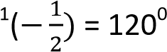
Or 2cos x - 1 = 0 cos x =
x = cos⁻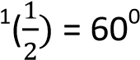 x(60⁰, 120⁰)

Alternatively cos2x = 4cos²x -2sin²x
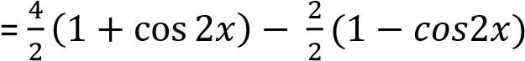
= 2 + 2cos 2x – 1 + cos2x 2cos2x + 1 = 0 cos2x = -
2x = cos₋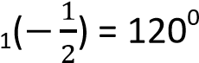, 240⁰ x = 60⁰, 120⁰

Alternatively cos2x = 4cos²x -2sin²x cos²x –sin²x = 4cos²x -2sin²x
3cos²x –sin²x = 0 Sin²x = 3cos²x tan²x = 3
tanx =

√

√

Either
tanx =
x = 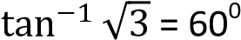
Or
tanx = 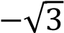
x = 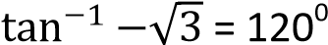
Hence x = 60⁰, 120⁰

Alternatively cos2x = 4cos²x -2sin²x
1-2sin²x = 4(1-sin²x)-2sin²x
1 = 4 – 4sin²x
4sin²x = 3
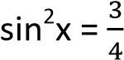
sinx = 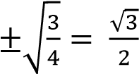

x = 60⁰, 120⁰

Alternatively cos2x = 4cos²x -2sin²x 1-2sin²x = 4cos²x -2sin²x 4cos²x = 1
Cosx = 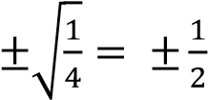
x = 60⁰, 120⁰
(b) Show that if sin(x + α) = psin(x – α) then tan x = .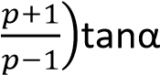.
Hence solve the equation sin(x + α) = psin(x – α) for p = 2 and α= 20⁰.

sinxcosα + coxsinα = p(sinxcosα - coxsinα) cosxsinα (p + 1) = sinxcosα (p - 1)
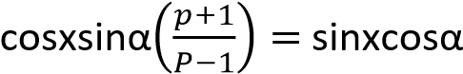
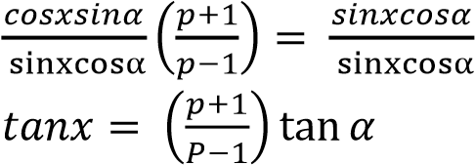
For sin(x + 20⁰) = 2sin(x – 20⁰)
tanx = 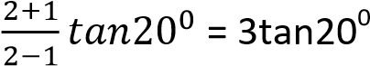 x = 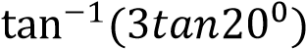 = 47.52⁰ Example 44
Prove that in any triangle ABC, 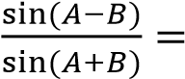
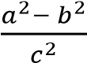
Solution
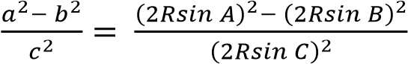
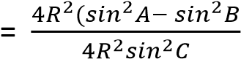
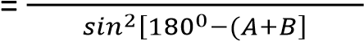
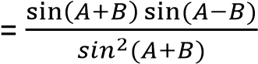
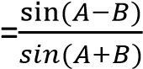

Inverse trigonometric functions
Note that
- If θ = 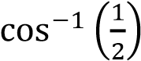 then cosθ =
- 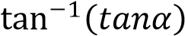= tan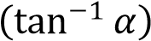 =α
- 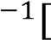
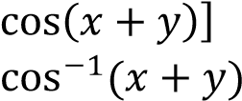
= cos[ = x+y
- 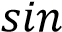
To avoid errors test the values
Example 45
Show that
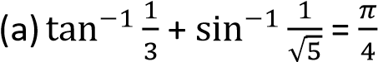
Solution


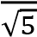
A = 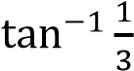 and B =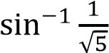
⇨

tanA =

and B =

B

√

1

2

- tan B =
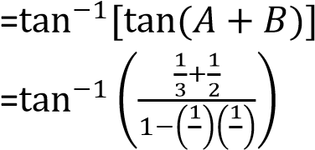
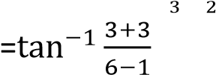
LHS = 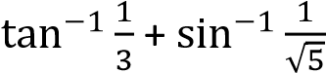 = A + B
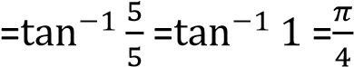

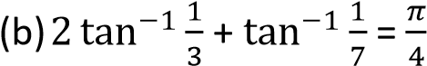
Solution
Let A = 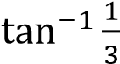 and B =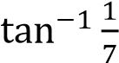
- tanA = and tanB =
LHS: 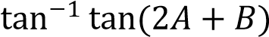 but tan2A =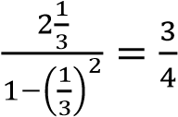
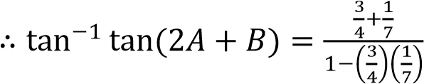
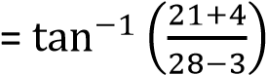
=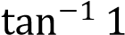
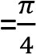
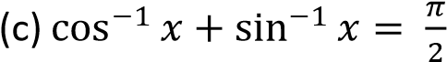
Solution
Let θ= 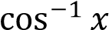; => x = cosθ = sin.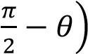
sinx = 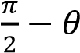
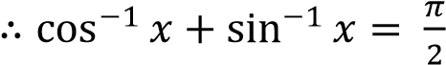

Example 46
Solve the equations
(a) tan⁻¹(2θ + 1) + tan⁻¹(2θ – 1) = tan⁻¹(2)
Solution
Let A = 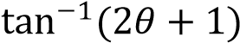 and B =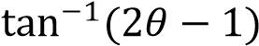
⇨ tanA = 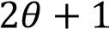 and tanB =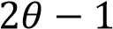
A + B = 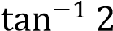 or tan(A +B) =2
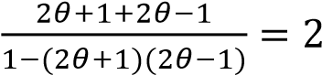
4θ = 2(1 - 4θ² – 1) 2θ² + θ – 1 = 0 (2θ – 1)(θ + 1) = 0 θ = or θ = -1
(b) tan⁻¹(1+ θ) + tan⁻¹(1 - θ) =32
Let A = 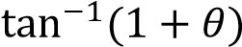 and B =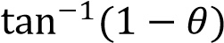 ⇨ tanA = 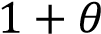 and tanB =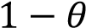
A + B = 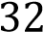 or tan(A +B) = tan32
Introducing tangents
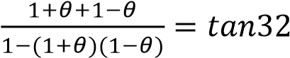
θ²tan32 = 2
θ = 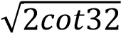 = 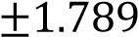

Example 47
If x = tan⁻¹α and y = tan⁻¹β;
Show that x + y = tan⁻¹.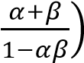

Solution
tanx = α; tany = β
(x + y) = tan[tan⁻¹(x + y)]
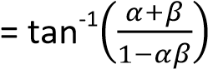

Example 48
Solve the equation
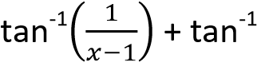(x + 1) = tan(-2)
Solution
Let A = tan⁻¹.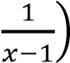 and B = tan⁻¹(x + 1)
⇨ A + B = tan⁻¹(-2)
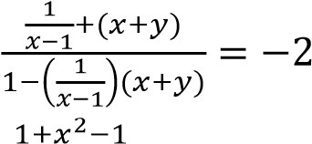
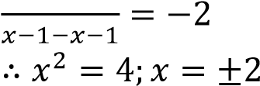

Example 50
Without using tables or calculators determine the values of 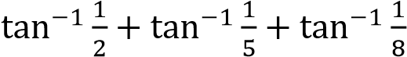.
Solution
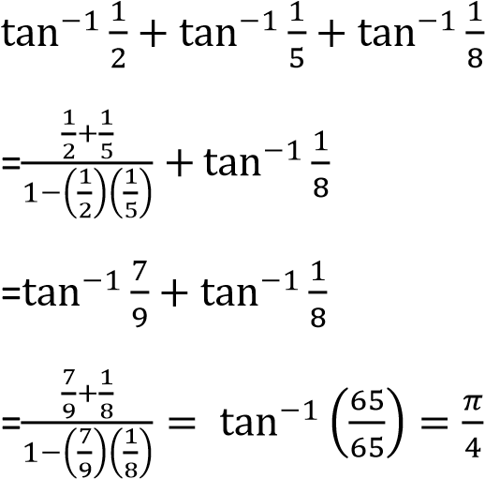.

Example 51
Solve equations
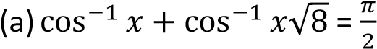
Solution
Let A = 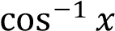 and B =

1

√

A + B =

Cos (A + B) = cos
.

/

A

B

1

x

1

√

𝑥

√

𝑥

𝑥
√

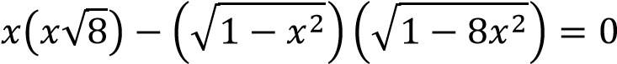
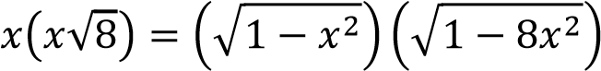
8x⁴ = 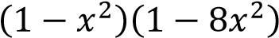
1- 9x² = 0
(1 – 3x)(1 + 3x) = 0
Either x = or x =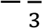
We discard the negative value, so the root is x
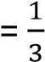
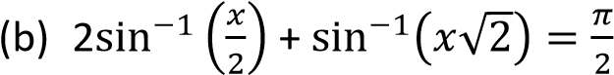
Solution
Let A = 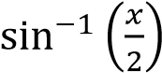 and B = 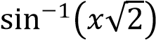
2A + B =
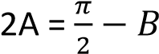
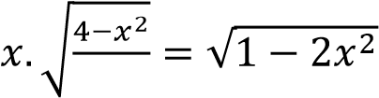
Sin(2A) = sin .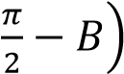

SinAcosA = cosB
2

.

/

√

=
√

A

B

1

√

𝑥

1

𝑥

𝑥
√

√

𝑥

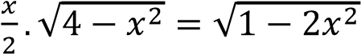
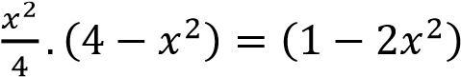
X⁴ – 12x² + 4= 0
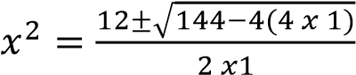
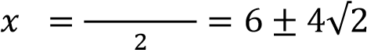
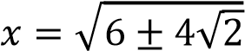
After testing for and for

=
√

√

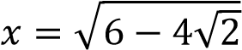, the value that satisfies the
equation is 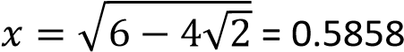
Hence the value of x = 0.5858

Revision exercise 6
- If p = sinα + sin β and q = cosα + cosβ show that 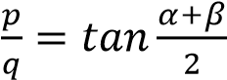
- (a) Prove that:
(i) (sin2x – sinx)(1+ 2cosx) = sin3x
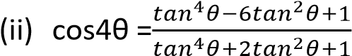
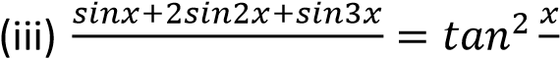
- Solve the equation for 0⁰ ≤ x ≤ 180⁰:
  - sinx + sn3x + sin5x + sin7x = 0
[x: x = 0⁰, 45⁰, 90⁰, 135⁰, 180⁰]
  - sin7x + sinx + sin5x + sin3x = 0
[x: x = 60⁰, 180⁰]
  - sinx + sin4x = 0
[x: x= 0⁰, 60⁰, 72⁰, 144⁰, 180⁰]
  - cos (x + 10⁰) -cos(x + 30⁰) = 0 [70⁰]
  - cos5x – sin2x = cosx [x: x = 0⁰, 70⁰, 90⁰, 110⁰,180⁰]
  - sin2x +sin10x + cos4x = 0
[x: x = 22.5⁰, 35⁰, 55⁰, 67.5⁰, 95⁰, 112.5⁰,
115⁰, 157.5⁰, 175⁰]

- Show that
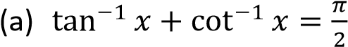
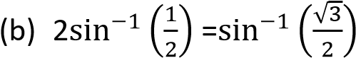
  - the positive value that satisfies the
equation 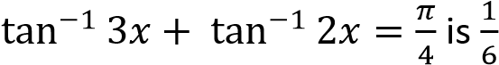
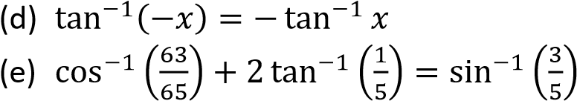
- Prove that
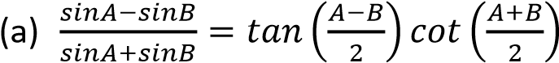
(b) Sin3x + sinx = 4sinxcos²x
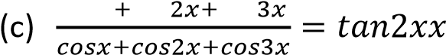
  - sin(A + B) – sin(A – B) =2cosAsinB
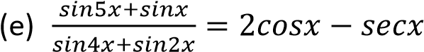
(f) Cos3x + cosx = 4cos²x – 2cosx

Solution to triangles in trigonometry

In a triangle ABC

A

B

C

a

b

c

- Six elements are considered: three angles and three sides
Capital letters denote angles and small bold and italics letters sides
- The opposite side of angle A is a, of angle B is b and of angle C is c.
- The angle sum of a triangle is two right angles i.e. A + B + C = 180⁰
- The sides are independent except that the sum of the two sides of the triangle should be equal to or greater than the third side

How to deal with triangles

The cosine rule
(a) Given an acute angle A


h

D

A

B

C

a

b

c

x

c
-
x

From triangle
ACD: x² + h² = b² ………………………...(i) BCD: (c – x)² + h² = a² c² – 2cx + x² + h² = a² …………… (ii) Substituting eqn. (i) into eqn. (ii)
c² – 2cx + b² = a² But x = bcosA
⇨ b² + c² – 2bccosA = a²
a² = b² + c²-2bccosA (1)
Similarly;
b² = a² + c² – 2accosB (2) c² = a² + b² – 2abcosC (3)
It follows that
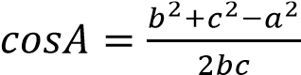
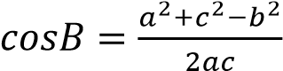
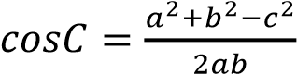
(b) Given an obtuse angle A


(180
0
-

A)

b

a

c

x

A

B

C

D

h

A

In triangle ABC, A is an obtuse angle and CD is the altitude.
From triangle
ACD: x² + h² = b² ………………………...(i) BCD: (c – x)² + h² = a² c² – 2cx + x² + h² = a² …………… (ii) Substituting eqn. (i) into eqn. (ii) c² – 2cx + b² = a² But
x = bcos (180⁰ – A) = -bccosA From triangle ACD
a² = b² + c²-2bccosA as before

The cosine rule can be derived using the vector approach.



Given a triangle above with BC

=
a
, AC =
c

and
A

B

C

a

b

c

AB = b
BC = BA + AC = AC – AB a = b – c
⇨ a.a = (b – c)(b – c)
= b.b – 2b.c + c.c
= b.b + c.c – 2b.c a² = b² + c² – 2bccosA
since b.c = 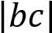cosA

Example 52
Solve the triangle in which AB = 6cm, BC = 4cm and angle ACB = 48⁰12’

Solution

A

B

C

4
cm

6
cm

48
0
12
’

Using: b² = a² + c² -2accosB
= 6² + 4² – 2(6)(4)cos48.2⁰ 1⁰ (degree) = 60’ (minutes) b = 4.47cm
Using: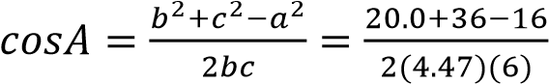
A =41.8⁰
But A + B + C = 180⁰
41.8⁰ + 48.2⁰ + C = 180⁰
C = 90⁰
AC = 4.47cm, angles BAC = 41.8⁰ and ACB
= 90⁰

Example 53
In a triangle ABC, prove that
(a) a² =(b – c)² + 4bcsin².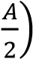 hence that a
= (b – c)secα where tanα = 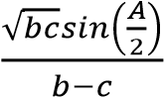
From cosA 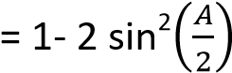
Substituting for cosA into the cosine formula a² = b² + c² – 2bccosA a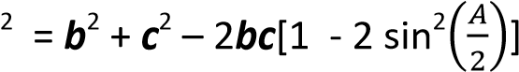
a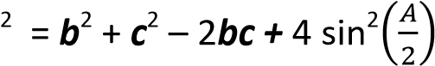 a² =(b – c)² + 4bcsin².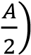
Hence, substituting for 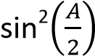into tanα expression we get a² = (b – c)² + (b – c)²tan²α a² = (b – c)²(1 + tan²α) a² = (b – c)²sec²α a = (b – c)secα

The Sine Rule


r

r

A

B

C

D

O

½ a

A

A

The figure shows a circle with center O and radius r circumscribing triangle ABC

Angle BOC = 2A [angle subtended by the same arc at the centre of the circle is twice the angle formed at any point on the circumference] Triangle BOC is isosceles

OD bisects angle BOC and side BC
BD = ½a
From triangle BOD
sinA = 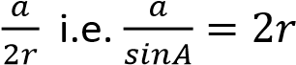
if instead we consider triangles AOC and AOB,
we obtain 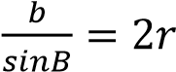 and 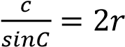
In general: 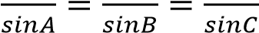

Example 54
Solve the triangle in which AB = 5cm, AC = 4cm and angle ACB = 600
Solution

A

B

C

4
cm

5
cm

60
0

Using sine rule
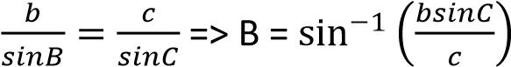
B = 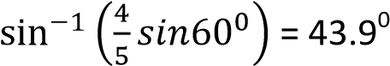
From A + B + C+ = 180⁰
A = (180 – 60 – 43.9)⁰ = 76.1⁰
Similarly a = 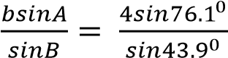 = 5.6cm

Example 55
Prove that in any triangle
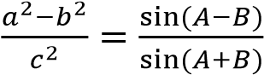
Solution
From sine rule formula; a = 2rsinA, b = 2rsinB, c = 2rsinC
By substitution
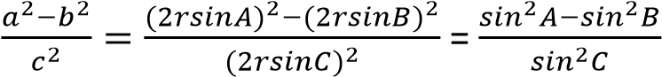
But A + B + C = 180⁰ C = 180⁰ – (A + B) sinC = sin[180⁰ – (A + B)] = sin (A + B)
By substitution
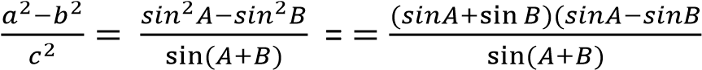
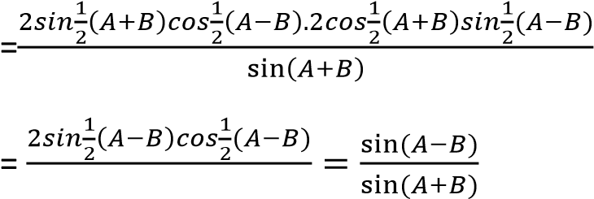
Hence 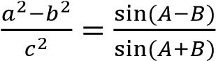

Example 56
Prove that in any triangle ABC,
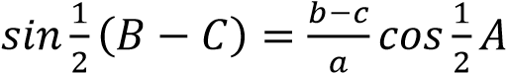
Solution
From sine rule formula; a = 2rsinA, b = 2rsinB, c = 2rsinC
By substitution
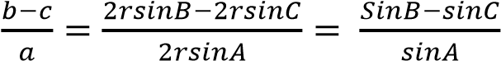
But A + B + C = 180⁰
- = 180⁰ – (B + C) sinA = sin[180⁰ – (B + C)] = sin(B + C)
By substitution
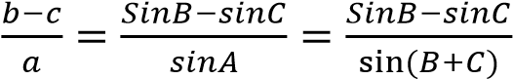
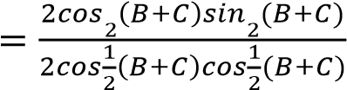
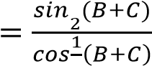
From A + B + C = 180⁰
- + C = 180⁰ – A
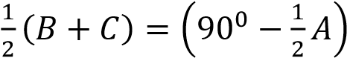
By substitution
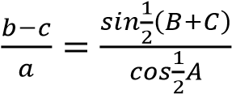
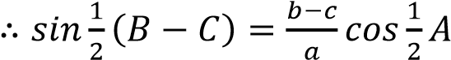

The Tangent Rule
It states that in a triangle ABC
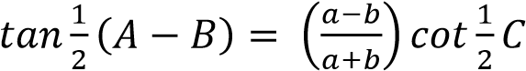
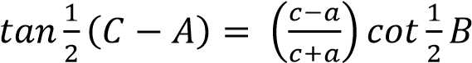
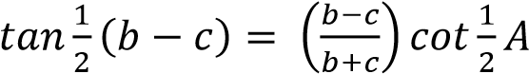
Proof
From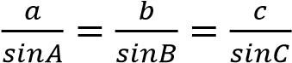
a = 2rsinA, b = 2rsinB, c = 2rsinC
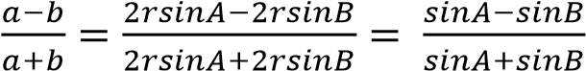
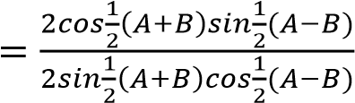
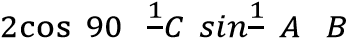
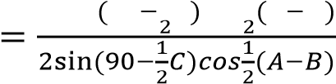
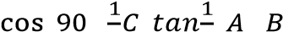
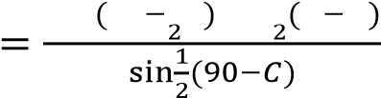
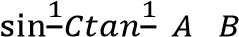
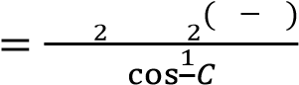
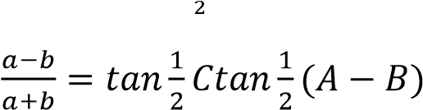
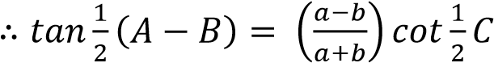

Example 56
Show that in a triangle PQR
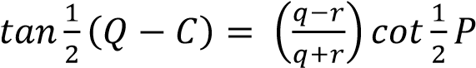
Hence solve the triangle in which q =15.32, r =
28.6 and P = 39⁰52’
Solution
From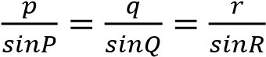
p = 2rsinP, q = 2rsinQ, r = 2rsinR
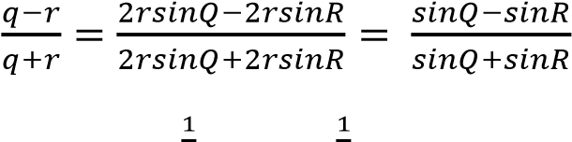
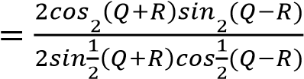
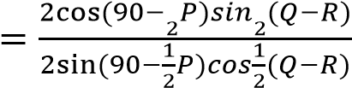
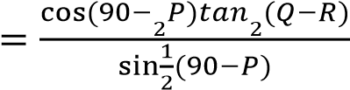
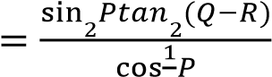
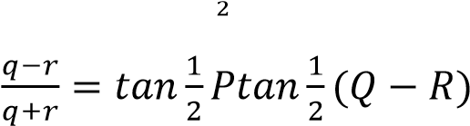
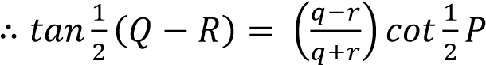
Hence
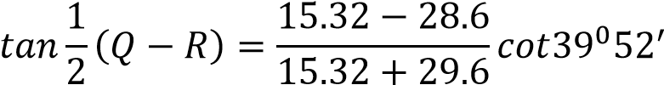
= -0.3621
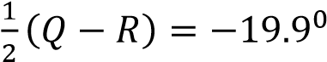 i.e. Q – R = -39.9⁰
But P + Q + R = 180
Q + R = 180 - 39.9 = 140.1⁰
Solving Q = 50.15⁰ and R = 89.95⁰
Now p = 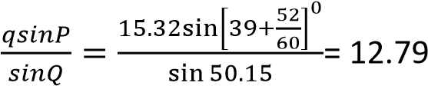
p = 12.79, Q =50.15⁰, R = 89.95⁰

Example 57
Show that 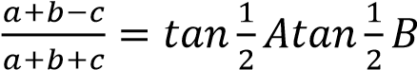
Solution
LHS = 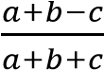
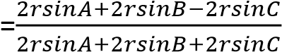
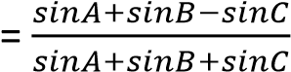
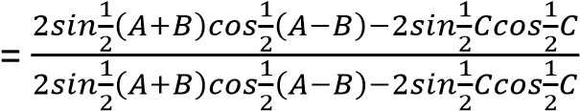
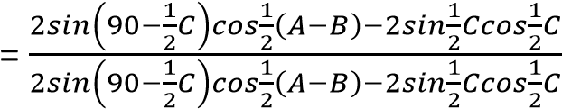
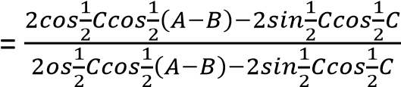
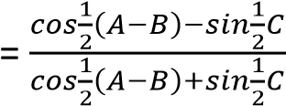

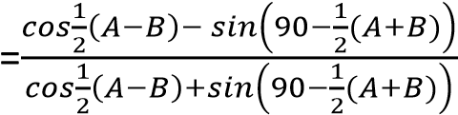
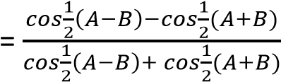
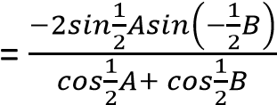
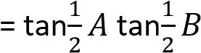

Expressions for sinA, sin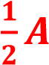 and cos in terms of the sides of the triangle
(a) sinA From the identity sin²A = 1 – cos²A = (1 – cosA)(1 + cosA)
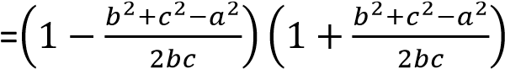
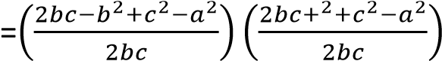
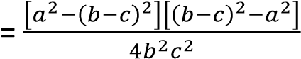
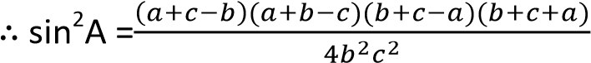
Let s =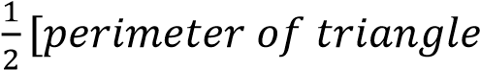-
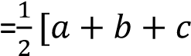-
2s =[a + b + c] a + b = 2s – c; i.e. a + b – c = 2s – c – c = 2(s – c) a + c= 2s – b; i.e. a + c – b = 2s – b – b =2(s – b) b + c = 2s – a; i.e. b + c – a = 2s- a – a = 2(s – a)
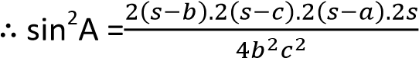
sinA =

√

(

)
(

)
(

)

√

(

)
(

)
(

)

√

(

)
(

)
(

)
Similarly, sinB =
sinC =
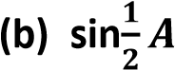 and cos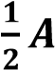
From sin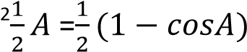
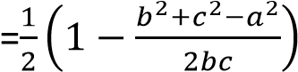
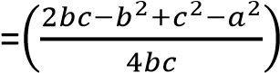
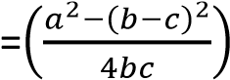
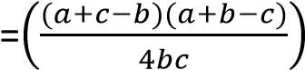
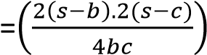
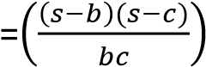
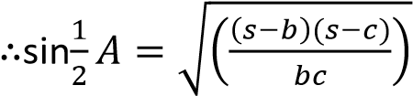
Similarly;
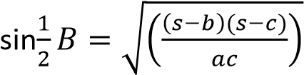
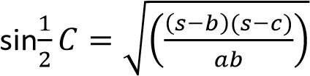
Also;
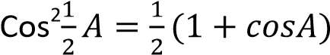
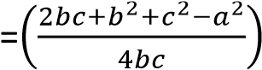
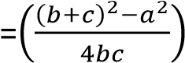
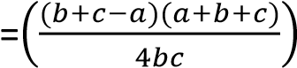
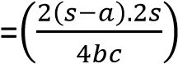
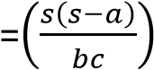
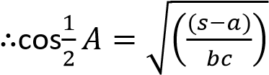
Similarly;
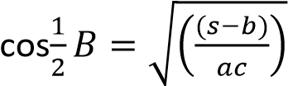
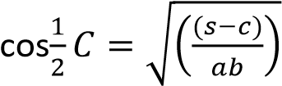
The expression for 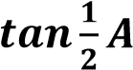 can be deduced as follows
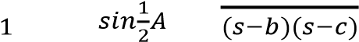
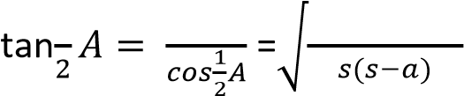
Similarly;
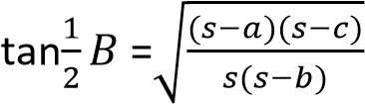
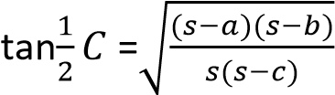

Area of a triangle in trigonometry

A

B

C

a

b

c

h

Area, Δ = 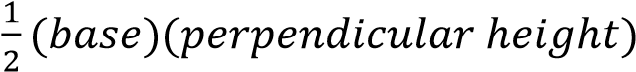
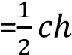
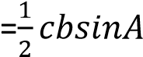
Substituting for
sinA =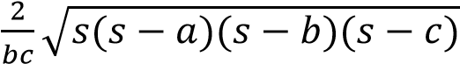
Δ =
1

√

(

)
(

)
(

)
√

(

)
(

)
(

)
Δ =
This a convenient form given the three sides of a triangle. The formula is called Hero’s formula from the first mathematician who suggested it.

Example 58
The area of a triangle is 336m². The sum of the three sides is 84m and one side is 28m.
Calculate the length of the remaining two sides
Solution
Given Δ = 336, a + b + c =84 and a = 28
s = 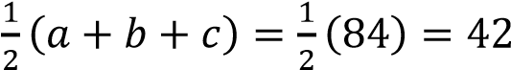
28 + b + c = 84 b + c = 56, or c = 56 – b But Δ² = 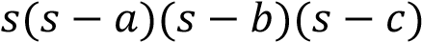
336² = 42(42–28)(42– b)(42 – 56 + b) b² – 56b + 780 = 0
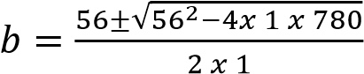
b = 30 or 26 substituting for c = 56 – b c = 26 or 30 the remaining sides are 30m and 26m

Applications of trigonometry in finding distances and bearings
Example 59
A vertical pole BAD stands with its base D on a horizontal plane where BA = a and AD = b. A point P is situated on the horizontal plane at a distance C from D and the angle APB = θ. Prove
that θ = 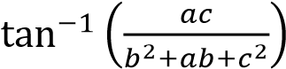
Solution

Let angle APD = α

B

A

D

P

a

b

c

θ

α

For triangle APD: tanα =
For triangle DPB: 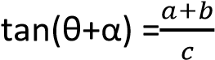
- 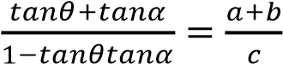
Substituting for tanα
- 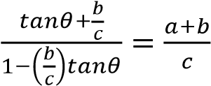
c²tanθ + bc = ac + bc –abtanθ – b²tanθ
(b² + ab + c²)tanθ = ac
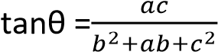
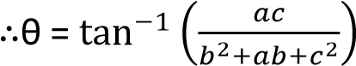

Example 60
The angle of the top of a vertical tower from a point A is 20⁰ and from another point B is 50⁰. Given that A and B lie on the same horizontal plane in the same direction where AB = 100m. Find the height of the tower
Solution
Let OT be the height of the tower


B

T

O

A

100
m

20
0

50
0

AB = 50 – 30 = 30⁰
Using sine rule
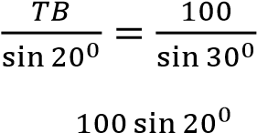
TB =

But OT = TBsin50⁰
OT =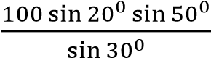 = 26.2m

Example 61
From a point A, a pilot flies in the direction N38⁰20’W to point B 125km from A. He then flies in the direction S50⁰40’E for 125km. He wishes to return to A from this point. How far and in what direction must he fly.

Solution

13
1

38
1

α

38
1

A

B

C

From the digram
Let BC = BA = θ
⇨ 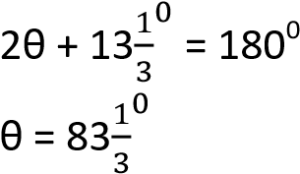
But 38 + α = θ
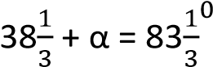
α = 45⁰
From the sine rule
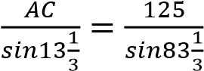
AC = 29km he has to fly 29km in the direction S45⁰W

Example 62
- Prove that tan(A – B) = 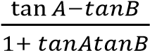 tan (A – B) = 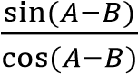
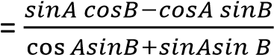
Diving numerator and denominator on the R.H.S by cosAcosB
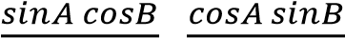
tan (A – B) =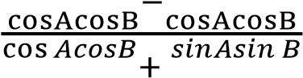
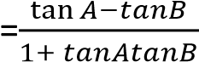
Hence show that 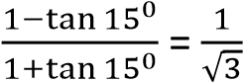
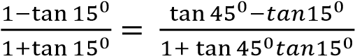
= tan (45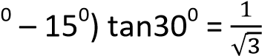

- Given that cos A = and cos B = 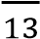 where A and B are acute, find the values of
  - tan (A + B)
  - cosec (A + B)
Solution
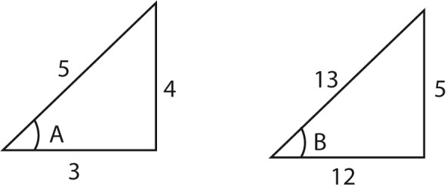
cos A = cos B = 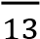 sin A = sin B = 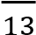 tan A = tanB = 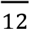
- tan (A + B)=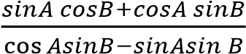
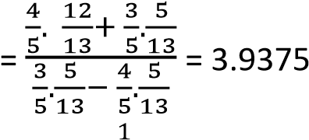
- cosec (A + B) = 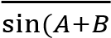
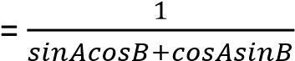
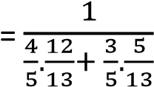
= 1.0317

Example 63
Express cos (θ + 30)⁰ – cos (θ + 48)⁰ in the form RsinPsinQ, where R is constant. Hence solve th3 equation cos (θ + 30)⁰ – cos (θ + 48)⁰ = 0.2
Solution cos (θ + 30)⁰ – cos (θ + 48)⁰
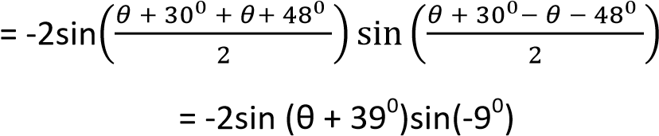

cos (θ + 30)⁰ – cos (θ + 48)⁰ = 0.
⇨ -2sin (θ + 39⁰)sin(-9⁰) = 0.2 sin (θ + 39⁰) = 0.63925
θ + 39⁰ = 39.74⁰ θ = 0.74⁰

Example 64
Express 7cos 2θ + 6sin 2θ in form Rcos (2θ – α), where R is a constant and α is an acute angle.
7cos 2θ + 6sin 2θ Rcos (2θ – α)
7cos 2θ + 6sin 2θ Rcos 2θ cos α +
Rsin2θsinα
Comparing both sides
Rcosα = 7 ………………… (i)
Rsinα = 6 ………………… (ii)
(i)2 + (ii)2 gives
R =
√

=

√

From equation (i)
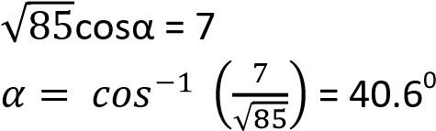

Hence solve 7cos 2θ + 6sin 2θ = 5 for 0⁰ 
180⁰. (07marks)
7cos 2θ + 6sin 2θ = 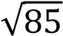 cos(2θ – 40.6⁰) =5
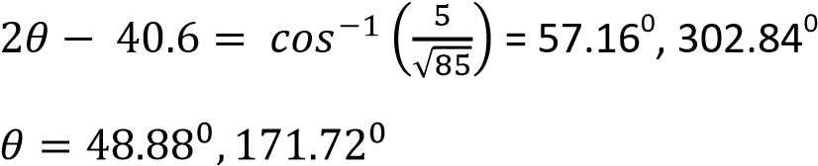

Revision exercise 7
1. Solve the triangles
- a = 17m, b = 21.42m, B = 51⁰34’
  - =38.44⁰, C = 90⁰, c = 27.34m]
- b = 107.2m, c= 76.69m, B =102⁰25’
  - =33.26⁰, C = 44.32⁰, a = 60.21m]
- a = 7m, b = 3.59m, C= 47⁰
[A= 103⁰2’, B = 29⁰52’, c= 5.25m+
- A = 60⁰, b = 8m, C = 15
[a = 13, B= 32.2⁰, C = 87.8⁰]
- Show that for all values of x
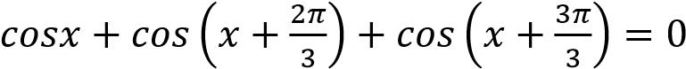
- (a) Simplify 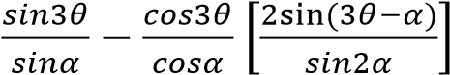
    - Express 5sinθ + 12cosθ in the form rsin(θ + α) where r and α are constant. Hence determine the minimum value of
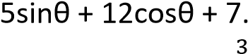 *r =13, α = 67.4⁰, -6]
    - Given that tanθ = , where θ is acute, find values of tan2θ and tan 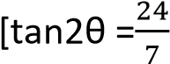 and tan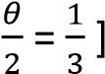
- (a) Show that 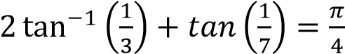
(b) Find x given that
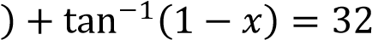
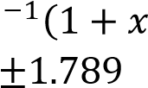
[x = ]
(c) Given that sinα+ sinβ = p and cosα + cos β = q
Show that sin(α + β) = 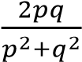
- (a) By expressing 2sinθsin(θ + α) as a difference of cosines of two angles or otherwise, where αis constant, find the least value *minimum value = cosα – 1. It occurs when θ = 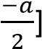
(b) Solve for x in the equation cosx – cos(x + 60⁰) = 0.4 for 0⁰ ≤ x ≤ 360⁰ [x: x = 126.4⁰, 353.6⁰]
- (a) Prove that in any triangle ABC
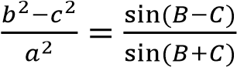
(b) Show that for any isosceles triangle ABC with AB = c the base, is given by
Δ = where s is the
1

√

(

)
perimeter of the triangle
Given that Δ= and s = 4, determine the sides of the triangle [1, 3.5, 3.5]
√

- Given that 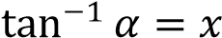 and 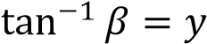, by expressing α and β as tangents ratio of x and y and manipulating the ratios show
that x + y = 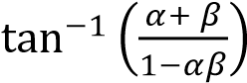
Hence or otherwise
(i) Solve for x in
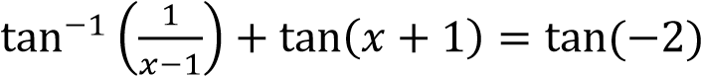
[x = 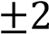]
(ii) Without using tables of calculators determine the value of
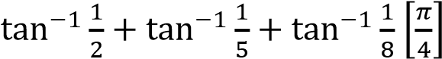
- (a) Prove that 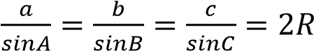
where ABC has all angles acute and R is the radius of the circumcircle.
(b) From the top of a vertical cliff 10m high, the angle of depression of ship A is 10⁰ and ship B is 15⁰. The Bearings of A and B from the cliff are 162⁰ and 202.5⁰ respectively. Find the bearing of B from A [301.5⁰]
- (a) Prove that
(sin2x –sinx)(1 + 2cosx) = sin3x
(b) A vertical pole BAO stands with its base O on a horizontal plane, where BA = c and AO = b, a point P is situated on horizontal plane at a distance x from O and angle APB = θ
Prove that tanθ =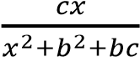
As P takes different positions on the horizontal plane, find the value of x for
which θ is greatest. *18⁰26’, when x = b = c]
- (a) Prove that sin3x = 3sinx – 4sin²x.
(b) Find all the solutions to 2sin²x = 1 for 00≤ x≤ 360⁰.
[x =10⁰, 50⁰, 130⁰, 170⁰, 250⁰, 290⁰]
- Solve cosx +sinx =2 for 0⁰ ≤ x ≤ 360⁰ [x = 60⁰]
- From the top of a tower 12.6m high, the angles of depression of ship A and B are 12⁰ and 18⁰ respectively. the bearing of ship A and ship B from the tower are 148⁰ and
209.5⁰ respectively
Calculate
    - How far the ships are from each other
[53.14m]
    - The bearing of ship A from ship B[108.1⁰]
- (a) Solve sin3x + 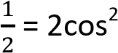x for 0⁰ ≤ x ≤ 360⁰
[x = 30⁰, 60⁰, 120⁰, 150⁰, 240⁰, 300⁰]
(b) Given that in any triangle ABC, 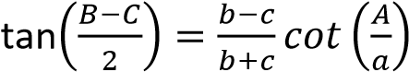 solve the
triangle with two sides 5 and 7 and the included angle 45⁰.
[A = 45⁰, B = 89.4⁰, C= 45.6⁰]
- (a) Solve cot²x = 5(coscx + 1) for 0⁰
≤ x ≤ 360⁰ [9.6⁰, 170.4⁰, 270⁰]
(b) Use tan =t to solve 5secθ – 2sinθ = 2 for 0⁰ ≤ x ≤ 360⁰ [46.4⁰, 270⁰]
- Given that sin2x = cos3x, fins the values of
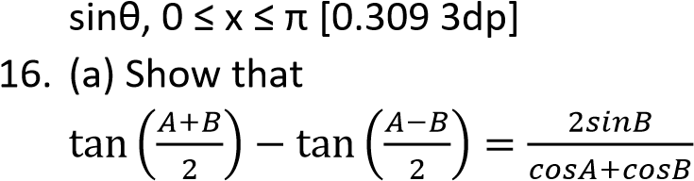
(b) Find in radians the solution of the equation cosθ + sin2θ = cos3θ for
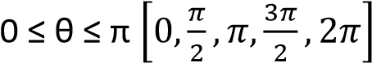
17. (a) Show that cotA + tan2A = cotAsec2A
(b) Show that 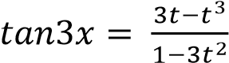, where t = tanx. Hence or otherwise show that
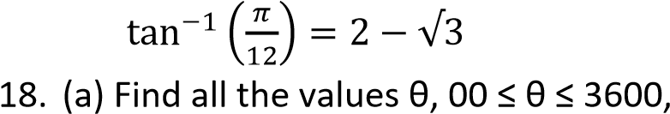
which satisfies the equation sin²θ
– sin2θ – 3cos²θ = 0 *θ =135⁰, 315⁰]
(b) Show that 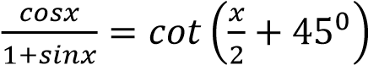.
Hence or otherwise solve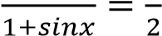;
0⁰ ≤ x ≤ 360⁰ [x = 36.8⁰]
- (a) Given that X, Y and Z are angles of a triangle XYZ. Prove that
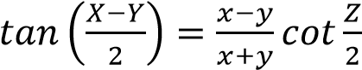.
Hence solve the triangle if x = 9cm, y = 5.7cm and Z = 57⁰. [z = 7.6cm, X= 84.4⁰]
  - Use the substitution t = tan.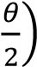 to solve the equation 3cosθ – 5sinθ = -1 for
0⁰ ≤ θ ≤ 360⁰ [40.84⁰, 201.1⁰]
- Prove that
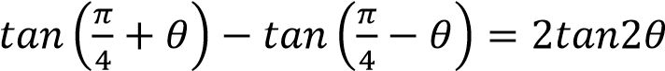
- (a) Solve the equation 3cosx + 4sinx = 2 for
0⁰ ≤ x ≤ 360⁰ [x = 119.5⁰, 346.7⁰]
  - If A, B, C are angles of a triangle. Show that cos2A + cos2B + cos2C = -1 –4cosAcosB
- (a) Solve 2sin2θ = 3 for -180⁰ ≤ x ≤ 180⁰
[-90⁰, 48.6⁰,90⁰, 131.4⁰]
  - Solve sinx – sin4x = sin2x – sin3x for – π ≤ x ≤ π
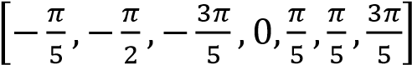
- Without using tables or calculator, show that tan150 = 2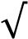-
- (a) Solve the equation cosx + cos2x = 1 for
0⁰ ≤ x ≤ 360⁰ [x = 38.67⁰, 321.33⁰]
  - (i) Prove that 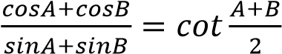
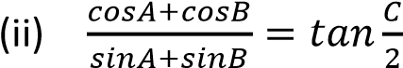 where A, B and C are angles of a triangle
- Given that sin(θ – 45⁰) = 3cos(θ + 45⁰) show that tanθ = 1. Hence find θ if 0⁰ ≤ θ ≤ 360⁰.
[45⁰, 225⁰]
- (a) Use the factor formula to show that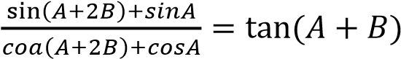
  - Express y = 8cosx + 6sinx in the form Rcos(x – α) where R is positive and α is
acute
Hence find the maximum and minimum
values of 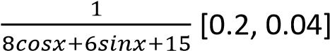
- Express sinx + cosx in the form Rcos(x – α). Hence, find the greatest value of sinx + cos x – 1. [0.4142]
- (a) Solve cosx + cos3x= cos2x, 0 ≤ x ≤ 360⁰
[x = 45⁰, 60⁰, 135⁰, 225⁰, 300⁰, 315⁰]
  - Show that 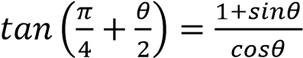
- Show that 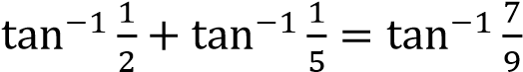
- (a) Solve 3sinx + 4cosx = 2 for 180⁰ ≤ x ≤ 180⁰. [-29.55⁰, 103.29⁰]
  - Show that in any triangle ABC
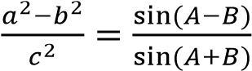
- (a) Prove that 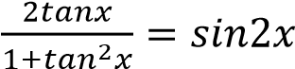
  - Solve sin2x = cosx; 0⁰ ≤ x ≤ 90⁰
[x = 30⁰, 90⁰]
- (a) Solve the equation
8cos⁴x – 10cos²x + 3 = 0; 0⁰ ≤ x ≤ 180⁰
[30⁰, 45⁰, 135⁰, 150⁰]
  - Prove that cos4A – cos4B – Cos4C =
4sin2Bsin2Ccos2A -1 given that A, B and C are angles of a triangle
- Given that cos 2A - cos 2B = -p and sin2A – sin2B = q, prove that
sec (A + B) =
1

√

- Solve
- 4sin²θ – 12sin2θ + 35cos²θ = 0; for
0⁰ 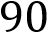 [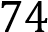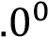]

- 3cosθ – 2sinθ = 2, for 0⁰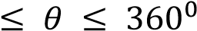 ,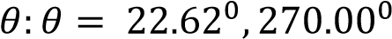-
- Solve the equation sin2θ + cos2θcos4θ = cos4θcos6θ for 0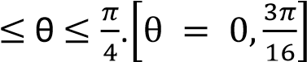
- (a) solve the equation cos2x = 4cos²x -2sin²x for 0 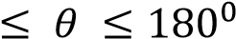*θ = 60⁰, 120⁰]
  - Show that if sin(x + α) = psin(x – α) then tan x = .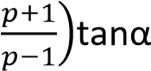. Hence solve the
equation sin(x + α) = psin(x – α) for p = 2 and α= 20⁰. [x = 47.52⁰]
- Solve the equation
3tan²θ + 2sec² θ = 2(5 – 3tanθ) for
0⁰ < θ <180⁰ [θ = 38.66⁰, 116.57⁰]
- (a) Show that tan4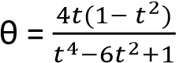 , where t = tanθ
  - Solve the equation
sinx + sin5x = sin2x + sin4x for
0⁰ < x < 90⁰ [x = 60⁰]
- Solve 2cos2θ – 5cos θ = 4 for
0⁰ θ 360⁰ [θ = 138.59⁰, 221.41⁰]

Applications of trigonometry
- Navigation and GPS
Application: Calculating distances and directions between locations.
Example: Pilots and sailors use trigonometry to determine their course and position using angles and coordinates.
- Architecture and Construction
Application: Designing buildings, bridges, and tunnels.
Example: Architects use trigonometric ratios to calculate structural angles and ensure stability in designs.
- Astronomy
Application: Measuring distances between celestial bodies.
Example: Astronomers use trigonometry to calculate the distance from Earth to stars and planets using parallax methods.
- Engineering
Application: Analyzing forces, motion, and wave patterns.
Example: Civil engineers use trigonometry to calculate load distributions and angles in mechanical systems.
- Geography and Surveying
Application: Mapping terrain and measuring land.
Example: Surveyors use trigonometry to determine land elevations and distances between points without direct measurement.
- Computer Graphics and Game Development
Application: Rendering realistic movement and angles.
Example: Trigonometric functions help animate characters, simulate physics, and create 3D environments.
- Medical Imaging
Application: Interpreting scans and modeling body structures.
Example: Techniques like CT scans and ultrasounds rely on trigonometric calculations to reconstruct internal images. 8. Music and Sound Engineering
Application: Modeling sound waves and frequencies.
Example: Trigonometric functions describe waveforms used in synthesizers and audio processing.

TOPIC 6/6: Descriptive Statistics
Competency: The learner analyses data through collection, presentation, and evaluation of population parameters and sample statistics in order to predict and plan for self and community development.
Contents
Statistics 2
Types of data 2
Discrete or ungrouped data 2
Revision exercise 1 6
Solutions to revision exercise 1 7
Continuous or grouped data 12
Revision Exercise 2 [answers are given in brackets besides the questions] for continuous data 31

Statistics
This a branch of mathematics dealing with collection, presentation, analysis and interpretation of data

Types of data
- Discrete data
Its information collected by counting and usually takes integral values that do not lie within a given range
- Continuous data
It is information that takes values within a given range

Discrete or ungrouped data
Terms Used
- Mean or average of a sample
It is denoted by and defined as 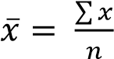; where x is the variable given and n is the number of variable
If assumed mean (working mean) a is given then
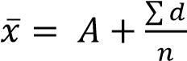; where d = x – A
If the frequency, f, s given then 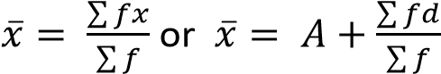
- Variance or Var(X) 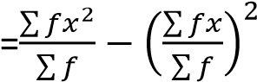
- Standard deviation 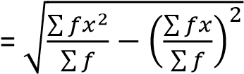
- Mode
This is the value of the distribution that appears most
- Median
This is the middle value of the distribution obtained after the values have been arranged either in ascending of descending order.
Median = 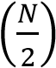 value.
Note that the values must be arranged in ascending or descending order
- Range
It is the difference between the largest value and the smallest value.

- Quartiles
A quartile is a value that divides given values into four equal parts q₁ is the lower quartile and is defined by
q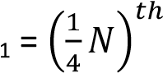value where N is the sum of all the variables
q₃ is the upper quartile and is defined by
q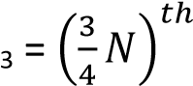value where N is the sum of all the variables
Note that the values must be arranged in ascending or descending order

- Percentiles
A percentile is a value that divides given values into 100 pats.
P₁₀ is the 10th percentile and is defined as
P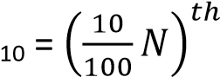value where N is the sum of all the variables
P₉₀ is the 10th percentile and is defined as
P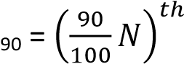value where N is the sum of all the variables
Note that the values must be arranged in ascending or descending order

- Deciles
A decile is a value that divides given values into 10 pats.
D₅ is the 5th decile and is defined as
D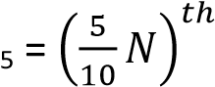value where N is the sum of all the variables
Note that the values must be arranged in ascending or descending order
Example 1
Given the following sets of values
2, 1, 3, 4, 5, 6, 7, 8, 9, 10, 3, 4, 6, 8, 9, 6, 3, 2
    - Form a frequency table of ungrouped data
x | f | fx | cf | x² | fx²
1  2  3  4  5  6  7  8  9  10 | 1  2  3  2  1  4  2  2  2  1 | 1  4  9  8  5  24  14  16  18  10 | 1  3  6  8  9  13  15  17  19  20 | 1  4  9  16  25  36  49  64  81  100 | 1  8  27  32  25  144  98  128  162  100
 | 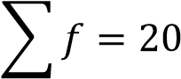 | 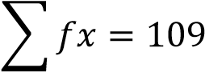 |  |  | 725

    - Use the table to find the mean and mode
      - Mean, 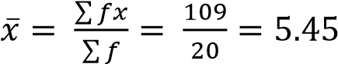
      - Standard deviation = 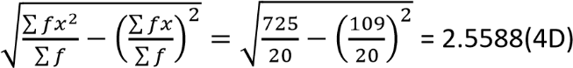
      - Mode = 6 (the value that appear most
      - Find the median value
Median = 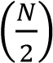 value = 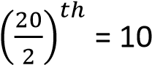^{th} value from cumulative frequency, cf ; median = 6
      - Range = 10 – 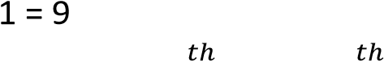
      - Lower quartile, q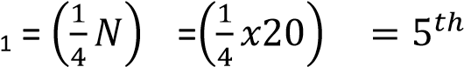 value, from cf, q₁ = 3
      - Lower quartile, q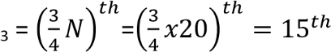 value, from cf, q₃ = 7
      - Tenth percentile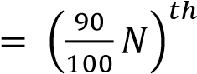value where N is the sum of all the variables

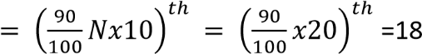
th
value
From cf,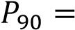9
Example 2
The ages of eight students in a class are: 12, 13, 14, 15, 12, 17, 12, 13, 16, 12.
Find the;
    - Form a frequency table of ungrouped data
x | f | cf | fx | x² | fx²
12 | 4 | 4 | 48 | 144 | 576
13 | 2 | 6 | 26 | 169 | 338
14 | 1 | 7 | 14 | 196 | 196
15 | 1 | 8 | 15 | 225 | 225
16 | 1 | 9 | 16 | 256 | 256
17 | 1 | 10 | 17 | 289 | 289
 | ∑f =10 |  | ∑fx = 136 |  | ∑fx²=1,880
    - Use the table to find
        - mean age
mean = 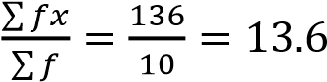
        - variance
Var (X) = 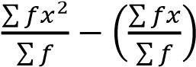
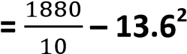

= 3.04
        - Standard deviation = 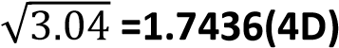

        - Mode = 12 (most frequent figure)

        - Median = 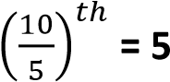^{th} value = 13

        - Range = 17 – 12 = 5
        - Lower quartile, q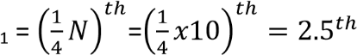 value, from cf, q₁ = 12
        - Lower quartile, q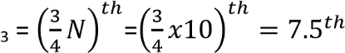 value, from cf, q₃ = 15
        - Tenth percentile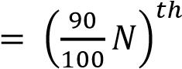value where N is the sum of all the variables

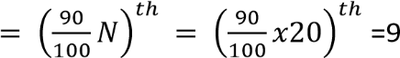^{th} value
From cf,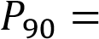16
Example 3
The frequency distribution table shows the marks of some student from a certain school
x | 45 | 63 | 65 | 66 | 70 | 72 | 75 | 80 | 88
f | 3 | 5 | 6 | 4 | 6 | 2 | 1 | 2 | 1
Calculate standard deviation
Solution
x | f | fx | fx²
45 | 3 | 135 | 6075
63 | 5 | 315 | 19845
65 | 6 | 390 | 25350
66 | 4 | 264 | 17424
70 | 6 | 420 | 29400
72 | 2 | 144 | 10368
75 | 1 | 75 | 5625
80 | 2 | 160 | 12800
88 | 1 | 88 | 7744
 | 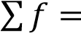30 | 1991 | 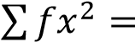134631
Using assumed mean to get variance and standard deviation
Var (X) = 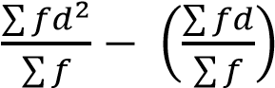
s.d =
√
∑

∑

(
∑

∑

)

S.d =
√
∑

∑

(
∑

∑

)

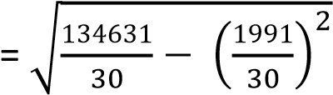
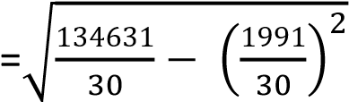
=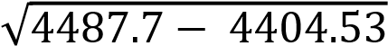
= 9.12

Revision exercise 1
- The data below represents the length of leaves in cm: 4.5 4.4, 6.2, 9.4, 8.2, 12.6, 10.0, 8.8, 3.8 and
13.6. find the;
    - Mean
    - Standard deviation
- The concentration in m per litre of a trace element in 7 randomly chosen samples of water from spring wells were: 240.8, 237.3, 236.6, 2333.9 and 232.5. Determine the mean and the variance of the concentration of the trace elements per litre.

- The table below shows the length of flowers from a certain plant to the nearest 0.5cm.
Length (cm) | 7.5 | 8.0 | 8.5 | 9.0 | 9.5 | 10.0 | 10.5 | 11.0
Number of flowers | 4 | 9 | 11 | 8 | 10 | 7 | 2 | 3
Find the:
    - Mean
    - Mode
    - The median
    - Standard deviation
- The marks scored by 11 students in a test are:52, 61, 78, 49, 47, 79, 54, 58, 62, 73, 72 Find;
    - Median,
    - Mean,
    - Interquartile range
    - Semi-quartile range
- The frequency distribution table shows the heights of some students at a certain school
Height | 154 | 155 | 160 | 164 | 171 | 180
Frequency | 4 | 6 | 8 | 5 | 4 | 3
Determine the variance and standard deviation of the data using a working mean of 160
- The table below shows the marks obtained by 20 students in a mathematics test marked out of 20
Marks | 10 | 11 | 12 | 13 | 14 | 15 | 16 | 17 | 18 | 19 | 20
Number of students | 1 | 2 | 2 | 2 | 2 | 4 | 2 | 1 | 2 | 1 | 1
Find:
    - Mean mark
    - Standard deviation (c) 60th percentile
(d) Interquartile range
- Given the following scores
8, 6, 8, 9, 10, 6, 4, 5, 6, 4, 4, 6, 8, 7, 10, 8, 6, 11, 12, 8
    - Form a frequency distribution table of ungrouped data.
    - Find the standard deviation
    - Calculate semi-quartile range
    - Determine the range of 45th and 90th percentile.

Solutions to revision exercise 1
- The data below represents the length of leaves in cm: 4.5 4.4, 6.2, 9.4, 8.2, 12.6, 10.0, 8.8, 3.8 and
13.6. find the;
    - Mean
    - Standard deviation
Solution
x | x²
4.5 | 20.25
4.4 | 19.36
6.2 | 38.44
9.2 | 84.64
8.2 | 67.24
12.0 | 144
10.0 | 100
8.8 | 77.44
3.8 | 14.44
13.6 | 184.96
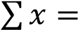80.7 | 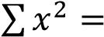750.77
∑ (a) Mean, ̅ =

(b) s.d =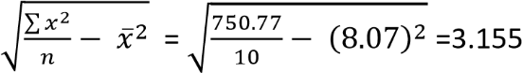
- The concentration in m per litre of a trace element in 7 randomly chosen samples of water from spring wells were: 240.8, 237.3, 236.6, 2333.9 and 232.5. Determine the mean and the variance of the concentration of the trace elements per litre.
Solution
 |   Mean,  𝑥  ̅  =  ∑  𝑥  𝑛  Var(x) =  ∑  𝑥  𝑛  𝑥  ̅  =  55,702.5  =  –  55,696  = 6.5
  x | x²
  240.8 | 57984.64
  237.3 | 56311.29
  236.7 | 56026.89
  234.2 | 54849.64
  236.6 | 55979.56
  233.9 | 54709.21
  232.5 | 54056.25
  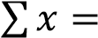1652 | 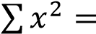389917.5

- The table below shows the length of flowers from a certain plant to the nearest 0.5cm.
Length (cm) | 7.5 | 8.0 | 8.5 | 9.0 | 9.5 | 10.0 | 10.5 | 11.0
Number of flowers | 4 | 9 | 11 | 8 | 10 | 7 | 2 | 3
Find the:
    - Mean
    - Mode
    - The median
    - Standard deviation
Solution
 |   (  a)Mean =  ∑  𝑓𝑥  ∑  𝑓  (  b) mode  = 8.5  c) Median =  (  (  )  𝑡  value  27  =  th  v  alue  From cf the 27  th  value = 9.0
  x | f | fx | fx² | cf
  7.5 | 4 | 30 | 225 | 4
  8.0 | 9 | 72 | 576 | 13
  8.5 | 11 | 93.5 | 794.75 | 24
  9.0 | 8 | 72 | 648 | 32
  9.5 | 10 | 95 | 902.5 | 42
  10.0 | 7 | 70 | 700 | 49
  10.5 | 2 | 21 | 220.5 | 51
  11.0 | 3 | 33 | 363 | 54
   | 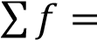54 | 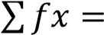486.5 | 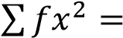4429.75

(d) s.d = 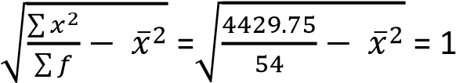
- The marks scored by 11 students in a test are:52, 61, 78, 49, 47, 79, 54, 58, 62, 73, 72 Find;
(a) Median
Arrange values in ascending order
47, 49, 52, 54, 58, 61, 62, 72,73,78,79
      - Median =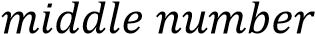 = 6th value = 61
      - Mean,
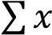 = 52+ 61+78 + 49 + 47 + 79 + 54 + 58 + 62 + 73 + 72 =685
Mean = 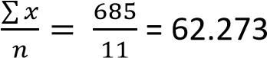
(b) Interquartile range
q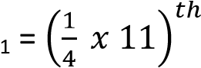value = 2.75th value = 52 q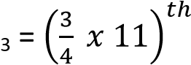value = 8.25th value = 73
Interquartile range = 73 -52 = 21

(c) Semi-quartile range = 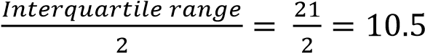

- The frequency distribution table shows the heights of some students at a certain school
Height | 154 | 155 | 160 | 164 | 171 | 180
Frequency | 4 | 6 | 8 | 5 | 4 | 3
Determine the variance and standard deviation of the data using a working mean of 160 Solution
 |   Var (X) =  ∑  𝑓𝑑  ∑  𝑓  (  ∑  𝑓𝑑  ∑  𝑓  )  =  (  )  = 63.156  s.d =  𝑉𝑎𝑟  (  𝑥  )  =  √  =7.95
  x |  | f | d = x - A | fd | fd²
   | 154 | 4 | -6 | -24 | 144
   | 155 | 6 | -5 | -30 | 150
   | 160 | 8 | 0 | 0 | 0
   | 164 | 5 | 4 | 20 | 80
   | 171 | 4 | 11 | 44 | 484
   | 180 | 3 | 20 | 60 | 1200
   |  | 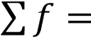30 |  | 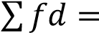70 | 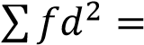2058

- The table below shows the marks obtained by 20 students in a mathematics test marked out of 20
Marks | 10 | 11 | 12 | 13 | 14 | 15 | 16 | 17 | 18 | 19 | 20
Number of students | 1 | 2 | 2 | 2 | 2 | 4 | 2 | 1 | 2 | 1 | 1
Find:
    - Mean mark
    - Standard deviation (c) 60th percentile
(d) Interquartile range

Solution
 |   (  a  )  s.d =  √  ∑  𝑓𝑥  ∑  𝑓  (  ∑  𝑓𝑥  ∑  𝑓  )  =  √  (  )  = 2.722  )  b  (  60  th  percentile  =  (  𝑥  )  𝑡  value  12  =  th  value from cf =15
  x | f | cf | fx | fx²
  10 | 1 | 1 | 10 | 100
  11 | 2 | 3 | 22 | 242
  12 | 2 | 5 | 24 | 288
  13 | 2 | 7 | 26 | 338
  14 | 2 | 9 | 28 | 392
  15 | 4 | 13 | 60 | 900
  16 | 2 | 15 | 32 | 512
  17 | 1 | 16 | 17 | 289
  18 | 2 | 18 | 36 | 648
  19 | 1 | 19 | 19 | 361
  20 | 1 | 20 | 20 | 400
   | 20 |  | 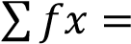294 | 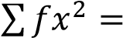4470
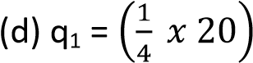
value = 5th value from cf = 12
Q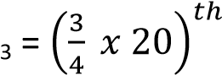value = 15th value from cf = 16
Interquartile range = 16 -12 = 4
- Given the following scores
8, 6, 8, 9, 10, 6, 4, 5, 6, 4, 4, 6, 8, 7, 10, 8, 6, 11, 12, 8
    - Form a frequency distribution table of ungrouped data.
    - Find the standard deviation
    - Calculate semi-quartile range
    - Determine the range of 45th and 90th percentile.
Solution

x | f | cf |  | fx | fx²
4 | 3 |  | 3 | 12 | 48
5 | 1 |  | 4 | 5 | 25
6 | 5 |  | 9 | 30 | 180
7 | 1 |  | 11 | 7 | 49
8 | 5 |  | 16 | 40 | 320
9 | 1 |  | 17 | 9 | 81
10 | 2 |  | 19 | 20 | 200
11 | 1 |  | 20 | 11 | 121
12 | 1 |  | 21 | 12 | 144
 | 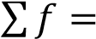20 |  |  | 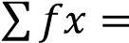146 | 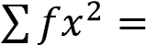1168

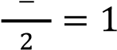
Semi-interquartile range =
(
b
)
s.d =
√
∑
𝑓𝑑

∑
𝑓

(
∑
𝑓𝑑
∑
𝑓
)

=
√

(

)

=2.26

)
c
(
q
1

=
(

𝑥

)
𝑡

value

5

=
th

value

from cf =
6

q
3

=

(

𝑥

)
𝑡

value

15

=
th

value
,
from

cf =
8

(d) 45th percentile = 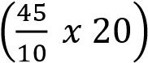 value = 9th value from cf = 6
90th percentile = 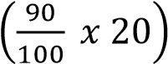 value = 18th value from cf = 10
The range between the 90th percentile and 45th percentile = 10 – 6 = 4

Continuous or grouped data
This is data whose scores or values are said to be continuous and take interval values Example
Class | 20 – 29 | 30 – 39 | 40 – 49 | 50 – 59 | 60 – 69 | 70 – 79 | 80 - 89
Number of students | 4 | 5 | 7 | 3 | 6 | 4 | 1
Terms used
- Class: these are limits of distribution. In the table above, the classes are: (20 – 29), (30 – 39), (40 – 49), (50 – 59), (60 – 69), (70 – 79), (80 – 89).
- Class mark or mark (x)
- Frequency (f) = number of items in a class
This is the mid-point value of the class. It is normally denoted by x. in the table above, the class marks are 24.5, 34.5, 44.5 …..
- Class boundary
These are continuous class limits. In the above table the first class boundary is (20-0.5) – (29
+0.5). In this case, the lower class boundary is 19.5 and upper class boundary is 29.5
For class interval 2.0 – 2.9, the class boundary is (2.0 -0.05) – (2.9 + 0.05) = 1.952.95.
- Class width or class interval
This is the width of each class boundary.
It is given by;
Class width = upper class boundary – lower class boundary
In the table above, class width = 29.5 – 19.5 = 10
- Mean, 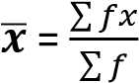
- Variance (Var(X) = 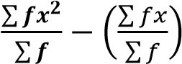
- Standard deviation =

(

)

√
∑

∑

(
∑

∑

)

- Median of grouped data
Median of grouped data is defined by
Median = L_{b} 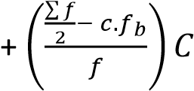
Where L_{b} = lower class boundary of the median class
C= class width of the median class
- Mode of grouped data
Mode of grouped data with equal class width is defined as
Mode = Lb 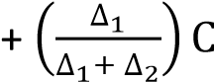
Where
Lb = lower class boundary of modal class
C = Class width of the modal class
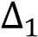 = Modal frequency (pre-modal frequency)
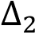 = Modal frequency (post modal frequency)

- Median of grouped data
Median of grouped data is defined by
Median = L_{b} 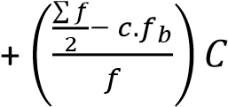
Where L_{b} = lower class boundary of the median class C= class width of the median class f = frequency of the median class
c.f_{b}= cumulative frequency before that of the median class

- Histogram
This is a graph consisting of vertical bars. It is a graph of frequency against class boundary. The area of the bar is equal to the frequency. Histogram is used to obtain the mode

- Percentile
This a value that divides a given distribution into 100 equal parts The 60th percentile for instance is defined as
P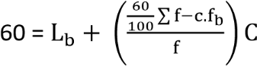
Where
Lb = lower class boundary of the 60th class
C= class width
F = frequency of the 60th class
c.f_{b} = cumulative frequency before that one of the 60th class
- Quartiles
This a value that divides a given distribution into 4 equal parts

The lower quartile denoted q1 for instance is defined as
q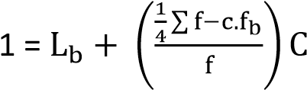
Where
L_{b} = lower class boundary of the q₁ class
C= class width
f = frequency of the q₁ class
c.f_{b} = cumulative frequency before that one of the q₁ class The upper quartile denoted q₃ for instance is defined as
q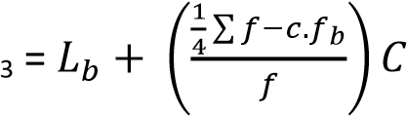
Where
L_{b} = lower class boundary of the q₃ class
C= class width
f = frequency of the q₃ class
c.f_{b} = cumulative frequency before that one of the q₃ class
Interquartile range = q₃ –q₁
Semi-interquartile range =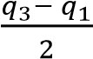
Example 4
The table below shows the weight of 250 students at The Science Foundation College
Weight (kg) | 44.0 –  47.9 | 48.0 –  51.9 | 52.0 –  55.9 | 56.0 –  59.9 | 60.0 –  63.9 | 64.0 –  67.9 | 68.0 –  71.9 | 72.0 –  75.9
Frequency | 3 | 17 | 50 | 45 | 46 | 57 | 23 | 9
Find
    - Average weight
    - Standard deviation
    - Median weight
    - Modal weight
    - Draw an Ogive and use it to find
      - Upper quartile
      - And 10th percentile
(f) Construct a histogram and use it to determine the mode
Solution
Class | Class boundary | x | f | fx | fx² | cf
44.0 - 47.9 | 43.95 - 47.95 | 45.95 | 3 | 137.85 | 413.55 | 3
48.0 - 51.9 | 47.95 - 51.95 | 49.95 | 17 | 849.15 | 14435.55 | 20
52.0 - 55.9 | 51.95 - 55.95 | 53.95 | 50 | 2697.5 | 134875 | 70
56.0 -59.9 | 55.95 - 59.95 | 57.95 | 45 | 2607.75 | 117348.8 | 115
60.0 - 63.9 | 59.95 - 63.95 | 61.95 | 46 | 2849.7 | 131086.2 | 161
64.0 - 67.9 | 63.95 - 67.95 | 65.95 | 57 | 3759.15 | 214271.6 | 218
68.0 - 71.9 | 67.95 - 71.95 | 69.95 | 23 | 1608.85 | 37003.55 | 241
72.0 - 75.9 | 71.95 - 75.95 | 73.95 | 9 | 665.55 | 5989.95 | 250
 |  |  | 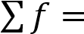250 | 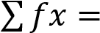15175.5 | 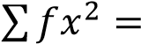655424.1
  - Mean, ̅ ∑
∑
  - Standard
  - Median = L_{b} 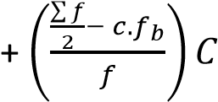
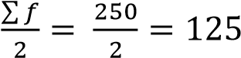
Median class boundary is 59.95 - 63.95, f = 46 and C = 4
Median = 59.95 + 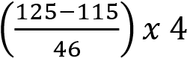 = 60.82kg
  - Modal class boundary is 63.95 – 67.95, since 57 is the highest frequency and C = 4
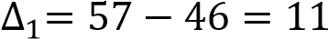 and 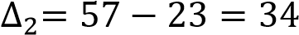
  - Draw an Ogive and use it to find
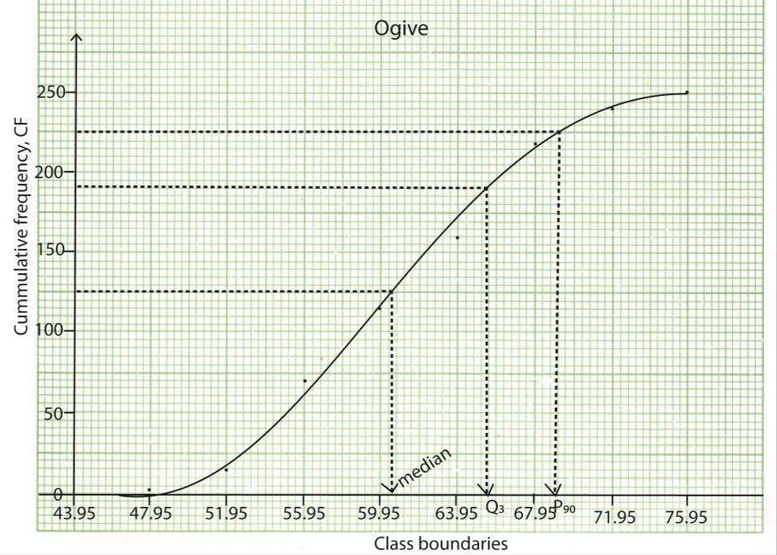
    - Upper quartile = 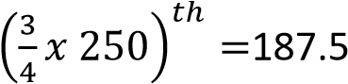^{th} value, from the graph q₃ = 65.55
    - Median = 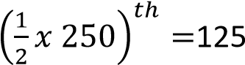^{th} value, from the graph, median = 65.55
    - 10th percentile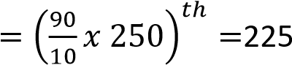^{th} value, from the graph, P90 = 69.15
(f) Construct a histogram and use it to determine the mode
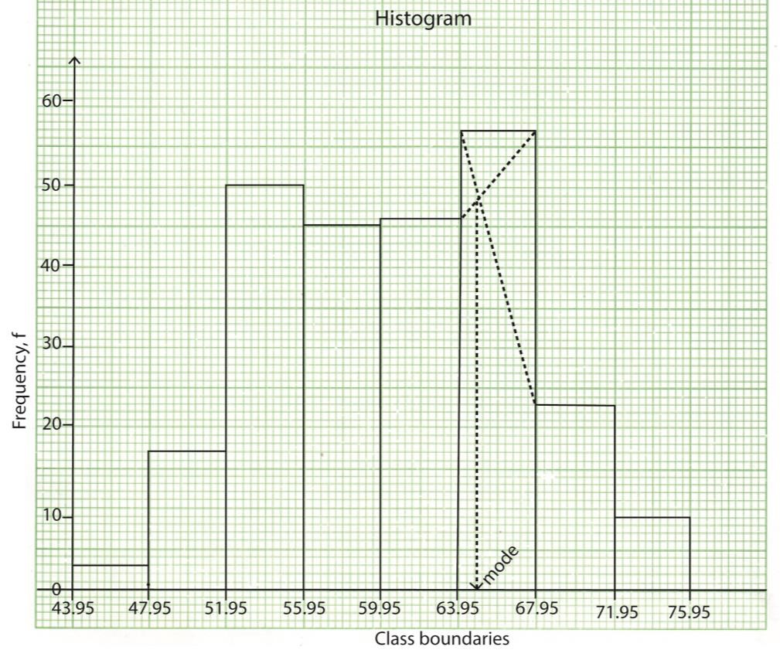
From the graph, the mode =63.95 + 0.8= 64.75

Example 5
The table below shows the number of students and the mark scored in a test.
MARKS | NUMBER OF STUDENTS
0 – 4 | 10
5 – 9 | 7
10 – 14 | 5
15 – 19 | 3
20 – 24 | 7
25 – 29 | 11
30 – 34 | 37
35 – 39 | 20
(a) (i) Draw a cumulative frequency curve (Ogive) for data

MARKS | Class boundaries | NUMBER OF  STUDENTS (f) | Cf | x | fx | fx²
0– 4 | 0 – 4.5 | 10 | 10 | 2 | 20 | 40
5 – 9 | 4.5 – 9.5 | 7 | 17 | 7 | 49 | 343
10 – 14 | 9.5 – 14.5 | 5 | 22 | 12 | 60 | 720
15 – 19 | 14.5 – 19.5 | 3 | 25 | 17 | 51 | 867
20 – 24 | 19.5 – 24.5 | 7 | 32 | 22 | 154 | 3388
25 – 29 | 24.5 – 29.5 | 11 | 43 | 27 | 297 | 019
30 – 34 | 29.5 – 34.5 | 37 | 80 | 32 | 1184 | 37888
35 – 39 | 34.5 – 39.5 | 20 | 100 | 23 | 740 | 27380
 |  | 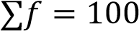 |  |  | ∑fx =2555 | ∑fx²=78645

- Use the Ogive to estimate the median mark (06marks)
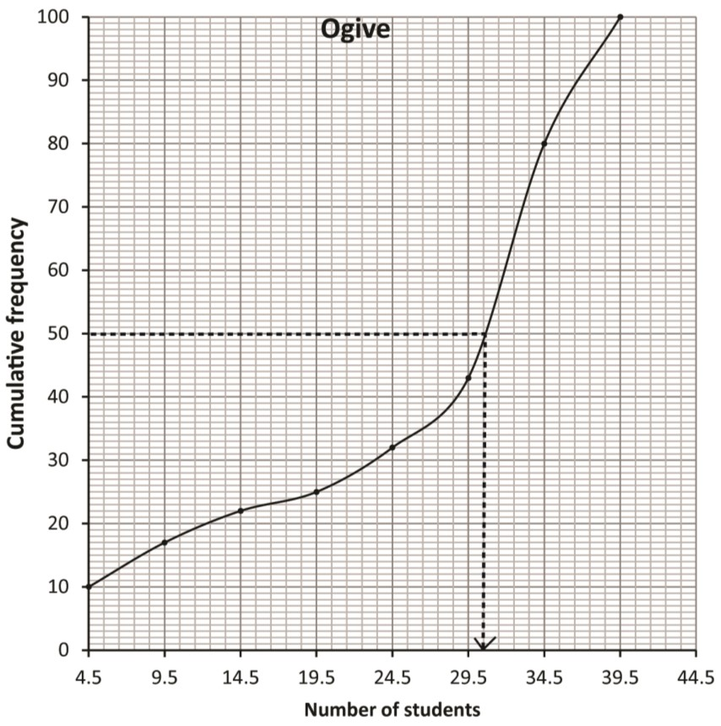
Note that Cf is plotted against the upper limit of the class

Median =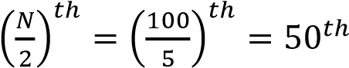 value= 30.5
(b) Calculate the
      - Mean mark
Mean = 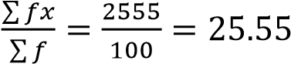
      - Standard deviation (09 marks)
S.d = 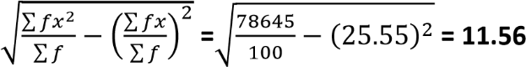
Example 6
The frequency distribution table below shows the marks of 50 students score in a test
Marks | Number of Students
50 – 52 | 3
53 – 55 | 16
56 – 58 | 14
59 – 61 | 13
62 – 64 | 2
65 – 67 | 2
(a) Calculate the:
Solution
Marks | Class boundaries | Number of  Students  (f) | fx | Fx² | CF
50 – 52 | 49.5 – 52.5 | 3 | 153 | 7803 | 3
53 – 55 | 52.5 – 55.5 | 16 | 864 | 46656 | 19
56 – 58 | 55.5 – 58.5 | 14 | 798 | 45486 | 33
59 – 61 | 58.5 – 61.5 | 13 | 780 | 46800 | 46
62 – 64 | 62.5 – 64.5 | 2 | 126 | 7938 | 48
65 – 67 | 64.5 - 67.5 | 2 | 132 | 712 | 50
 |  | 50 | 2853 | 163395

      - Mean mark (04 marks)
Solution
Mean,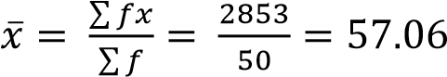
      - Standard deviation. (05 marks)

s.d =
√
∑

∑

̅

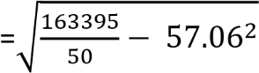
= 12.06

(b) (i) Plot a cumulative frequency curve (Ogive) for the given data. (04 marks)
Note that CF is plotted against the upper limit of each class
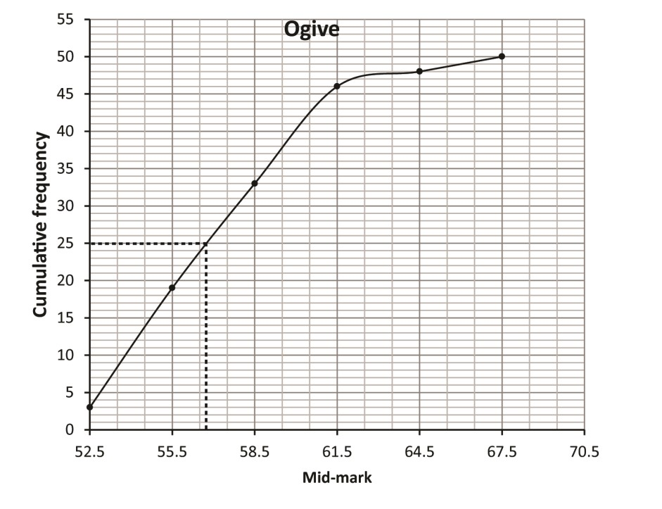
- Use the Ogive to estimate the median mark. (02 marks)
56.5
Example 7
The table below shows the age in years of mothers at the time they had their first child.
Age in years | 15 - | 20 - | 25 - | 30 - | 35 - | 40 - 45
Number of mothers | 2 | 14 | 29 | 43 | 33 | 9
Calculate the modal age of the mothers. (05 marks)
Using the formula
Mode = Li + 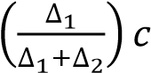
Modal class (30 – 35)
∆1 = 43 - 29 = 14
∆2 = 43 – 33 = 10
Li = 30, Cc = 5
Mode = 30 + 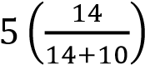= 32.92 (2D)

Example 8
The table below shows a frequency distribution of marks scored by s5 students in a test.
Marks | 10 - | 20 - | 30 - | 40 - | 50 - | 60 - | 70 - | 80 -  ≤90
Number of students | 2 | 6 | 12 | 15 | 10 | 6 | 3 | 1
- Draw a histogram for the data and use it to estimate the modal mark. (05marks)
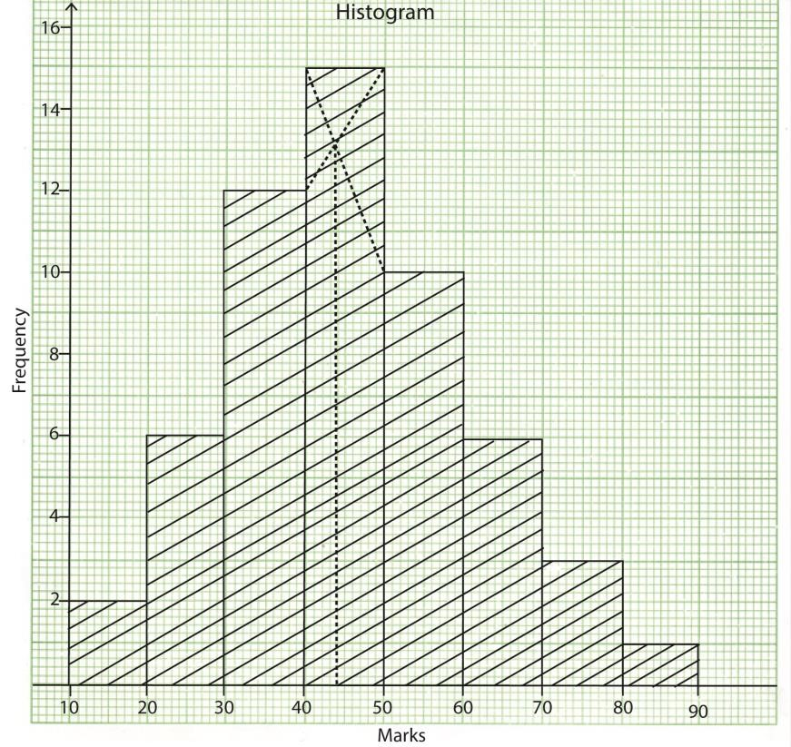
From the graph modal mark is 44
- Calculate the
Marks | x | f | fx | fx²
10 - 20 | 15 | 2 | 30 | 450
20 - 30 | 25 | 6 | 150 | 3750
30 - 40 | 35 | 12 | 420 | 14700
40 - 50 | 45 | 15 | 675 | 30375
50 - 60 | 55 | 10 | 550 | 30250
60 - 70 | 65 | 6 | 390 | 25350
70 - 80 | 75 | 3 | 225 | 16875
80 - 90 | 85 | 1 | 85 | 7225
 |  | ∑f = 55 | ∑fx=2525 | ∑fx²=128975
    - mean mark
Means, 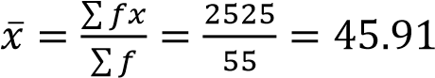
    - standard deviation (10marks)
S.D = 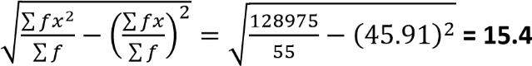
Example 9
The table below shows the weights in kg of 50 cattle on a farm
60 | 81 | 76 | 68 | 84 | 112 | 76 | 102 | 86 | 67
65 | 98 | 107 | 110 | 72 | 99 | 87 | 92 | 76 | 77
94 | 102 | 87 | 86 | 73 | 118 | 98 | 120 | 62 | 87
65 | 92 | 104 | 116 | 91 | 93 | 78 | 122 | 102 | 92
80 | 111 | 73 | 120 | 106 | 123 | 94 | 109 | 80 | 96
- Form a grouped frequency table for the data with classes of equal intervals, starting with the class 60 – 69. (06 marks)
Classes | Class boundaries | Frequency, f | Cumulative frequency, CF
60 – 69 | 59.5 – 69.5 | 6 | 6
70 – 79 | 69.5 – 79.5 | 8 | 14
80 – 89 | 79.5 – 89.5 | 9 | 23
90 – 99 | 89.5 – 99.5 | 11 | 34
100 – 109 | 99.5 – 109.5 | 7 | 41
110 – 119 | 109.5 – 119.5 | 5 | 46
120 – 129 | 119.5 – 129.5 | 4 | 50
- Draw a cumulative frequency curve (Ogive) for the given data. (04 marks)
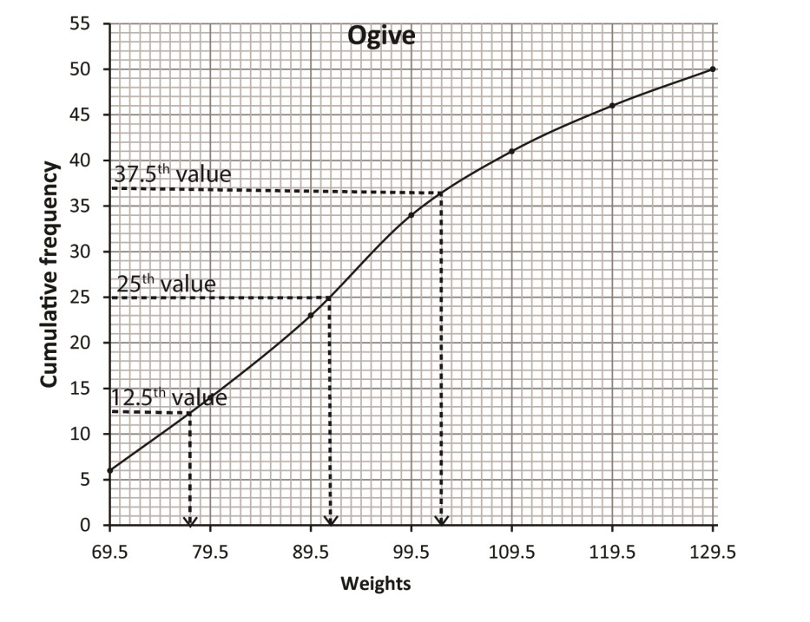
Note that CF is plotted against the upper limit value of the class
- Use your Ogive to estimate the;
  - lower and upper quartile
Lower quartile, q
  - median weight
Median =
  - number of cattle which weigh 118kg and above. (05 marks)
Upper quartile, q
Example 10
Given the data below
Marks (x) | 10-19 | 20-24 | 25-34 | 35-39 | 40-54 | 55-64 | 65-79
Frequency (f) | 4 | 6 | 7 | 3 | 8 | 6 | 6
Find the mode
Solution
 |   Mode = L  b  +  𝑓  𝑑  𝑓  𝑑  𝑓  𝑑  𝐶  =  19.5 +  (  (  )  (  )  )  𝑥  = 22.58
  Class boundary | Class width |  | f | Frequency density
  9.5 - 19.5 |  | 10 | 4 | 0.4
  19.5 - 24.5 |  | 5 | 6 | 1.2
  24.5 - 34.5 |  | 10 | 7 | 0.7
  34.5 - 39.5 |  | 5 | 3 | 0.6
  39.5 - 54.5 |  | 15 | 8 | 0.53
  54.5 - 64.5 |  | 10 | 6 | 0.6
  64.5 - 79.5 |  | 15 | 6 | 0.4
   |  |  | 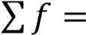40

Example 11
The table shows the weights (kg) of 150 patients who visited a certain health centre.
Weight (kg) | 0 – 9 | 10 – 19 | 20 – 29 | 30 – 39 | 40 – 49 | 50 – 59 | 60 - 69
Frequency (f | 30 | 16 | 24 | 32 | 28 | 12 | 8
Calculate
- Mean
- Mode
- Median
Class | Class boundary | class mark (x) | f | fx | cf
0 - 9 | 0 - 9.5 | 4.5 | 30 | 135 | 30
10 - 19 | 9.5 - 19.5 | 14.5 | 16 | 232 | 46
20 - 29 | 19.5 - 29.5 | 24.5 | 24 | 588 | 70
30 - 39 | 29.5 -39.5 | 34.5 | 32 | 1104 | 102
40 - 49 | 39.5 - 49.5 | 44.5 | 28 | 1246 | 130
50 - 59 | 49.5 - 59.5 | 54.5 | 12 | 654 | 142
60 - 69 | 59.5 - 69.5 | 64.5 | 8 | 516 | 150
 |  |  | 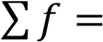150 | 4475
- Mean ̅ ∑ = 29.83kg
∑
- Mode = L_{b} 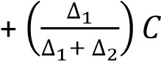
Modal class boundary is 29.5 – 39.5, since 32 is the highest frequency and C = 10
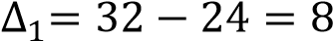 and 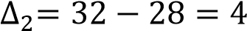
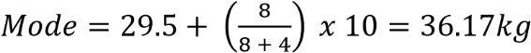
- Median = L_{b} 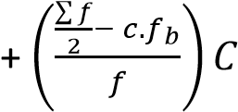
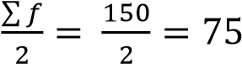
Median class boundary is 29.5 -39.5, f = 32 and C = 10
Median = 29.5 + 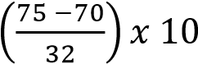 = 30.06kg
Example 12
The table below shows the number of crimes committed by students
Number of crimes | 5-<10 | 10-<20 | 20-<30 | 30-<50 | 50-<100
Number of students | 10 | 15 | 25 | 40 | 26
Calculate the variance and standard deviation for the number of crimes committed
Solution
Number of crime | x | f | fx | fx²
5-<10 | 7.5 | 10 | 75 | 562.5
10-<20 | 15 | 15 | 225 | 3375
20-<30 | 25 | 25 | 625 | 15625
30-<50 | 40 | 40 | 1600 | 64000
50-<100 | 75 | 25 | 1875 | 140625
 |  | 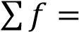115 | 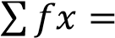4400 | 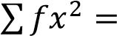224187.5
∑ ∑ Var(x) = ( ) ( )
∑ ∑
s.d = 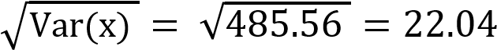
Example 13
The table below shows the weight of 250 students at a certain day school
Weight  (kg) | 44.0 –  47.9 | 48.0 –  51.9 | 52.0 –  55.9 | 56.0 –  59.9 | 60.0 –  63.9 | 64.0 –  67.9 | 68.0 –  71.9 | 72.0 –  75.9
Frequency | 3 | 17 | 50 | 45 | 46 | 57 | 23 | 9
Using assumed mean of 57.95, find
- average weight
- variance
- standard deviation
Solution
weight | x | f | d = x - A | fd | fd²
43.95-47.95 | 45.95 | 3 | -12 | -36 | 432
47.95-51.95 | 49.95 | 17 | -8 | -136 | 1088
51.95-55.95 | 53.95 | 50 | -4 | -200 | 800
55.95-59.95 | 57.95 | 45 | 0 | 0 | 0
59.95-63.95 | 61.95 | 46 | 4 | 184 | 736
63.95-67.95 | 65.95 | 57 | 8 | 456 | 3648
67.95-71.95 | 69.95 | 23 | 12 | 276 | 3312
71.95-75.95 | 73.95 | 9 | 16 | 144 | 2304
 |  | 250 |  | 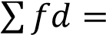688 | 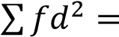12320
- ̅ ∑
∑
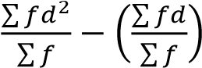
- Var(x) =
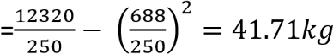
- S.d = 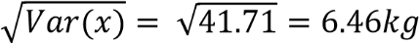

Example 14
The following table shows the marks obtained by to students in a physics test marked out of 100
Marks (%) | 20 -29 | 30-39 | 40-49 | 50-59 | 60-69 | 70-79 | 80-89 | 90-100
Number of students | 4 | 6 | 2 | 5 | 7 | 8 | 5 | 2
Find
- Mean
- Standard deviation
- Median and mode
- Semi-interquartile range
- 40th and 85th percentile range
Solution
Class boundary | x |  | f | fx | fx2 | cf
19.5-29.5 |  | 24.5 | 4 | 98 | 2401 | 4
29.5-39.5 |  | 34.5 | 6 | 207 | 7141.5 | 10
39.5-49.5 |  | 44.5 | 2 | 89 | 3960.5 | 12
49.5-59.5 |  | 54.5 | 5 | 272.5 | 14851.25 | 17
59.5-69.5 |  | 64.5 | 7 | 451.5 | 29121.75 | 24
69.5-79.5 |  | 74.5 | 8 | 596 | 44402 | 32
79.5-89.5 |  | 84.5 | 5 | 422.5 | 35701.25 | 37
89.5-99.5 |  | 94.5 | 3 | 283.5 | 26790.75 | 40
 |  |  | 40 | 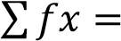2420 | 164370
- Mean ̅ ∑
∑
- S.d = 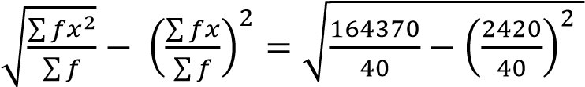 = 21.19%
- Median 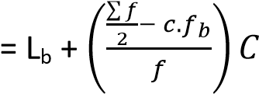
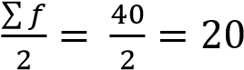
Median class boundary is 59.5-69.5, f = 7 and C = 10
Median = 59.5 + 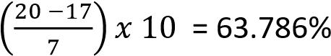
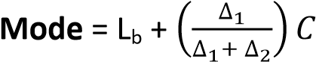
Modal class boundary is 69.5-79.5, since 8 is the highest frequency and C = 10
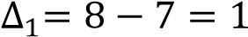 and 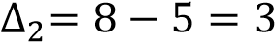
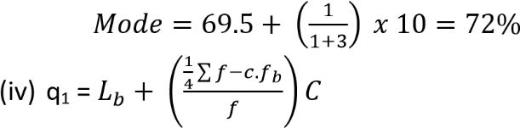
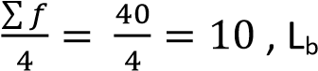=29.5, f= 6, C = 10
q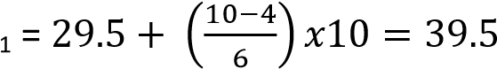
q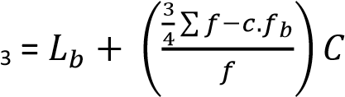
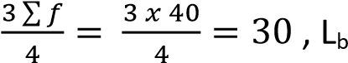=69.5, f= 8, C = 10
q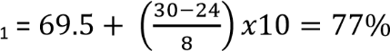
Semi-quartile range = 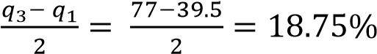
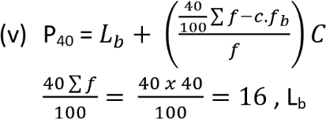=49.5, f= 5, C = 10
P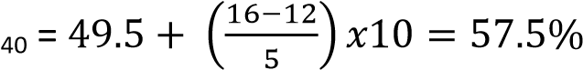
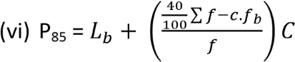
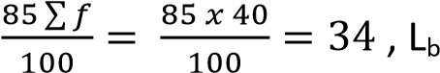= 79.5, f= 5, C = 10
P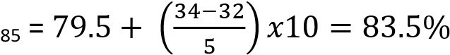
40th and 85th range = 83.5 – 57.5 = 26%
Example 15
Given the information in the table
Class | 20-29 | 30-34 | 35-44 | 45-64 | 65-74 | 75-84
Frequency | 5 | 5 | 12 | 20 | 10 | 8
Find
- Mean value
- Standard deviation
- Mode
- Median
- Interquartile range
- 90th percentile
Solution
Class boundary | class width | x | f | f.d | fx | fx² | cf
19.5-29.5 | 10 | 24.5 | 5 | 0.5 | 122.5 | 3001.25 | 5
29.5-34.5 | 5 | 32 | 5 | 1 | 160 | 5120 | 10
34.5-44.5 | 10 | 39.5 | 12 | 1.2 | 474 | 18723 | 22
44.5-64.5 | 20 | 54.5 | 20 | 1 | 1090 | 59405 | 42
64.5-74.5 | 10 | 69.5 | 10 | 1 | 695 | 48302.5 | 52
74.5-84.5 | 10 | 79.5 | 8 | 0.8 | 636 | 50562 | 60
 |  |  | 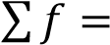60 |  | 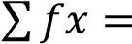3177.5 | 185113.8
- Mean ̅ ∑
∑
- S.d = 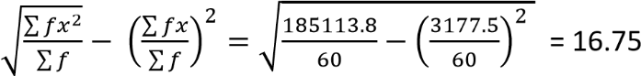
- Mode = L_{b} 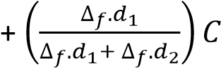
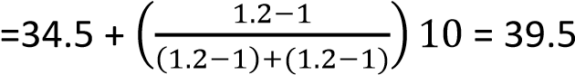
- Median 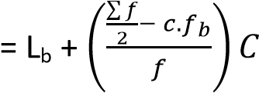
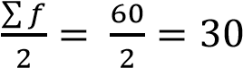
Median = 44.5 + 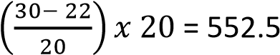

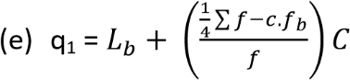
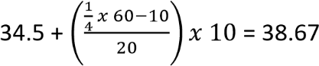
Q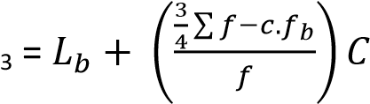
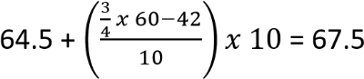
Interquartile range = 67.5 – 38.67 = 28.83
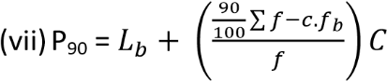
= 74.4 +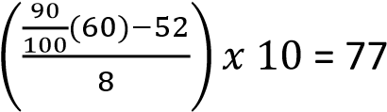
Example 17
Given the data below
Marks | 5-14 | 15-24 | 25-34 | 35-44 | 45-54 | 55-64 | 65-74 | 75-85 | 85-94
Frequency | 3 | 7 | 12 | 20 | 30 | 15 | 8 | 3 | 2
Draw a histogram and use it to determine the mode
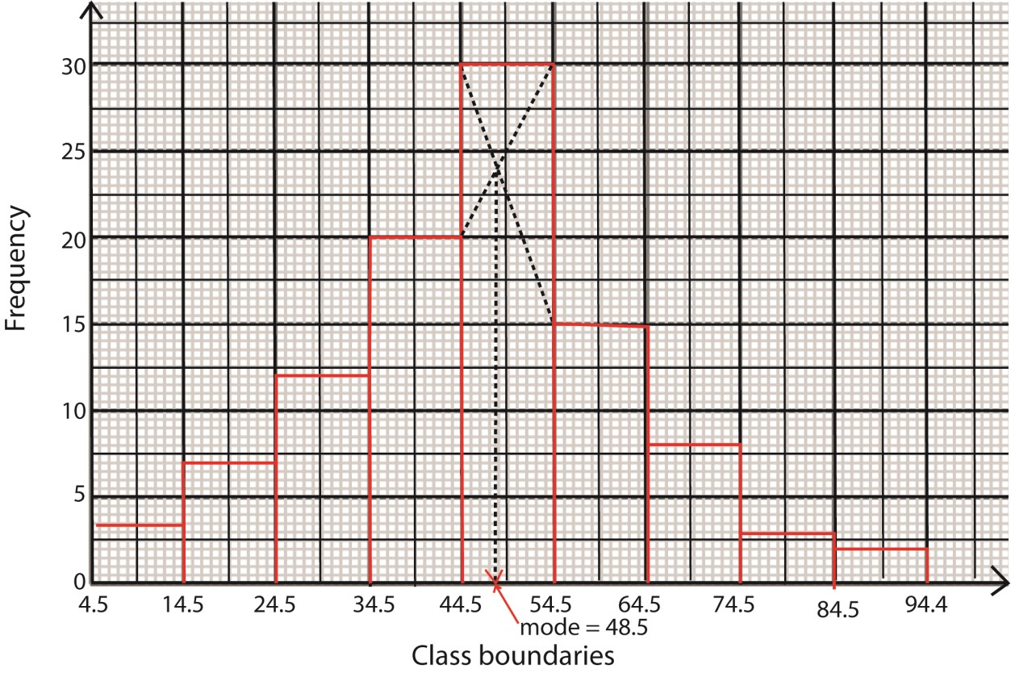

Example 18
Given the data below
Marks | 20-29 | 30-39 | 40-49 | 50-59 | 60-69 | 70-79
Frequency | 4 | 6 | 12 | 8 | 7 | 3
Draw an Orgive and use it to determine
- Median
- Interquartile range
- 10th percentile
Solution
Class boundary | 19.5 – 29.5 | 29.5–39.5 | 39.5–49.5 | 49.5 – 59.5 | 59.5 – 69.5 | 69.5 – 79.5
cf | 4 | 10 | 22 | 30 | 37 | 40
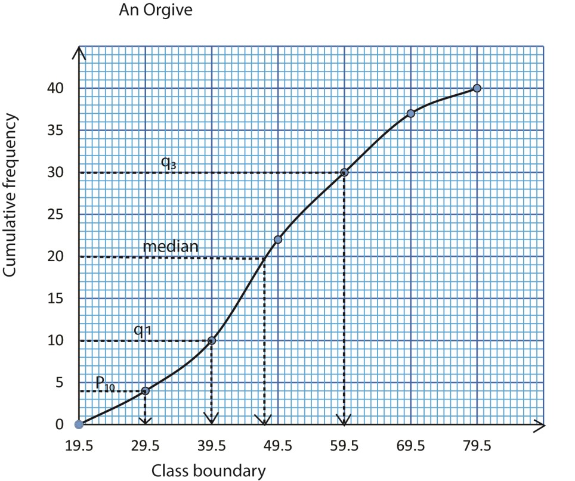
(a) The median = 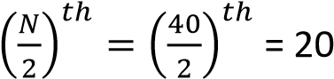^{th} value from the graph = 48.5
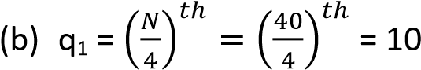
th
value ; from the graph q₁ = 39.5
q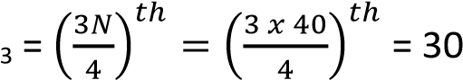^{th} value; from the graph q₃ = 59.5
Interquartile range = 59.5 – 39.5 = 20

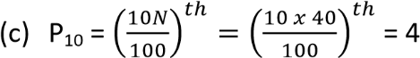
th
value ; from the graph P₁₀ = 29.5

Grouped data with unequal class width
(i) Histogram
This is a graph of frequency density against class boundary
Note that frequency density = 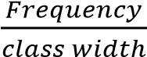
Orgive
This is a graph of cumulative frequency against the class boundary
Example 19
The data shows the length in centimetres for different calendars produced by a printing press. A cumulative frequency distribution was formed
Length (cm) | <20 | <30 | <35 | <40 | <50 | <60
Cumulative frequency | 4 | 20 | 32 | 42 | 48 | 50
- Construct a frequency table.
- Find the mean length of the calendars
- Draw a histogram and use it to estimate the modal length (d) Draw an Orgive and use it to estimate the median length.
Solution
- Frequency table
Class boundary | x |  | f | fx | class width | frequency density | cf
0 - 20 |  | 10 | 4 | 40 | 20 | 0.2 |  | 4
20 - 30 |  | 25 | 16 | 400 | 10 | 1.6 |  | 20
30 - 35 |  | 32.5 | 12 | 390 | 5 | 2.4 |  | 32
35 - 40 |  | 37.5 | 10 | 375 | 5 | 2 |  | 42
40 - 50 |  | 45 | 6 | 270 | 10 | 0.6 |  | 48
50-60 |  | 55 | 2 | 110 | 10 | 0.2 |  | 50
 |  |  | 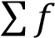50 | 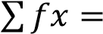1585
- Mean 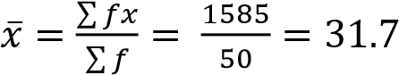
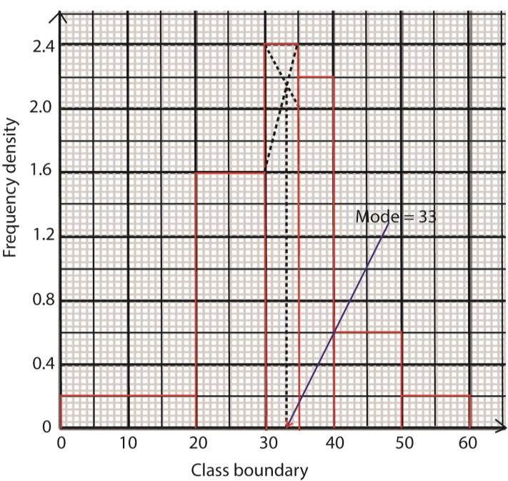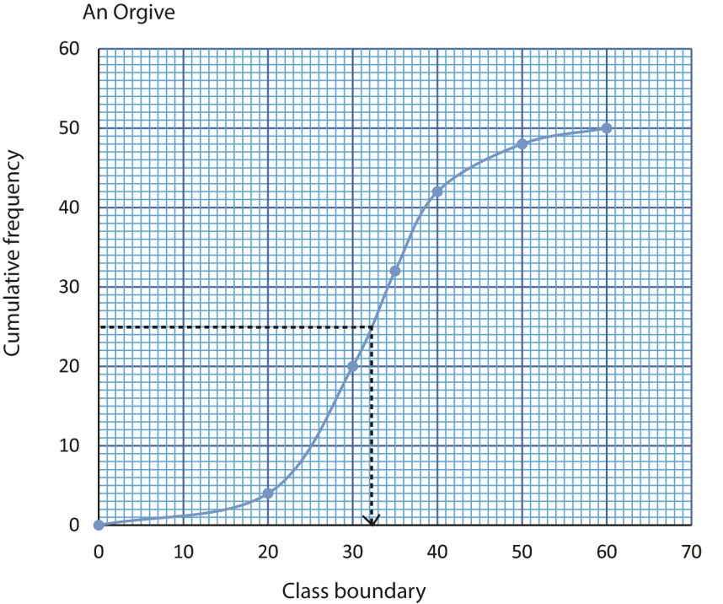

Median length is the 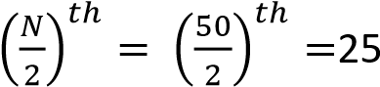^{th} value, from the graph = 32

Revision Exercise 2 [answers are given in brackets besides the questions] for continuous data
- The table below shows cumulative distribution of ages (in years of 400 student
Age(years) | <12 | <13 | <14 | <15 | <16 | <17 | <18 | <19
Cumulative frequency | 0 | 27 | 85 | 215 | 320 | 370 | 395 | 400
  - Construct a cumulative frequency curve
  - Use the curve to estimate
  - Median age [14.9]
  - 20th and 80th percentile range [2.1]
- The table below shows the time taken by students to solve a mathematics problem
Time (mins) | 5-9 | 10-14 | 15-19 | 20-24 | 25-29 | 30-34
Frequency | 5 | 14 | 30 | 17 | 11 | 3
  - Draw a histogram and use it to estimate the modal time. [17.3]
  - Find the mean and standard deviation of solving the problem
[Mean = 18.5mins, s.d = 5.9896 (4D)]
- The frequency distribution table shows the heights of s.6 students measured to the nearest cm;
Height | 149-152 | 153-156 | 157-160 | 161-164 | 165-168 | 169-172 | 173-176
Frequency | 5 | 17 | 20 | 25 | 15 | 6 | 2
  - Calculate
    - Mean height [160.9cm]
    - Standard deviation [Ans. 5.5873]
  - Draw a cumulative frequency curve and use it to estimate the median (Ans. 161cm) and range of height of the middle 60% of the candidates. [10cm]
- The table below the weights of some S.5 students from a certain school
Weight | 50-53 | 54-57 | 58-61 | 62-65 | 66-69 | 70-73 | 74-77 | 78-81
Number  of student | 3 | 8 | 12 | 18 | 11 | 5 | 2 | 1
  - Calculate
    - Mean [63.1kg]
    - Standard deviation of students’ weight [6kg]
  - Draw a cumulative frequency curve and use it to estimate
    - Median weight [63.1kg]
    - Number of students with weight between 58.9kg and 66.7kg [29students]

- The table below is the distribution of weights of a group of animals
Mass (kg) | Frequency
21-25 | 10
26-30 | 20
31-35 | 15
36-40 | 10
41-50 | 30
51-60 | 45
66-74 | 5
  - Draw a cumulative frequency curve to estimate semi-quartile range [24kg]
  - Find
    - Mode [28.8333kg]
    - Standard deviation [11.772]
- The table below shows the amount of money (in thousands of shillings) that was paid out as allowances to participants during a certain workshop
Amount  (shs’000s) | 110-114 | 115-119 | 120-129 | 130-134 | 135-144 | 145-159
Number of participants | 13 | 20 | 32 | 17 | 16 | 12
  - Draw a histogram and use it to estimate the modal allowance [shs. 11800] (b) Calculate the:
    - Median allowance [shs. 126,375/=]
    - Mean allowance [shs. 128,000/=]
- The table below shows the income of 40 factory workers in millions of shillings per annum
1.0 | 1.1 | 1.0 | 1.2 | 5.4 | 1.6 | 2.0 | 2.5
2.1 | 2.2 | 1.3 | 1.7 | 1.8 | 2.4 | 3.0 | 2.2
2.7 | 3.5 | 4.0 | 4.4 | 3.9 | 5.0 | 5.4 | 5.3
4.4 | 3.7 | 3.6 | 3.9 | 5.2 | 5.1 | 5.7 | 1.5
1.6 | 1.9 | 3.4 | 4.3 | 2.6 | 3.8 | 5.3 | 4.0
  - Form a frequency distribution table with class interval of 0.5millin shillings starting with the lowest limit of 1million shillings
  - Calculate the
    - Mean income [shs. 3,175,000]
    - Standard deviation [shs. 1,413,992.574]
  - Draw a histogram to represent the above data. Use it to estimate the modal income Modal income: [shs. 5, 200,000]
- The table below shows the mars obtained by students in a physic test
Marks (%) | 25-29 | 30-34 | 35-39 | 40-44 | 45-49 | 50-54 | 55-59 | 60-64 | 60-69 | 70-74
Frequency | 9 | 12 | 10 | 17 | 13 | 25 | 18 | 14 | 8 | 8
  - Draw a histogram and use it to estimate the modal mark. [52.5] (b) Find the
    - Mean mark [49.4627]
    - Standard deviation [12.424]
- The table below shows the marks obtained in an examination by 200 candidates
Marks(%) | 10-19 | 20-29 | 30-39 | 40-49 | 50-59 | 60-69 | 70-79 | 80-89
Number of candidates | 18 | 34 | 58 | 42 | 24 | 10 | 6 | 8
  - Calculate the
    - Mean mark [40.2%]
    - Modal mark [35.5%]
  - Draw a cumulative frequency curve for the data. Hence estimate the lowest mark for a distinction one if the top 5% of the candidates qualify for the distinction. [75%]
- A class performed on an experiment to estimate the diameter of a circular object. A sample of five students had the following results in centimetre. 3.13, 3.16, 2.94, 3.33 and 3.0.
Determine the sample;
    - Mean [3.11]
    - Standard deviation [0.1356](05marks)
- The times taken for 55 students to have their lunch to the nearest minute are given in the table below
Time (minutes) | 3 -4 | 5-9 | 10-19 | 20 – 29 | 30 – 44
Number of students | 2 | 7 | 16 | 21 | 9
    - Calculate the mean time for the student to have lunch. [mean=20.65] (04marks)
    - (i) Draw a histogram for the given data
(ii) Use your histogram to estimate the modal time for the students to have lunch. (08marks) [modal time = 22 minutes]
- The frequency distribution below shows the age of 240 students admitted to a certain University.
Age (years) | Number of student
18 - < 19 | 24
19 -< 20 | 70
20 -< 24 | 76
24 -< 26 | 48
26 -< 30 | 16
30 -< 32 | 6
    - Calculate the mean age of the students. [mean = ](04mark)
    - (i) Draw a histogram for the given data
(ii) Use the histogram to estimate the modal age [modal age = 19.58] (08mark)
- The table shows the masses of bolts bought by a carpenter.
Mass (grams) | 98 | 99 | 100 | 101 | 102 | 103 | 104
Number of bolts | 8 | 11 | 14 | 20 | 17 | 6 | 4
Calculate the:
(a)median mass [101g]
(b) mean mass of the bolt [100.7625g] (05mark
- The table below shows the marks obtained in a mathematic test by a group of student
marks | 5 -<15 | 15-<25 | 25-<35 | 35-<45 | 45-<55 | 55-<65 | 65-<75 | 75-<100
Number of | 5 | 7 | 19 | 17 | 7 | 4 | 2 | 3
students
    - Construct a cumulative frequency (O give) for the data (05 marks)
    - Use your Ogive to find the
      - Range between the 10th and 70th percentiles [26]
      - Probability that a student selected at random scored below 50 marks. [0.8125] (07 marks)
- The table below shows the marks obtained by 100 students in a mathematics test
Marks | 20-<40 | 40-<50 | 50-<55 | 55-<60 | 60-<70 | 70-<90 | 90-<100
Number of students | 5 | 15 | 10 | 15 | 25 | 25 | 5
  - Calculate the mean mark [63.125]
  - Construct a cumulative frequency curve (Ogive) and use it to find the
    - Median mark [61.5]
    - Range of the middle 40% of the mark [15]

